How to customize your Dashboard
(Students)
Step 1:
Log on to https://my.csustan.edu/
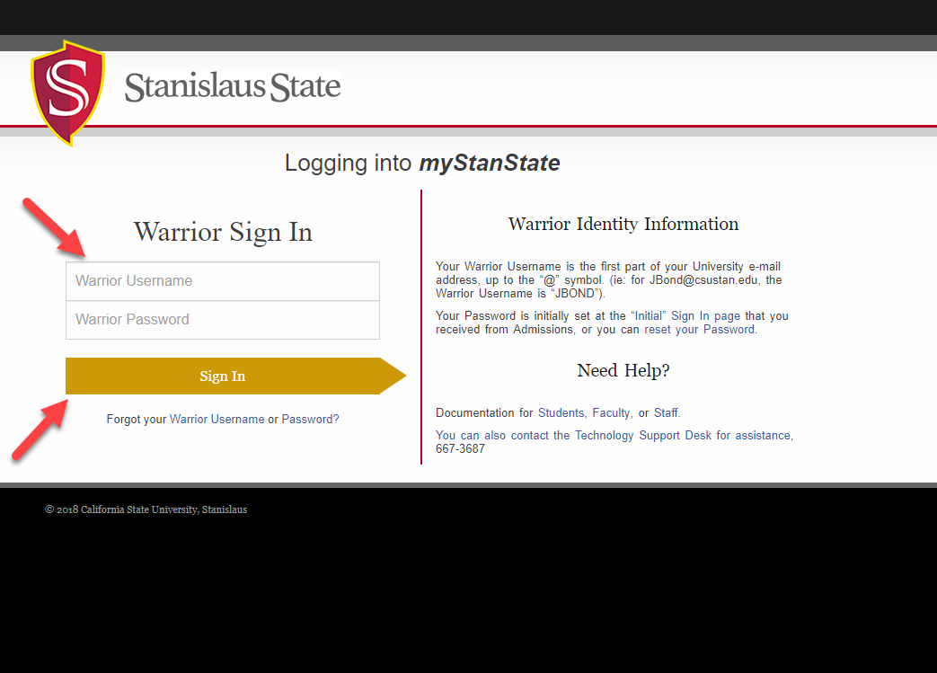
Step 2:
Select “Add Dashboard”

Step 3:
To add the Dashboard create a name, then select to copy the Student Dashboard. (To create a blank dashboard, leave blank) Click Insert.
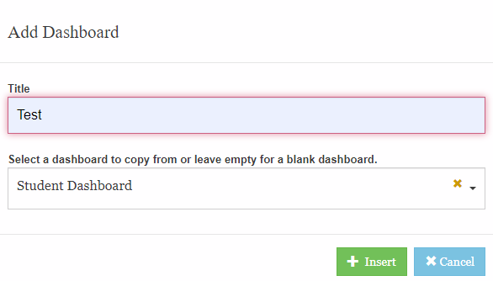
Step 4:
Once the Dashboard is created its name should be on the top left side of the page
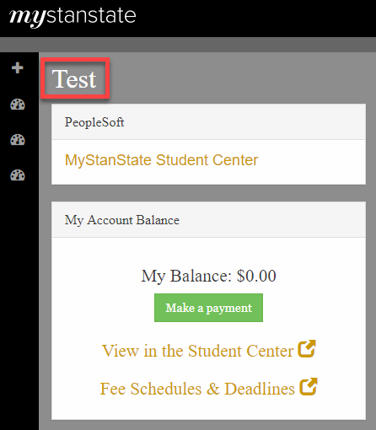

Step 5:
Select the top yellow icon to customize your dashboard
.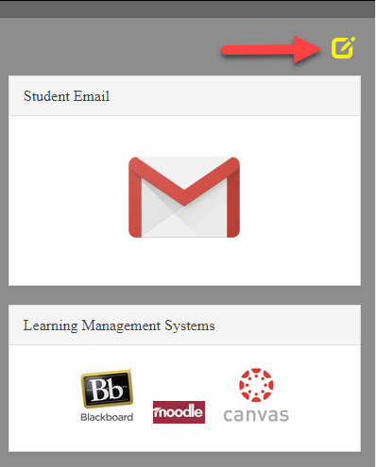
Step 6:

Tools for the entire Dashboard
1st- Adding Widgets
2nd- Edit Dashboard
3rd- Save Changes

4th- Delete the page
5th- undo the change

Step 7:
Tools to move/change Widgets
1st- Reload widget content
2nd- Change widget location (Use this tool to move each one in preferred areas. In order for it to be moved, you must left click on the mouse and hold while moving the widget)
3rd- Collapse Widget
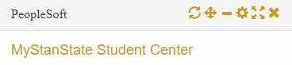
4th- Edit the widget configuration
5th- Make it a full screen widget
6th- Remove the Widget

Step 8:
To add a Widget click on the Icon
Each section offers different widget options
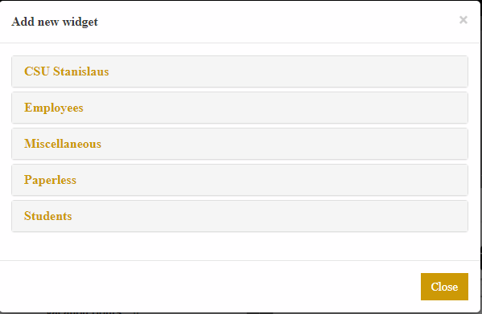
Select one and it will appear on the portal

Step 9:
Move the widget in the preferred location by selecting the move tool. (Left click on the mouse and hold to move the widget)
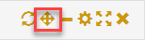

Step 10:
Once the dashboard is complete, select the Save button at the top right

