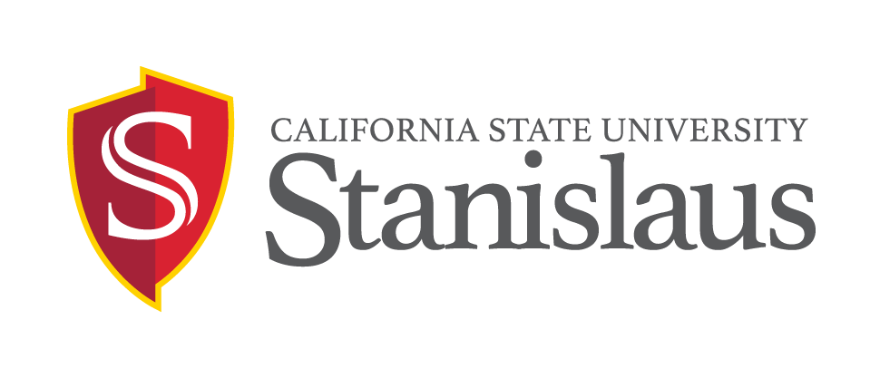
FEDERAL WORK STUDY EMPLOYMENT OPPORTUNITY

POSITION: International Education Study Abroad Ambassador
Temporary hourly-intermittent position available on or after January 12, 2018 and ending on or before May 31, 2018 in International Education.

DUTIES: Under the supervision of the International Admissions and Service Coordinator, this position will perform duties to include, but not limited to:

Essential Duties:
This position handles the daily routine for the Front Desk in the Office of International Education (OIE), and will perform the following duties to include but not limited to:
- Support the International Admissions and Services Coordinator by assisting with the development of Study Abroad presentations
- Conduct Presentations on Study Abroad at campus events.
- Assist with the editing of OIE PowerPoints & other publications
- Assist with the Email & Phone Correspondence regarding Study Abroad
- Assist with Outreach on campus events (Ex: Preview Day, Orientations)
- Willing to complete university training
- Flexible schedule (possible evening and weekend work)
- Public speaking
- (information sessions)
- Social media
- Adobe, Canva, video edit
- Microsoft suite
- Perform other duties or projects as assigned.

REQUIRED QUALIFICATIONS:
- Undergraduate students must be registered/enrolled in a minimum of six (6) Fall/Spring Units.
- Post-baccalaureate students must be registered in a minimum of four (4) Fall/Spring units in a graduate program.
- Must meet all other eligibility requirements per the Student Employment Policies (see http://www.csustan.edu/hr/EmployeeResources/HiringStudentAssistants.html
- Must have international experience (studying abroad or living abroad)
- This is a sensitive position that will require completion of a background check (which may include: checks of employment records, criminal records, civil records, motor vehicle records, and sex offender registries, as position requires) be completed satisfactorily before finalist may start work. Failure to satisfactorily complete the background check may affect the application status of applicants or continued employment of current CSU employees who apply for the position.
PREFERRED QUALIFICATIONS
- Reliable transportation
- Willing to travel locally if needed
- Bilingual

SALARY: 11 per hour.

APPLICATION DEADLINE: March 1, 2018 – open until filled

APPLICATION PROCEDURE: Qualified candidates should submit a completed Student Assistant employment application (download electronic application at https://www.csustan.edu/hr/employment-opportunities/student-assistants) résumé, cover letter, available schedule via email / mail / in-person to:

Office of International Education
[MSR 180
Phone: (209) [667.3117
Email: intlstudent@csustan.edu]

All sensitive positons will require that a background check (which may include: checks of employment records, criminal records, civil records, motor vehicle records, and sex offender registries, as position requires) be completed satisfactorily before any candidate can be offered a position with the CSU. Failure to satisfactorily complete the background check may affect the application status of applicants or continued employment of current CSU employees who apply for the position.

Applicants requiring necessary accommodations to the application process may contact the Human Resources Department at (209) 667-3351. California Relay Service is available at (800) 735-2922 voice and (800) 735-2929 TDD. As a federal contractor, we are committed to attracting a diverse applicant pool. Please consider completing the Voluntary Self-Identification of Disability form (your response will not be shared with the search committee) at: http://www.dol.gov/ofccp/regs/compliance/sec503/Voluntary_Self-Identification_of_Disability_CC-305_SD_Edit1.24.14.pdf.

The university is an Equal Opportunity Employer and does not discriminate against persons on the basis of race, religion, color, ancestry, age, disability, genetic information, gender, gender identity, gender expression, marital status, medical condition, national origin, sex, sexual orientation, covered veteran status, or any other protected status. All qualified individuals are encouraged to apply. CSU STANISLAUS HIRES ONLY INDIVIDUALS LAWFULLY AUTHORIZED TO WORK IN THE UNITED STATES. THE PERSON HOLDING THIS POSITION IS CONSIDERED A ‘MANDATED REPORTER’ UNDER THE CALIFORNIA CHILD ABUSE AND NEGLECT REPORTING ACT AND IS REQUIRED TO COMPLY WITH THE REQUIREMENTS SET FORTH IN CSU EXECUTIVE ORDER 1083 AS A CONDITION OF EMPLOYMENT.

iNFORMATION CONTAINED IN THIS ANNOUNCEMENT MAY BE SUBJECT TO CHANGE WITHOUT NOTICE

