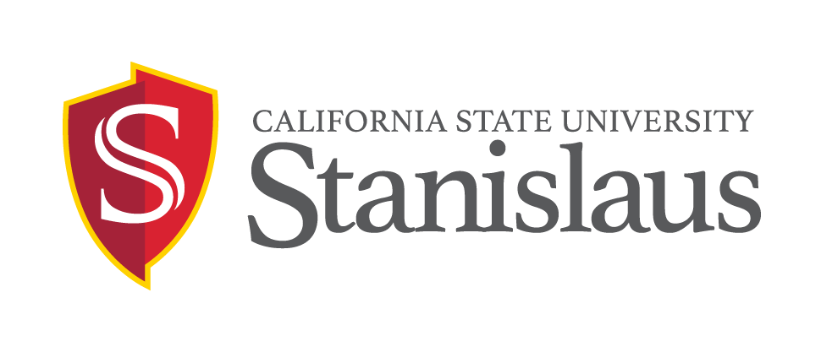

WORK-STUDY STUDENT
EMPLOYMENT OPPORTUNITY

(On Campus Work Study)

POSITION: Biology Laboratory Assistant

JOB NUMBER:
One temporary hourly-intermittent position(s) available on or after 01/22/2018 and ending on or before 05/31/2018 in the Biological Sciences Department. Possibility of rehire based on performance, department needs, and budget.

DUTIES: Under the supervision of the Biology Instructional Support Tech, this position will perform duties to include, but not limited to:
- Tracking and moving biological equipment, glassware, supplies, etc.
- Assist professors with laboratory preparation
- Perform other duties or projects as assigned

QUALIFICATIONS:
- Experience/ Skills Desired: Must be able to follow instructions very carefully. Must have a background in biology and possess very good organization skills. Ability to work independently with numerous interruptions. Dependable and able to follow-through on assignments.
- Varying hours between 8:00am – 5:00pm. Must be available on Mondays and Fridays for at least 2 hours/day.
- Must meet all other eligibility requirements per the Student Employment Policies (see http://www.csustan.edu/hr/EmployeeResources/HiringStudentAssistants.html).
- Current enrollment in California State University, Stanislaus matriculated classes. Undergraduate students must be enrolled in a minimum of six (6) Fall/Spring units. (Extended Education classes do not qualify.)
- The successful candidate must be fingerprinted and successfully pass a background check, which may include checks of employment records, criminal records, civil records, and motor vehicle records.

SALARY: $10.50 per hour

APPLICATION DEADLINE: January 17, 2018

APPLICATION PROCEDURE: Qualified candidates should submit a completed Student employment application (download electronic application https://www.csustan.edu/hr/employment-opportunities/student-assistants ), and 2) cover letter, 3) available work schedule via email , mail , or in-person to:

Carrie Sonke
Biological Sciences
Naraghi Hall, Room 259
One University Circle ∙ Turlock, CA 95382
Phone: (209) 667-3486
Email: csonke@csustan.edu

A background check (which includes checks of employment records, education records, criminal records, civil records; and may include motor vehicle records, professional licenses, and sex offender registries, as position requires) must be completed satisfactorily before any candidate can be offered a position with the CSU. Failure to satisfactorily complete the background check may affect the application status of applicants or continued employment of current CSU employees who apply for the position.

Applicants requiring necessary accommodations to the application process may contact the Human Resources Department at (209) 667-3351. California Relay Service is available at (800) 735-2922 voice and (800) 735-2929 TDD. As a federal contractor, we are committed to attracting a diverse applicant pool. Please consider completing the Voluntary Self-Identification of Disability form (your response will not be shared with the search committee) at: http://www.dol.gov/ofccp/regs/compliance/sec503/Voluntary_Self-Identification_of_Disability_CC-305_SD_Edit1.24.14.pdf.

THE INDIVIDUALS WHO APPEAR TO BE THE BEST QUALIFIED FOR THIS POSITION WILL BE CONTACTED BY TELEPHONE FOR AN INTERVIEW

The annual Campus Security and Fire Report includes statistics for the previous three years concerning reported crimes that occurred on campus; in certain off-campus buildings or property owned or controlled by Stanislaus State; and on public property within, or immediately adjacent to and accessible from the campus. The report also includes institutional policies concerning campus security, such as alcohol and drug use, crime prevention, the reporting of crimes, sexual assault and, campus fire statistics. You can obtain a copy of this report at: https://www.csustan.edu/upd/crime-statistics. To request a printed copy call: (209) 667-3572; Fax: (209) 667-3104; or email: Public_Safety@csustan.edu. Information regarding Campus Security Reports at other locations can be found at: http://ope.ed.gov/security/. CLERY ACT: IN COMPLIANCE WITH THE JEANNE CLERY DISCLOSURE OF CAMPUS SECURITY POLICY AND CRIME STATISTICS ACT, CRIME REPORT STATISTICS ARE AVAILABLE AT: WWW.CSUSTAN.EDU/UPD/PAGES/CAMPUSCRIMESTATISTICS/INDEX.HTML.

The university is an Equal Opportunity Employer and does not discriminate against persons on the basis of race, religion, color, ancestry, age, disability, genetic information, gender, gender identity, gender expression, marital status, medical condition, national origin, sex, sexual orientation, covered veteran status, or any other protected status. All qualified individuals are encouraged to apply. CSU STANISLAUS HIRES ONLY INDIVIDUALS LAWFULLY AUTHORIZED TO WORK IN THE UNITED STATES. THE PERSON HOLDING THIS POSITION IS CONSIDERED A ‘MANDATED REPORTER’ UNDER THE CALIFORNIA CHILD ABUSE AND NEGLECT REPORTING ACT AND IS REQUIRED TO COMPLY WITH THE REQUIREMENTS SET FORTH IN CSU EXECUTIVE ORDER 1083 AS A CONDITION OF EMPLOYMENT.

iNFORMATION CONTAINED IN THIS ANNOUNCEMENT MAY BE SUBJECT TO CHANGE WITHOUT NOTICE
(08/11/15)

