Stanislaus State Graduate Education Assessment Plan
Graduate Council
April 17, 2018

Introduction
The Graduate Council, within the scope of its authority to advocate for and improve Graduate Education, reviews and discusses assessment results at both the program level and the institutional level. The Council makes recommendations regarding graduate education at the institutional level based on institutional-level assessment. The Office of Assessment archives assessment findings and subsequent actions. Summary information is reported via the Graduate Assessment website.

The Graduate Council has updated the 2008/09 Graduate Assessment Plan. The following Graduate Education Assessment Plan adheres to the University’s Principles for the Assessment of Student Learning. It also takes into account the University’s current landscape and infrastructure, and results in processes that are meaningful, feasible, and sustainable.

Structure of Institutional-Level Assessment of Graduate Education
There are three levels of student learning assessment at Stanislaus State including course-level, program-level, and institutional-level (see Figure 1). Program-level assessment, which is based on course-level assessment of student learning, provides the foundation for institutional assessment of graduate education. Institutional-level Graduate Learning Goals (GLGs) provide the structure for institution-wide learning outcomes assessment to occur.

Figure 1. University Assessment Structure
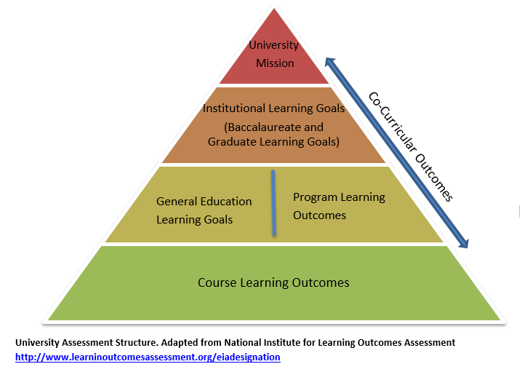

The Stanislaus State GLGs were approved by both Academic Senate and the University President in Spring 2016. The GLGs describe the assessable knowledge, skills, and dispositions students are expected to demonstrate upon completion of their graduate degree. These GLGs are enumerated below.

- Students will demonstrate advanced knowledge, skills, and values appropriate to the discipline.
- Students will demonstrate the ability to be creative, analytical, and critical thinkers within the scope of the discipline.
- Students will demonstrate the ability to contribute to the scholarship of their disciplines.
- Students will demonstrate relevant knowledge of diverse perspectives and broader contexts as appropriate to the discipline.
- Students will demonstrate knowledge of new and various methods and applications as appropriate to the discipline.
- Students will be required to demonstrate advanced communication skills, complemented, as appropriate to the discipline, by the ability to access and analyze information from myriad primary, print, and technological sources.

Graduate programs regularly assess student progress with respect to these goals using both direct and indirect assessment methods including surveys, program reviews, and analyses of student artifacts. Each graduate program determines specific learning outcomes that can be evaluated in particular courses within the program. Findings from regular assessment are summarized in the program’s Annual Reports (or in the case of accredited programs, Annual Accreditation Updates) which are submitted to the Office of Assessment each Fall (see Office of Assessment website for Annual Report procedures). Data in the Annual Reports/Accreditation Updates are then reviewed and analyzed by programs and incorporated into their 7-year Academic Program Review (APR) reports (or in the case of accredited programs, APR Self-Study Substitution reports), which undergo a department, college, dean, Graduate Council, and Provost review process (see Office of Assessment website for APR procedures).

Graduate Program Learning Outcomes (PLOs) have been mapped by each graduate program to the six GLGs to ensure achievement at the time of graduation. Identifying the courses with outcomes satisfying PLOs and the mapped GLGs ensures that institutional learning goals are achieved in graduate programs (see the Graduate Assessment website for program examples of alignment between PLOs and GLGs). An assessment conducted in a course contributes to determining the level of student competency in the program and achievement of the GLGs.

Program-level and Institutional-level Graduate Education Assessment
According to the Graduate Education Action Plan (11/AS/18/GC Resolution), Priority VI, Graduate Council is responsible for ensuring that institutional-level assessment of Graduate Education occurs. At the foundation of institutional-level assessment of graduate education is program-level assessment. The sequence of steps that enable institutional-level assessment of Graduate Education at Stanislaus State are as follows.

Program-level Graduate Education Assessment
- Each graduate program conducts an annual program-level assessment, based on course-level assessment, and reports findings and actions taken based on those findings in an Annual Report/Accreditation Update in Fall. Each Annual Report/Accreditation Update is reviewed by the program’s college dean in Spring. The Annual Reports/Accreditation Updates and deans’ reviews are entered into Campus Labs, the University’s accountability management system.

Each graduate program compiles information from their Annual Reports/Accreditation Updates into their 7-year APRs/Self-Study Substitution form. APR/Substitution forms are reviewed by the appropriate college committee, the college dean, Graduate Council, and the Provost.

The Graduate Council reviews APR/Substitution forms as part of the 7-year cycle, and writes a memo to the program summarizing observations and recommendations for the program based on the review. The graduate program then considers Graduate Council’s recommendations for incorporation into an implementation plan developed with the college dean.

Following college and Graduate Council review of the APR/Substitution forms, the Provost meets with the program faculty and dean to discuss the implementation plan and any support required for implementation of the plan. In the case of accredited programs, feedback from the accrediting agency is also discussed, including the support required to address those recommendations.
Institutional-level Graduate Education Assessment

In Spring of each year, the Office of Assessment distributes the Annual Reports/Accreditation Updates and APR/Self-Study Substitution forms submitted that year to the corresponding College Assessment Faculty Learning Community (FLC) and the Faculty Fellow for Assessment for annual review.
- College Assessment FLCs review Annual Reports/Accreditation Updates and APRs/Substitution forms across all programs within their respective colleges in Spring. Then, facilitated by the Faculty Fellow, the College FLCs examine program-level findings across the colleges and report observations to deans, chairs, directors, and the Provost.
- In early Fall, the Faculty Fellow for Assessment reviews the College FLC reports from the previous year and writes an Annual Institutional Graduate Education Report, in consultation with Graduate Council, summarizing observations about graduate education across colleges, and make recommendations regarding graduate education at the institutional level. The observations from the Annual Institutional Graduate Education Assessment Reports are integrated into a 7-year Graduate Education Academic Program Review, developed by the Faculty Fellow for Assessment in collaboration with, and approved by, Graduate Council.
- In late Fall, Graduate Council shares and discusses its assessment report with Academic Affairs leadership, making recommendations regarding graduate education at the institutional level. Graduate Council also makes recommendations regarding the effectiveness of the assessment plan.

Sources of Information for Assessment in Graduate Education
The following websites provides useful information for assessment in Graduate Education.
- Office of Assessment Website – provides a description of campus assessment processes and links to assessment planning resources.
- Graduate Assessment Website – for the Graduate Education assessment plan, reports, and other resources.
- Institutional Research Website – provides links to institutional data, executive summaries of university‐wide assessment methods, and benchmarking/peer institutions information.

Refer to 10/AS/18/GC Resolution Graduate Education Assessment Plan

Approved by the Academic Senate on April 17, 2018
Approved by President Ellen Junn on May 17, 2018

