For

Consent Item: 16/AS/14/AS
Commendations for Dr. Betsy Eudey. Passed unanimously.

First Reading Items
15/AS/14/FAC Endorsement of RPT Survey Report Recommendations. Will return as a second reading item.

Second reading of 13/AS/14/FBAC Resolution on Campus Staff Compensation. Passed unanimously.

Next Academic Senate Meeting:
January 27, 2015
2:00-4:00pm, JSRFDC Reference Room

Minutes submitted by:
Betsy Eudey, Clerk

___________________

Next Academic Senate Meeting:
October 1, 2013
2:00-4:00pm, JSRFDC Reference Room
Minutes submitted by:
Mark Thompson, Clerk
Academic Senate
December 2, 2014

Present: Bettencourt, Brodie, Burroughs, Carroll, Dorsey, Edwards, Eudey, Filling, Foreman, Gerson, Ghuman, Guichard, Hoover, Huang, Johnson, Pengtao Li, Littlewood, Manrique, Miller-Antonio, Morris, Mulder, Nagel, Olivant, Park, Peterson, Phillips, Powell, Price, Provost Strong, Roe, Silverman, Strong, Strahm, Thompson, and Wood.

Excused: Advanced Studies and Chris Lore.

Proxies: Noelia Gonzalez for Espinoza, Jean Britt for Crayton.

Guests: The following guests were welcomed: John Tillman, Oddmund Myhre, James Tuedio, Kim Tan, Robert Rodriguez, Marge Jaasma, David Lindsay, John Sarraille, and Lauren Byerly.

Isabel Pierce Recording Secretary

- Call to order
2:00pm

- Approval of Agenda
There is a page missing from packet about the nomination of the faculty trustee, item 10. The missing page was distributed at the meeting.

Speaker Carroll noted 9A, was asked to move to 3pm time certain.

- Approval of Academic Senate Minutes of November 4, 2014 (distributed electronically)
O’Brien motioned to approve. Seconded by Petrosky. Approved.

- Introductions
The following guests were welcomed: John Tillman, Oddmund Myhre, James Tuedio, Kim Tan, Robert Rodriguez, Marge Jaasma, David Lindsay, John Sarraille, and Lauren Byerly.
- Announcements
Edwards announced that tomorrow the Art department is putting on a candlelight vigil for the 43 missing students from Ayotzinapa, Mexico in the arts quad near the music department. There will be a slide presentation and performances. This is a great experience for these students going through the process of putting this event together. Considers Dean Tuedio a hero for the students involved and thanks him for making it a great experience.

Dennis Shimek motioned to add a consent item. Shimek distributed a commendation resolution for Betsy Eudey and read it aloud.

16/AS/14/AS
Commendations for Dr. Betsy Eudey

Whereas, Dr. Betsy Eudey has provided outstanding leadership for the Faculty Development
Center…
Whereas, Dr. Betsy Eudey has through her leadership provided an outstanding program that has
responded to the needs of faculty and members of the campus community…
Whereas, Dr. Betsy Eudey is recognized as having successfully identified the CSU
Stanislaus FDC as one of the most outstanding centers in the CSU system…
Whereas, Dr. Betsy Eudey will forever be remembered as part of the heart and soul of the
FDC…
Whereas, Dr. Betsy Eudey will now have the time to continue her contribution to the department,
colleagues and students…
Be it therefore resolved,
- That the CSU Stanislaus Academic Senate recognizes the outstanding leadership of Dr. Betsy Eudey and wishes her the very best in her future endeavors.

- That the Academic Senate on this date December 2, 2014 stands to recognize and applaud Dr. Betsy Eudey.

Eudey thanked Shimek and everyone for the nice commendation and thanked everyone for all the support you’ve given her these past 6 years. Eudey also announced that Marina Gerson will be taking over the position of interim director of the Faculty Development Center. She’s already started and is doing a fantastic job. Eudey asked that everyone provide Gerson with the same support they gave her. There will be a call for a 3 year position sent out soon to the campus community.

Price noted that there is still one more week in the Turlock Together Toy Drive. The blue barrels are available till next Tuesday if you want to give a new unwrapped toy to a needy child.

Strahm announced that Alfredo Mirando wrote Jalos, USA, and will be at the Sacred Heart church for a bilingual presentation from 7-9pm tonight. He’s been here as a visiting scholar and talked with many students. He clearly appreciates that as Hispanic serving institution we are sensitive to the needs of our community.
Brodie announced that the World Aids Day recognition is tomorrow. The official day was yesterday but tomorrow is the activity day at campus between 11-1pm. They’re relocating the event to the Event Center and will also be showing the Dallas Buyers Club movie at 5:30pm.
Eudey received a grant from the Chancellor’s Office providing Faculty Learning communities which starts next week thru January and another one in Spring term. Faculty that participate will get great tips to support development of courses you’re offering. You can receive $750 and for longer ones $1,000. They had 10 faculty participate in this project during the summer and supported 16 folks between the winter and spring. Contact Betsy Eudey for more information.
Lauren Byerly noted that on Sunday is the Carol Fest by the Music Department. There will be two performances in the Snider Music Recital Hall. Tickets are $15. Shows feature CSU Stanislaus chorus directed by Dr. Daniel Afonso, as well as local school choirs.

Friday at 8 pm and Saturday at 2pm at the Gallo Center, the Modesto Symphony Orchestra and Chorus present their annual Holiday Pops concert. The symphony and chorus include faculty and graduates from CSU Stanislaus. Come and see both of these shows.

- Committee Reports/Questions
Dennis Shimek and Dr. Kilolo Brodie presented to the UEPC about the campus Statement on Diversity. UEPC supports the sentiments of the Statement and joins with the Campus Affirmative Action and Diversity Committee in encouraging the Senate to join with the Diversity Committee in a review and discussion of the several action steps that are identified in the statement as it moves forward.

UEPC is waiting on data on how many students attempt to change their majors after 90 units. Drs. Elaine Peterson and Marina Gerson spoke to the UEPC regarding their concerns with the proposed policy. UEPC has set the issue aside for now.

UEPC is voting to approve the GE goals and outcomes. If approved they will be forwarded to SEC

- Information Item
Strategic Planning (Provost Strong)
Strategic Planning (Provost Strong)
Handouts of a PowerPoint presentation and a printout of the strategic plan survey were distributed by David Lindsay.

The purpose of the presentation is to describe the survey prepared by the Committee to Implement and Prioritize the Strategic Plan (CIPSP). The members of the Committee include:
Dr. James Strong, Chair
Ms. Pam Burns Mr. Marvin Hooker
Dr. Elmano Costa Dr. David Lindsay
Dr. Michael Drake Mr. Ronald Rodriguez
Dr. Suzanne Espinoza Ms. Mariam Salameh
Ms. Tawn Gillihan Mr. Dennis Shimek
Dr. Jennifer Helzer Dr. Kim Tan
Ms. Maryann Hight

Framing the Future is the name of the strategic plan which was approved in 2007.

This University Strategic Plan frames our future through three key themes:
  - Student engagement, development, and student achievement,
  - Support for teaching and learning, scholarship and service, and
  - The University and the community.

The Strategic Plan Working Group (SPWG) was created in fall 2007 to seek input on prioritization and implementation of the strategic plan. There were a number of activities over the years, which were not outlined in the talk but in the slides. In May of 2014 the SPWG recommended to the president that the 2007 plan should be retained. They noted that the only problem is that it hasn’t been operationalized, and we should do that. SPWG recommended a committee to prioritize the plan, and the President accepted this recommendation. The President’s charge to the committee is to identify the campus’ top five priorities for the next two years, and why each is important and how progress towards each priority will be measured. To date, CIPSP examined the 26 strategic actions from Framing the Future, as well as 25 division goals for 2014-15 submitted by VPs and the 15 presidential goals submitted to the Chancellor.

Each committee member selected their top priorities and defended them. Results were aggregated to derive a top 10 consensus of the Committee as a whole. The consensus was reviewed for reasonability prior to approving it. Each of the 10 priorities ultimately selected are strategic actions in Framing the Future. The Committee wishes to receive input from all major stakeholder groups prior to paring the list down to the top 5 priorities for the next two years.

Lindsay reviewed the 10 selected by the committee.
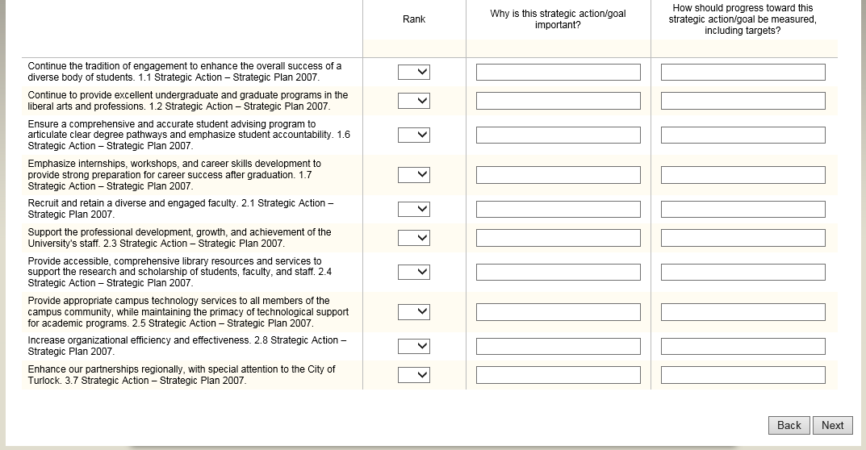

The Committee did not rank order the list of ten. One of the goals of this meeting is to explain the nature of the Qualtrix survey that will be distributed, and to encourage you to complete it and forward the link to other interested parties. Stakeholders will be asked to rank order the 10, to identify the 5 to concentrate on during the next 2 years. You can write in new priorities other than the 10, and offer input on how to improve the integration of planning, implementation and measurement. The survey will be open Dec 1-Dec 19. Links were sent out campus wide to anonymous survey.

Handout shows the text of the survey. The PPT slide is how it will appear on your computer screen. Page one is an instruction screen on top, then below it are html links to source documents. Page two is most important, you’re asked to self-identify because it’s an anonymous survey. The bottom half of this page asks you to rank-order the 10 strategic actions mentioned earlier via drop-down menus. The third column is open-ended, which makes the survey more valuable but puts more work on John Tillman in IR. “Why is this strategic action important” – write as much or as little as you want. Last column, “How should progress toward this strategic action be measured?”

On the next page, you can list new strategic actions, why it’s important, and how progress can be measured. The next page has two open ended questions, “How can strategic planning become more integrated….” Write as little or as much as you care to do.

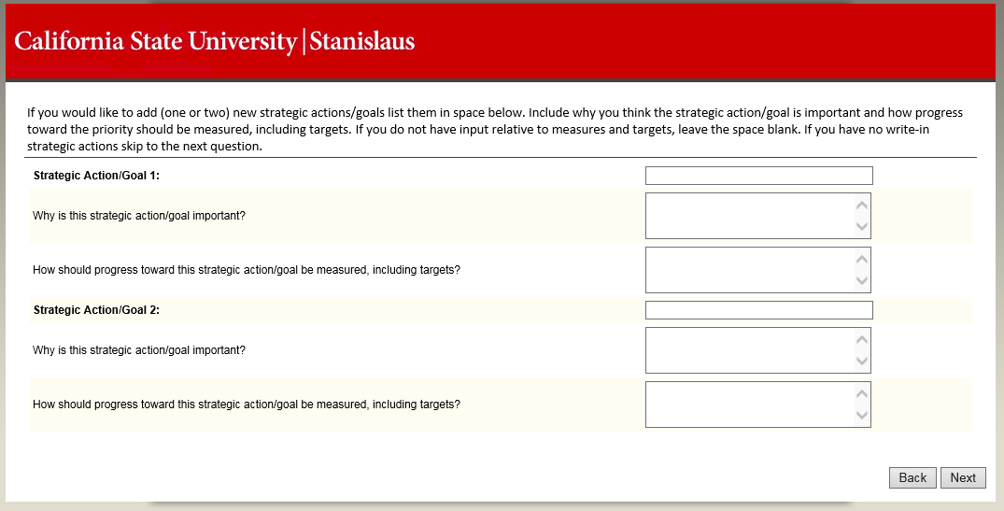

Silverman said a question on page 2, number 9 asks about organizational efficiency – does that include something like defining a new or improved work processes within the organization? Provost Strong agreed.

O’Brien said from the presentation to department chairs, the pull down is qualitative, so you can indicate what you believe fits, how you see it how you think it fits. This is not a fixed format. Provost Strong noted that respondents can write in as much as they want as it is open ended. If you wanted to talk about process improvement or other issues you have three places or more to write in and inform the committee what you think. They will take the information, categorize it and bring to campus at start of spring. The plan is for it to go out today.

Nagel wanted to know when and how results of the survey will be communicated back to the university. Provost Strong said at the start of spring we will have open forums to discuss the results of the survey and possibly some draft recommendations. The committee needs to decide how we will communicate the results. They could post the analysis of the survey on the SP website for folks to look at. Generally, those are the thoughts they have discussed to some degree. He would like to have recommendations to the president sometime in February. Originally charged to have them by October 1, but that deadline was unrealistic.

The University received a letter from the WASC Special Visit team. One recommendation was to revise or rewrite the SP. The WASC commission is likely to accept that recommendation. We have a WASC visit in 2019, and the report is due before that. So we may be looking at some additional revisions of SP in the next 3 years. This process is an intermediate step to additional SP.
- First Reading Items
15/AS/14/FAC Endorsement of RPT Survey Report Recommendations
First reading, Lynn Johnson moved the resolution. She read the resolution aloud. Seconded by Eudey.

15/AS/14/FAC Endorsement of RPT Survey Report Recommendations

Resolved: That the Academic Senate, California State University, Stanislaus express appreciation for the excellent work of the RPT Survey Group (Steve Filling, John Garcia, Mark Grobner, Ian Littlewood, Dennis Shimek, Jim Strong, and Jim Youngblom); and be it further
Resolved: That the Academic Senate recognize that the observations and recommendations contained therein are supported by a rigorous, thoughtfully designed research methodology; and be it further
Resolved: That the Academic Senate affirm that California State University, Stanislaus, has a highly functional RPT Policy and Procedures and recognizes that the conflicts that developed around Retention, Promotion, and Tenure were largely symptoms of a broader organizational issue surrounding trust between faculty and administration; and be it further
Resolved: That the Academic Senate endorse and recommend that the university implement the three recommendations contained in the RPT Survey Report and continue efforts to share and discuss the report widely in Academic Affairs, appropriate governance committees, and the Colleges, Library, and Psychological Counseling.

Rationale: At the recommendation of the Academic Senate, the RPT Survey Group was established to better understand views surrounding the RPT policy and procedures and to determine if steps can be taken to reduce conflict and/or build trust in the RPT process. Over a two-year period, the Survey Group gathered and analyzed data about faculty and administrators’ views on specific issues related to the RPT process. As a result of their research, the Survey Group recommended three sets of actions that the campus community should take to reduce conflict and rebuild trust in the RPT process. An initial step in implementing the recommendations is acknowledging that CSU Stanislaus has a highly functional RPT Policy and Procedures as stated in the first recommendation of the RPT Report.
Approved at FAC on 11/29/14
Johnson distributed a handout with the three recommendations included as follows:
Recommendation 1: Acknowledge that the University has a highly functional RPT Policy and Procedures. Understand that the conflicts that have developed around Retention, Promotion, and Tenure are (largely) symptoms of a broader organizational issue surrounding trust between faculty and administration. Continue efforts, similar to those outlined in 9/AS/11, to build trust around issues of shared governance, the primacy of faculty in issues related to the curriculum, and the leadership roles of administration in pursuing the mission of the institution.
Recommendation 2: Ensure that all parties involved in the RPT process are utilizing the established review criteria. This can be encouraged by continuing and expanding outreach and training efforts targeting the various groups involved in the process. These outreach efforts should ensure that all parties as informed of the candidate’s rights, the review criteria, and the established timelines. All parties should also be informed that all review levels are receiving the same training and information.
Recommendation 3: Continue efforts to ensure that all tenured and tenure-track faculty, as discipline experts, have a good understanding of the complexity of developing elaborations and the role elaborations play in the RPT process. Share elaborations within and across Colleges and call upon all departments to regularly discuss and examine their elaborations with attention to both the unique aspects of their discipline and to the means by which other departments communicate their priorities and expectations. Utilize the Faculty Development Center to engage faculty in critical dialogue regarding strategies for thinking about and preparing elaborations.
Filling made a public acknowledgement that the mechanism was a product of John Garcia. On behalf of other members of the committee, tutor in research methodology.

Eudey affirmed a call to action and the importance of supporting the endorsement of the survey. She knows that there will be additional actions in the future. Those involved in the process were very thoughtful and she appreciates the way the report was written. Endorsing it is a nice closure and the next step in the process.

Nagel asked if it is a sense of the senate. Johnson says it is not. Nagel notes if it is not a sense of the senate, but a call for the university to implement it, then it should say explicitly that the university should implement instead of saying what the senate should do rather than the university. Johnson said it is not a Sense of the Senate resolution in that we are hoping the president will sign this. On other hand, she doesn’t know that the senate can do more than recommend action by others. FAC will consider the recommendation to change the language.

Johnson pointed out that if this resolution passes and is approved, it is an implementation of Recommendation 1 which calls for acknowledgement by the university that we have a highly functioning policy.

Guzman noted in Recommendation 3, second sentence, Share elaborations within and across Colleges and call upon all departments to regularly discuss and examine their elaborations with attention to both the unique aspects of their discipline and to the means by which other departments communicate their priorities and expectations. For “regularly” should we insert a time recommendation, 2-3 years perhaps. Regularly could mean every decade or more, what does it stand for? Johnson pointed out that the recommendations don’t come from FAC. These recommendations are from the RPT committee so they can’t do anything with the recommendations. But we can consider at a later point to implement this.

Speaker Carroll said that when FAC first looked at it, the idea behind the resolution is to take the RPT report that so many worked so hard on to turn it into a working document. Make this an active working document via the resolution.

Provost Strong supports the resolution and thanks the RPT survey group for their good work.

Speaker Carroll also speaks in favor. It’s important to endorse this. The recommendations hit on several themes important to faculty, some highlighted during the opening address at the fall general faculty meeting in late August. Primacy of the faculty in issues related to the curriculum and on the whole emphasized disciplinary expertise. He can’t emphasize enough how important that is.

Strahm appreciates in the recommendation about asking us to share our elaborations so that we understand to some degree how each other goes about it, sharing of ideas, reflecting in our own depts. If what we’re doing is good, make it better. Many in here may be on URPTC or other locations when looking at the files of colleagues from a variety of disciplines, and it’s helpful to develop that understanding. Sharing is always good.

Johnson pointed out the RPT Survey Report is still on the FAC agenda. This is just an acknowledgement of the hard work of this committee. FAC will go through the RPT report in detail to determine actions to consider addressing recommendations. Filling thinks #1 is most important. Found clearly in opinion of virtually all, have a highly functional RPT policy and procedures do work when followed. Rejoinder to opinions of one on WASC team. This is a dream list of what he hopes departments would do, encourages support for it.

Thompson said if this is something requiring the President’s signature, you might consider incorporating the recommendations into a resolved clauses so they travel together forever. FAC meets again on Wednesday and will discuss the resolution.

- Second Reading Item
13/AS/14/FBAC Resolution on Campus Staff Compensation
Second reading of the sense of the senate resolution:

Foreman speaks in favor of the resolution and says this is a way for us to honor our co-workers who are staff and very much underpaid and for whom pay has been a disincentive for a long time. He is in favor for that reason.

Neil Jacklin noted a typo. It should have read 36.9% instead of 6.9% in the fourth resolved.
O’Brien has heard the staff presentation in multiple venues, this is one compelling reason is to keep quality staff here to not have turnover. We’re doing the right thing for them.

Regalado supports this whole-heartedly. Reaffirms that as faculty pursues similar goals, he hopes to have equal support from staff as well.

Eudey thinks that our hope is to unanimously approve this. The number of staff showing up for this today shows how important this is to them. We need to be unified and respect the contributions of the staff. This helps affirm what we should have been doing and is important to recognize how important every single member of campus is.

Provost Strong supports the resolution and values the contributions of staff on campus. Shimek fully supports the resolution and thinks the statement of faculty helps us realize the things we need to do. He is very much supportive of this resolution. He is already making efforts in areas outlined in the resolution.

Renee Giannini wants to thank FBAC for the resolution. She looks at the different staff from all over the campus. Some don’t have access to email that much, and not all have read the resolution. She asked if it could be read aloud again. Foreman read the resolution and rationale.

13/AS/14/FBAC Resolution on Campus Staff Compensation
(Sense of the Senate)

Be it Resolved: That the Academic Senate recognizes and honors the role staff plays in all the functions of the university, particularly in regard to our primary mission, educating our students, and be it further
Resolved: That the Academic Senate of CSU, Stanislaus recognizes that the small compensation of campus staff, particularly staff who have been employed at the university for many years, has often been demotivating and even inadequate, and be it further
Resolved: That the Academic Senate recognizes the negative effects of staff attrition on the university and its mission, since we lose the expertise of long-serving staff members and must train new staff more frequently, costing considerable time and effort, and be it further
Resolved: That the Academic Senate commends recent improvements in the number and rate of individual in-range progressions granted to staff members who have applied for them, moving from a low of 36.9% in FY2012 to 84% over the last year. The Senate notes that more in-range progressions have been approved this year than in all years since FY2006 combined, and be it further
Resolved: That the Academic Senate urges administration to communicate effectively with staff about compensation issues and opportunities, and to reward the efforts of individual staff members while following faithfully the collective bargaining agreements negotiated by staff unions.
Rationale: According to Staff representatives, Staff at CSU, Stanislaus are among the lowest paid on all CSU campuses under the just expired contract; their pay specifically compares unfavorably against the compensation of staff at our neighbor campuses with similar costs of living. As with faculty compensation, staff pay has not kept up with inflation, and as many as one-third of campus staff must supplement their incomes via second jobs or public assistance. Some staff members have spent many years at the bottom of their salary scale. Staff unions conducted a survey of staff members; it revealed that while 80% believed they qualified for an IRP, 55% believed they would be denied, while others did not know they could apply for an IRP.
Anecdotally, it is reported that staff members leave CSU Stanislaus for other campuses. Department chairs have recognized the problem that staff attrition creates, reporting to the Faculty Affairs Committee chair a year ago that “staff turnover has also created considerable additional work, as chairs…have to train new staff; expertise is often lost…which must be recreated.” Staff members made a presentation to the University Budget Advisory Committee and to the Senate in spring 2014 arguing for the long-term benefits of institutional memory gained by retaining staff.
Filling proposed the addition of a resolved that this be shared with the HR division in Long Beach. That this resolution be forwarded to Vice Chancellor of HR, Lori Lamb for her perusal. Seconded by Eudey. No objections. Petrosky asked for a voice vote.

Dawn McCulley thanked all the faculty bodies who put forth the effort to get this issue heard. She encourages HR and administration to provide, thoughtful, timely and tangible feedback in response to the in-range progression requests that are received.

Voice Vote. Loud Aye. No opposition. Unanimous. 24 staff guests.

Ovation for staff who came to the meeting.

- Discussion Items
Nominees for 2015-17 Faculty Trustee
There is a copy of the call for nominees in packet. First of all, campuses’ nominees have to be sent to Long Beach by January 16, so we may have to take care of this over the break. Highlighted from the materials that the nominee should not be a current member of the SWAS, so that rules out Filling. Process as it has worked here includes getting signatures of 10% of the full-time teaching faculty or 50 faculty whichever is less. Speaker Carroll will send out a request for signatures on behalf of the senate. Signatures can be electronic.

Filling said how important this position is. There are 15 trustees, a single person who teaches. Trustees have good intentions, but are not always aware about what we do. We really need the input from a Trustee who has actually taught our students. Desperately need a trustee that helps them understand how to make things work better on our campuses.

Regalado said in the criteria for nominating the faculty that it indicates teaching, achievement, university service. He’s concerned there’s a research component, research excellence is important given the vital role in RPT and in the trustee. We will be experiencing down times for budget and that’s a time when there may be decisions made about research subsidies. Hates to see only a celebrated teacher lacking the research component. Filling said “professional achievement” is that it includes research. Not specific, but its language that is there. It is beyond our power to change it.

Johnson said that it could not be someone who is currently on Statewide, but if we nominated someone who is currently on that person could resign from the position.

Eudey noted that this senate and many others voted on several resolutions indicating to have faculty trustees endorsing continuing. We have supported this role and it would be fantastic to nominate someone from our campus as we would benefit to have someone with state-wide experience Like Paul O’Brien, Mark Thompson and Steven Filling. They all have broad campus experience. She’s hoping to have a sabbatical in fall so won’t accept a nomination.
Regalado encouraged colleagues to consider someone with a strong publication record. Filling is right that professional achievement could be part of that, or not part of that, but he would hope that qualification would be important if not explicitly stated. Hoping for some diversity to the group.

O’Brien is not interested. Thompson is not interested. Eudey is not interested. Strahm inquired if Sari Miller-Antonio was interested. She declined as did Lynn Johnson. Regalado noted we didn’t need to get a name today. Speaker Carroll noted that we can get names via email to Carroll. Nominees need a tailored cover letter, statement, and signatures by January 16th.

Regalado asked about logistics about meetings, travel schedule, etc. Speaker Carroll said there is a description of the duties. Isabel Pierce will send it to all faculty. Signatories must be full time teaching faculty. Filling said it is a full-time 12 month position. Current trustee visited 14 campuses this year. No teaching allowed, as it’s a full time job with a fair bit of time spent in Long Beach. It’s a two year commitment. The packet goes to SWAS, then they will send the candidates forward to the Governor. The Governor’s office does an investigation and interview process. It would be important and nice to have a trustee from our campus.

- Open Forum
Petrosky said something came up a while ago, but wanted to announce that the affordable college’s online website has named our online MBA program the 28th best such program. Although most agree that it’s somewhere between Nobel and crackerjack prize, but we beat out Mississippi State, Baylor, Penn State, UFLA, Colorado Boulder, I Bloom and Nebraska Lincoln.

Eudey noted that there will be a late party for the spring tenures because the FDC has not yet received official notification of those that received tenure and promotion. This is why we haven’t had the celebration but it will happen in the spring. Sorry about that but we will still have a party.
- Adjournment
3:15pm

