- Launch the SPOT Evaluation Request Form, and then click the “New” button to create a new request.
SPOT Course Evaluation Request
Click “Create Request For Current Term” to create a new SPOT Evaluation Request.
NOTE: Make sure AY is current.

- Click the “Add Course” button to see available list of courses.
SPOT Course Evaluations
Click “Add Course” button to select available courses.
Click “Change” to select a different supervisor.
- Click a row to select a specific course.
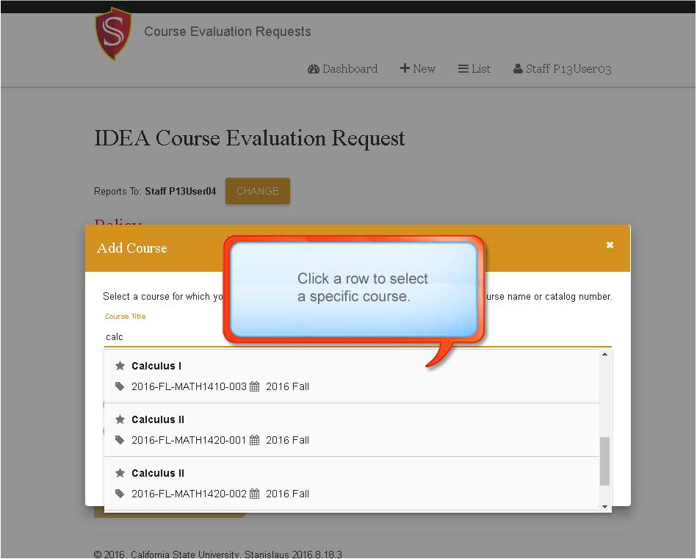
SPOT Course Evaluation Request
- Choose how you would like the course evaluated (online, in person) and select if the course is required or voluntary.
SPOT Course Evaluation Request
Select how you want the course evaluated.
Select Required or Voluntary
- Add any additional courses then click “save and Continue”
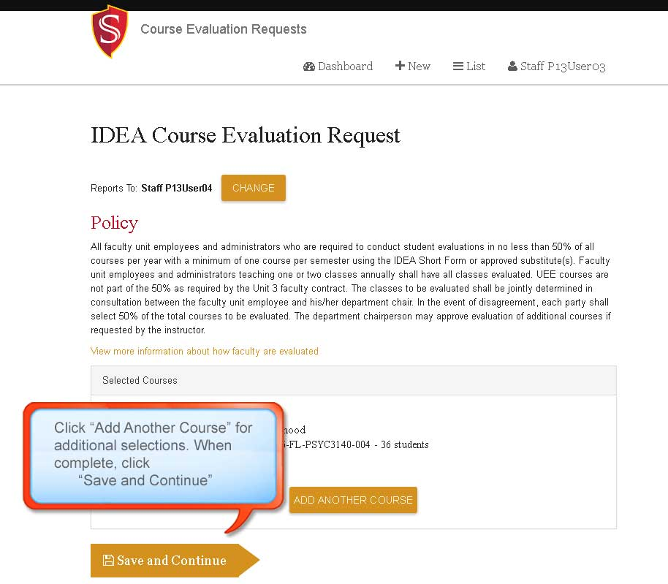
SPOT Course Evaluation Request
NOTE: There is one more page. This is NOT the submit button
- Review your selections and click “Submit” to send your requests to the Department Chair or Dean for approval.
