- You will receive an email notification letting you know an SPOT Evaluation Request has been completed and needs your approval.

- Click the link in the email to “Approve or Comment and Reject”.

- You will be asked to log into the system.

- The following form will appear and provide the name of the instructor and the selected courses.

- Review the selected courses.

- Click “Approve” to complete this request, or you can add a note and click “Reject” and ask the instructor to revise their selections.

- To select your own courses for evaluation, click the “New” tab in the top right.

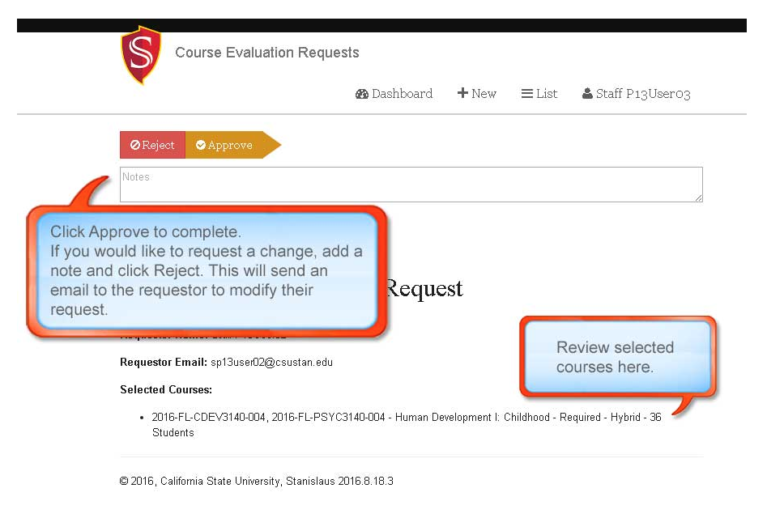
By clicking the “List” tab you can see a list of all the faculty who have made selections in your department.

