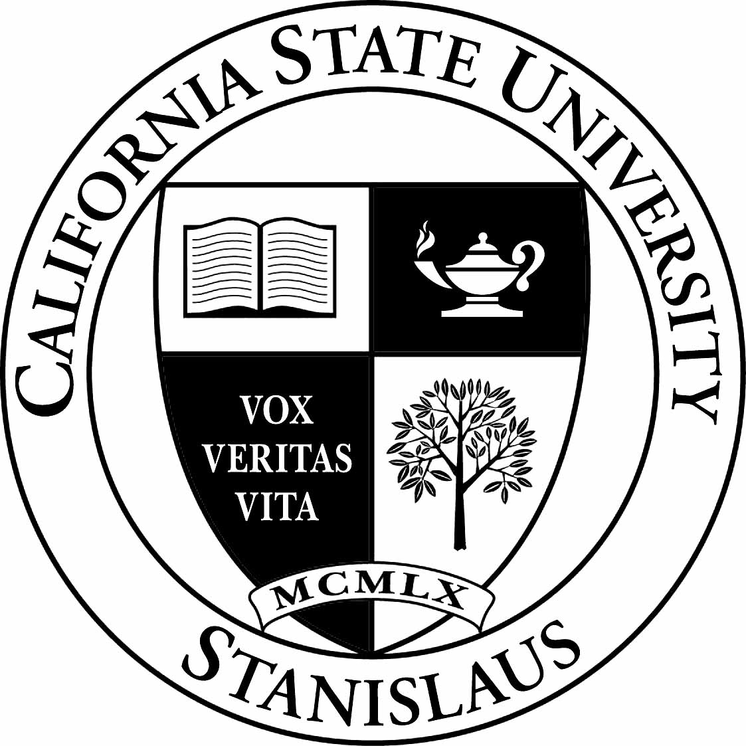 | CALIFORNIA STATE UNIVERSITY, STANISLAUS  One University Circle • Turlock, CA 95382  Office of the Academic Senate 209 667-3400
TO: Members of the Academic Senate DATE: October 21, 2010

FROM: Kelvin Jasek-Rysdahl, Speaker of the Faculty

SUBJECT: Academic Senate Meeting
TUESDAY, October 26, 2010
Meeting time: 2:00-4:00 pm
Place: JSRFDC Reference Room

Academic Senate Agenda
1. Call to order

2. Approval of Agenda

3. Approval of Academic Senate Minutes of October 12, 2010

4. Announcements

5. Committee Reports/Questions

6. Action Items
- Second Reading of 10/AS/10/SEC Resolution on Respect for Diversity of all members of Campus Community

7. First Reading Items
- 3:00 PM Time Certain for Jim Riggs to discuss 11/AS/10/GC Dissertation Policy Resolution

8. Discussion Items
- FBAC review of programs proposed for UEE

9. Open Forum

10. Adjournment

KJR:isp

cc: All Faculty

Attachments: October 12, 2010 Academic Senate Minutes
10/AS/10/SEC Resolution on Respect for Diversity of all members of Campus Community
11/AS/10/GC Dissertation Policy

