CALIFORNIA STATE UNIVERSITY, STANISLAUS

OFFICE OF THE ACADEMIC SENATE

l/AS/14/SEC -- POLICY REGARDING FLEXIBILITY IN TEACHING ASSIGNMENTS FOR FULL-TIME FACULTY

Be it Resolved: That the Academic Senate, California State University, Stanislaus recommend the attached Policy Regarding Flexibility in Teaching Assignments for Full-Time Faculty; and be it further

Resolved: That, upon approval by the President, the Policy Regarding Flexibility in Teaching Assignments for Full-Time Faculty be effective immediately and be incorporated as soon as possible into the Faculty Policies section of the Faculty Handbook (any and all printed and/or online versions), and that the policy be positioned there together in close proximity with all other faculty policies or Collective Bargaining Agreement excerpts contained in the Faculty Policies section of the Faculty Handbook that relate to full-time faculty teaching assignments.

Attached policy:
Policy Regarding Flexibility in Teaching Assignments for Full-Time Faculty

Full-time Faculty instructional assignments do not require a minimum number of weighted teaching units (WTUs). Teaching assignments for full-time tenure-track faculty and full-time lecturer faculty shall be characterized by a principle of flexibility. Decisions regarding faculty instructional assignments reside with college deans (via delegation from the provost) after consultation with department chairs and/or the individual faculty member. Ordinarily, colleges, departments and programs will be permitted to meet their full-time-equivalent-student (FTES) targets and curricular objectives through flexible use of teaching loads, course schedules, number of sections, and section sizes.

Approved by the Academic Senate on 2/11/14
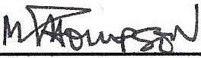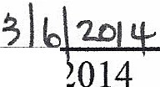
---Mark Thompson, Clerk

316i

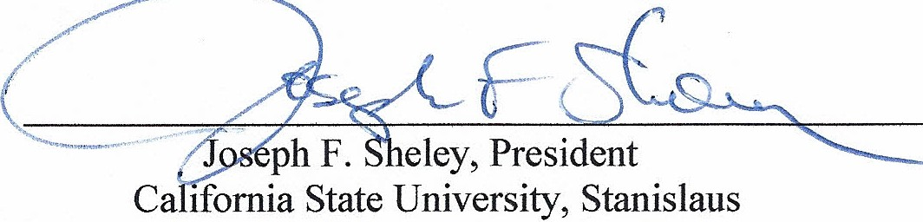
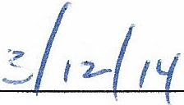Dat

ACTION OF THE PRESIDENT:
Approval X.

History:
30/AS/13/SEC Denied by President 7/1/13

O NE UNIVERSITY C IRCLE • TURLOCK, CALIFORNIA 95382 • WWW.CSUSTAN.EDU • PHONE (209) 667-3400• FAX (209) 667-3632
THECALIFORNIASTATEUNNERSITY •Bakersfield• Channellslands •Chico• DominguezHills • EastBay •Fresno• Fullerton• Humboldt• Long Beach• LosAngeles
Ma riti m P AcadPmv • MoniPrPV Rav • NorthrfriPP • Pomon.1 • SacramPnto • San 'RPmarrlino • San DiPuo • San Franrisco • San To.c.P • San T.uis Ohic;no • San Marroc; • Sonoma • Stani .c.lan c;

