Veteran Spotlight

Veteran Spotlight
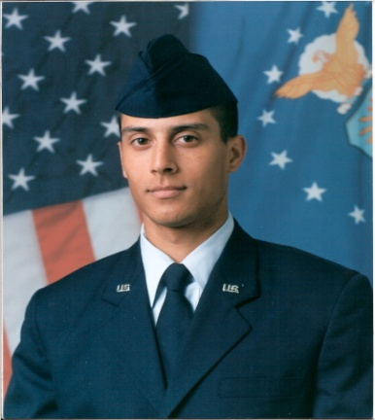

Travis Sanchez
Class Level:
Senior
Degree Objective:
Bachelor of Science
Major/Department:
Kinesiology with a Psychology Minor
Hometown/Branch of Service:
Eildon, Australia/U.S. Air Force

Biography
Why did you choose CSU Stanislaus?
I was a student prior to enlistment.
Where have you been stationed/Specialty while in the military?
Malmstrom AFB DC, Bollins AFB, DC and Keesler AFB, MS/Financial Controller
What advice would you give Prospective Students?
Communicate with the faculty and always double check advice through professor and administrators.
What is your career objective?
My career object is to become a Commission Officer in the U.S. Air Force.
Do you plan to attend Graduate School?
Chiropractic school if I am unable to obtain a commission.

