Stanislaus State
University Police Department

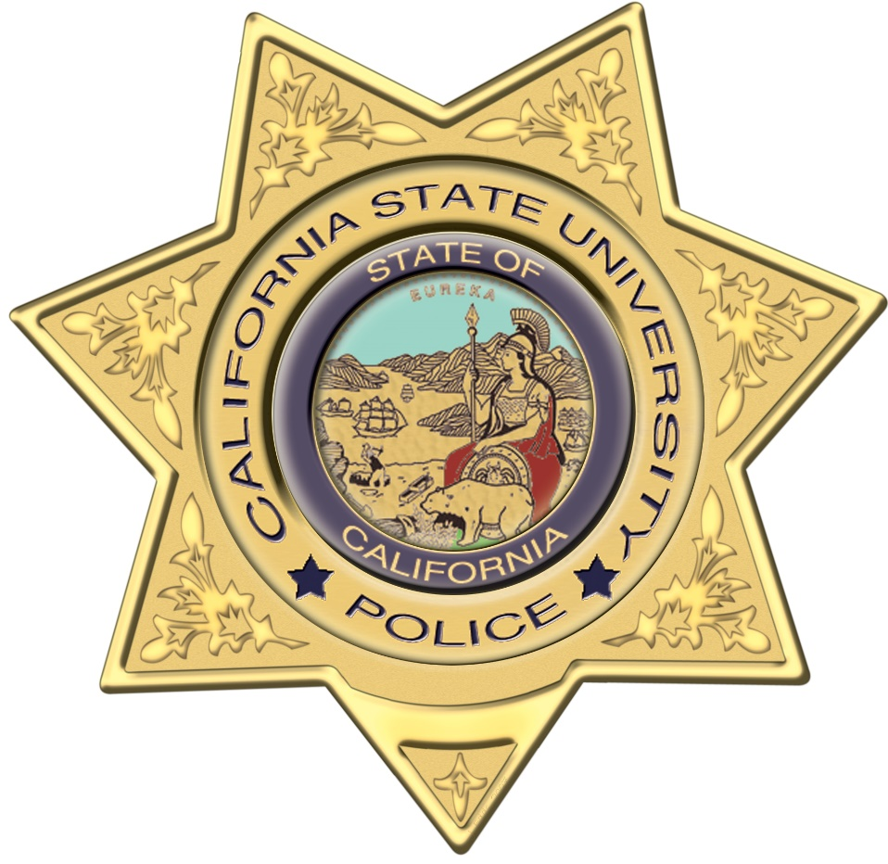

Student Police Academy
Class #9
September23, 2020 – November 18, 2020

Instructors / UPD Staff

Chief of Police Clint Strode
Lieutenant Cheri Silveira
Sergeant Steve Olson
Sergeant Givo Ysael
Officer Phil Kozicki
Officer Jennifer O’Brien
Officer Quenna Martinez
Officer Jose Ramirez
Officer Colton Risley
Officer Adam Kent
Officer Mayra Lewis
Officer Sunny Purewal
Dispatcher Lorrie Lucas
Dispatcher Patricia Sanchez
Community Service Officer Baltazar Reyes
Community Service Officer Jose Villagomez
Introduction:

The Stanislaus State Student Police Academy is a seven-week program designed to educate members of the campus community about law enforcement on our campus through various methods of instruction including lectures, activities, discussions and scenario training. In addition to learning about law enforcement and community service, students will have the opportunity to explore new career opportunities and develop relationships that will last well beyond the course.

Objectives:

- To promote the Stanislaus State Police Department as an agency that is dedicated to the students, staff and faculty of our campus, and to the community we live in.
- To educate the public about the necessity of a positive community/police relationship.
- To provide members of the public the opportunity to learn from officers who have knowledge in a variety of areas of law enforcement.
- To provide transparency and build trusting relationships with the members of our community.
- To have fun!

The Student Police Academy is not designed to be a substitute for accredited law enforcement training, provide legal advice or teach people how to circumvent the law.

Participant Requirements:

- Participation in all activities and discussion.
- Participants are allowed two absences each.
- Participants must adhere to campus rules and parking fees.

Week 1: September 23, 2020 @ Zoom, 6pm to 7pm

- Introduction to the University Police: Participants will become familiar with the University Police Department, including authority & jurisdiction, POST training requirements, patrol areas, and receive a tour of the facility and equipment employed by its officers. Instructor: Chief Clint Strode
- Basic Law Enforcement Principals: Participants will received an overview of the criminal justice system, and learn how it is applied on a day to day basis by officers. Instructor: Chief Clint Strode

Week 2: September 30, 2020 @ Zoom, 6pm to 7pm

- Introduction to Dispatch: Participants will learn about 911 call taking and how officers are dispatched in the field. (Instructor: Dispatcher Lorrie Lucas)
- Introduction to Taser: Students will receive an overview on the operation of Taser electronic control device and its proper use and deployment. (Instructor: Sergeant Steve Olson)

Week 3: October 7, 2020 @ Zoom, 6pm to 7pm

- Traffic Enforcement: Students will learn about traffic stops and some of the considerations & dangers associated with them. Students will review videos of traffic stops from an officer’s perspective and review tactics and outcomes. (Instructor: Officer’s Mayra Lewis and Sunny Purewal )

Week 4: October 14, 2020 @ Zoom, 6pm to 7pm

- DUI Investigation: Students will learn about the effects of driving while under the influence of alcohol and narcotics. Students will learn about preliminary alcohol screening (PAS) devices, & participate in mock standardized field sobriety tests (SFST). (Instructor: FTO Jose Ramirez and FTO Quenna Martinez )

Week 5: October 21, 2020 @ Zoom, 6pm to 7pm

- Principled Policing: Students will learn to unpack the concept of procedural justice and how it strengthens the relationship of trust between police and communities, and to present the concept of implicit bias. (Instructor: Lieutenant Cheri Silveira)

Week 6: October 28, 2020 @ Zoom, 6pm to 7pm

- Use of Force: Students will learn about the Departments policy on use of force, and some of the associated legal considerations. Participants will participate in reviews of current use of force issues that have received media national coverage. (Instructor: FTO Adam Kent )

Week 7: November 4, 2020 @ Zoom, 6pm to 7pm

- Theory and Operation of Traffic Radar: Students will learn the basic principles behind the theory and operation of traffic radar. Discussion will include how radar equipment works, proper care and maintenance of the equipment, and proper field applications for enforcement. (Instructor: Officer Phil Kozicki )

- Active Shooter: Students will receive and overview of active shooter incidents to better understand what motivates individual shooters, and how they can maximize their safety during an active shooter event. Participants will also learn what to expect from law enforcement responding to an active shooter incident. (Instructor: Sgt. Givo Ysael )

Week 8: November 18, 2020 @ Zoom, 6pm to 7pm

- Virtual Ride-Along: Students will view an online virtual ride along with a University Police Officer.

