Honors Department honored to visit Ai Weiwei exhibit at Alcatraz

By Patricia Garcia on April 30th, 2015
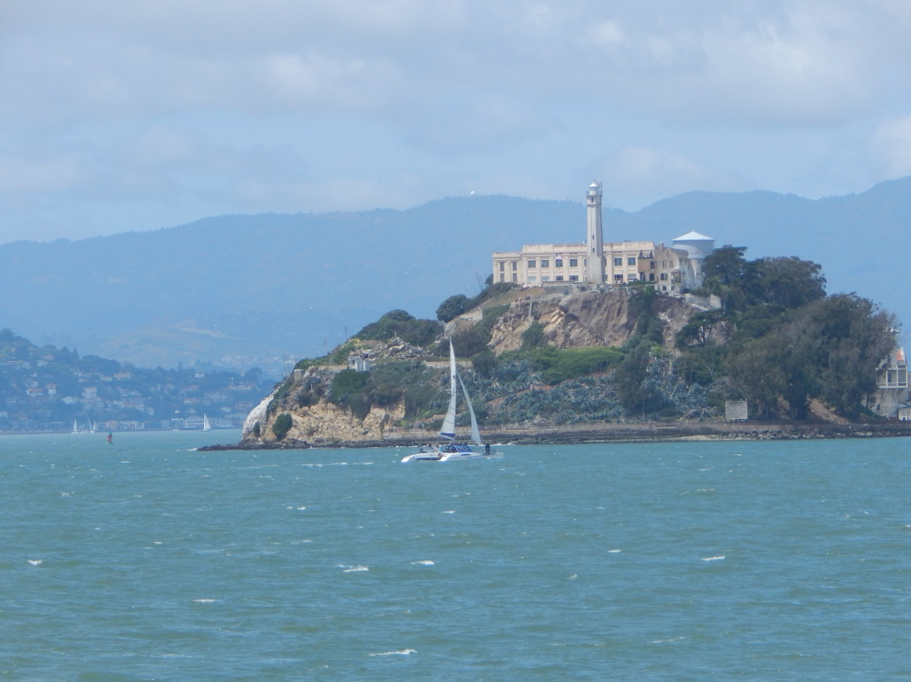
The view of Alcatraz Island from the ferry.
The Honors department and the Weekend Warrior Program held similar trips to San Francisco this weekend so students could enjoy an educational trip to Alcatraz Island and the Ai Weiwei Art Exhibit installed in the prison.
Alcatraz, once home to notorious prisoners and infamous escape attempts, is now known for its educational audio tour that accompanies the prison-turned-museum. But contemporary Chinese artist Ai Weiwei altered some of the prisons exhibits and opened a few new ones for tourists to see. The exhibit encompassed seven total installations of art.
The tour kicks off with Stay Tuned, which diverts from the regular audio tour along a row of A Block cells. Stay Tuned featured open cells with audio clips of poetry or music created by people like Ai Weiwei, people imprisoned for their art forms. Poems came from the devastation of massacres like the Tiananmen Square protests of 1989, speeches came from the injustice of Martin Luther King Jr’s time and songs came from the opposition of Vladimir Putin. The cells in which the audio could be listened to were a symbol of the same cells in which the artists were held or are currently being held in.
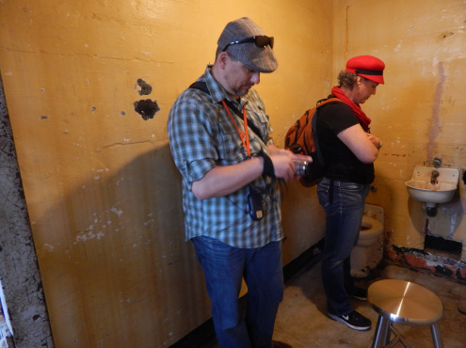
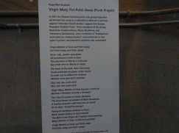
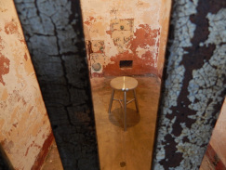
Followed by Stay Tuned, Yours Truly was a personal installation that allowed those visiting the art exhibit to choose a postcard, match it to a prisoner of conscience and write them a note. The postcards were collected in two large bins and would be sent to the prisoners for encouragement or support. Several generations of visitors could be seen across the tables writing notes to complete strangers with words of encouragement, some even taking the time to translate their notes into the prisoner’s native language.
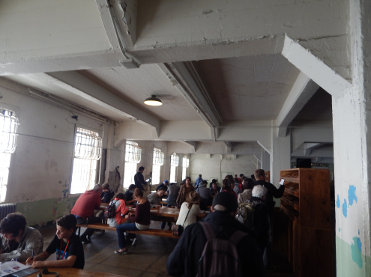
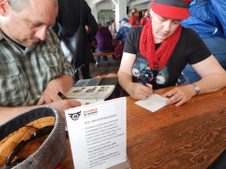
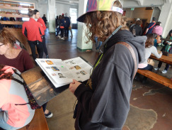
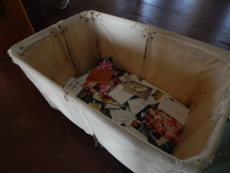
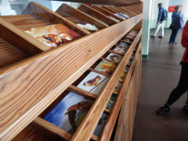
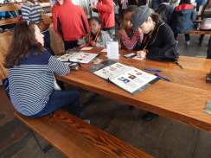
The following two installations were a part of the Medical Ward: Blossoms and Illumination. Unfortunately, Illumination was facing technical difficulties playing the audio files of Native American chants, so Blossom was the focus of this portion of the tour.
The Medical Ward, which is not normally open to the public, included more cells and rooms that had sinks, tubs and toilets– but these porcelain fixtures were filled with white porcelain flowers. The meaning behind this installation was much more subtle and can be interpreted in two different ways: as flowers sent to comfort those in the Medical Ward or as a symbol of China’s Hundred Flowers Campaign. In 1956, the Chinese government supposedly entered a time of tolerance for freedom of expression. A crackdown on those who practiced said tolerance followed, leading to the murder of Ai Weiwei’s father.
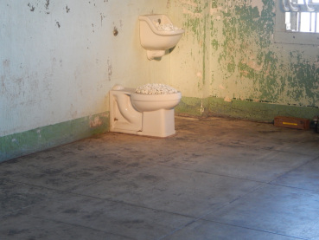
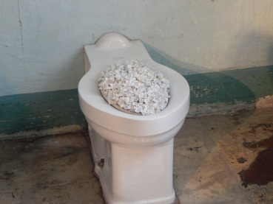
“The installation has so many meanings that everyone can take away a unique meaning that speaks to them,” Josey Hazelton (senior, Communication Studies) said. “I liked how the exhibit incorporated standard, human, everyday tools such as sinks, toilets and bathtubs which causes the viewers to think about what they are seeing as well as bring a universalistic meaning to the entire collection.”
The final leg of the tour took visitors down the steep hills of Alcatraz to the workhouses that once housed inmates doing monotonous and repetitive labor. The first room featured the installation With Wind which included a large Chinese dragon kite and a few smaller kites in the shape of birds and flowers. While colorful and large, the dragon kite symbolizes personal freedom and includes quotes from other prisoners like Ai Weiwei, including Edward Snowden and Nelson Mandela.
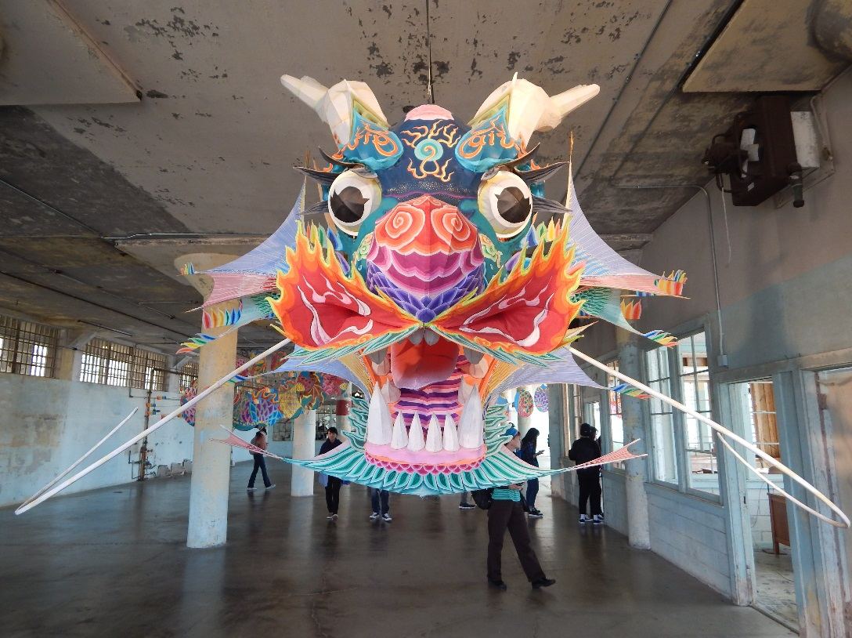
With Wind utilizes the large Chinese dragon kite to insert political quotes.
Beyond the room full of kites, a workroom was laid out with several panels of LEGOs. The six panels featured the portraits of 176 people who were incarcerated at the time of assembly, some of which have since been released. The portraits were created by thousands of tiny LEGOs and consisted of numerous colors. While faces like Nelson Mandela and Edward Snowden were easy to pick out, other portraits were a sign of the hundreds of people being held captive by their government across the world.
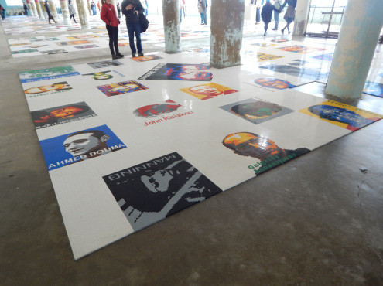
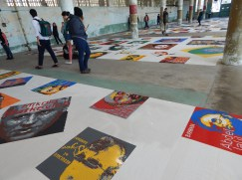
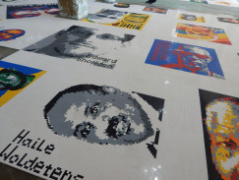
Last, but certainly not least, the neighboring workhouse held Refraction. This installation is only viewable from a tiny hallway that guards used to walk through with guns to keep an eye on the prisoners at work below. In this room, there was a wing made entirely of solar panels that are used in Tibet for energy to cook meals. The large wing was assembled in this room with the intentions of never being used for its purpose: flying. It is symbolic of prison itself.
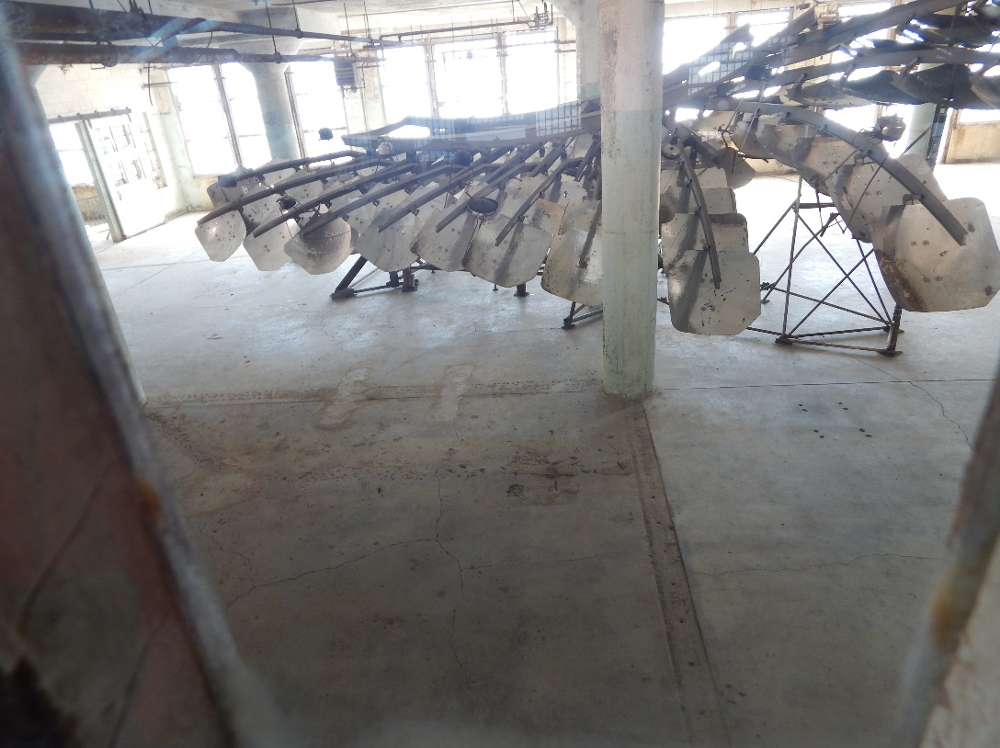
The final installation, Refraction, could only be seen from the gun gallery where guards patrolled the area.
For those who do not know, Ai Weiwei is a Chinese artist who was arrested in 2011 and held for 81 days without his family’s knowledge. His work openly protests the Chinese government and upon his release his visa was taken and he was barred from leaving China. All of his work was designed in his studio in Beijing and shipped to Alcatraz before being assembled by volunteers with page-by-page instructions.
“This trip provided students with the opportunity to confront the reality that there are prisoners of conscience all around the world,” Boden Holland (senior, Communication Studies) said. “While these exhibits are powerful in their own right, I would have to say that Alcatraz serves as a stark reminder of our own nation’s relationship with imprisonment.”
Ai Weiwei’s work is a moving reminder of the injustices of the world we live in. He not only highlights the corrupt government he lives in but the corrupt attributes of all governments including the United States (as seen in the Snowden reference). While the last chance to see Ai Weiwei’s rendition of Alcatraz was on April 26, I can only hope that his work will come to light again soon for people to honor and remember for years. Until then, those interested in his work can find more of it at aiweiwei.com or connect with Ai Weiwei on Twitter @aiww.

