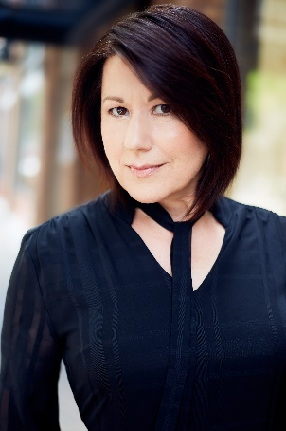
Marika is an actor, director, writer, and Assistant Professor of Theatre, specializing in the areas of Voice/Movement Studies and Acting. She has worked in film, television, and theatre for the past 25 years, having co-founded two professional theatre companies and served on many faculties throughout the U.S. She is also a certified Yoga instructor, certified Reiki Master, certified Fitzmaurice Voicework Practitioner, and certified Energy Medicine Practitioner. She has given public lectures both nationally and internationally about the value of empathy in theatre and its effects on the well-being of society and is currently working on her first book on the craft of acting.

