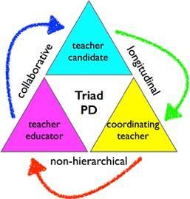
Triad NGSS Unit Plan Tool
Triad Team Names:
Teacher Candidate: Sarah Lee
Science Cooperating Teacher: Michael Munoz
Science Educator: Dr. Kanwaljit Dulai, Eric Houck
School and District: Virginia Parks Elementary School, Ceres Unified School District
Grade Level: 6th Grade
Science Content Area: Life Science

A. Grade Level and Standard
- California NGSS
MS-LS1-5 Construct a scientific explanation based on evidence for how environmental and genetic factors influence the growth of organisms.
Clarification Statement: Examples of local environmental conditions could include availability of food, light, space, and water. Examples of genetic factors could include large breed cattle and species of grass affecting growth of organisms. Examples of evidence could include drought decreasing plant growth, fertilizer increasing plant growth, different varieties of plant seeds growing at different rates in different conditions, and fish growing larger in large ponds than they do in small ponds.

Three NGSS Dimensions Contained in the Standard:
  - Science and Engineering Practice:

Constructing Explanations and Designing Solutions
Constructing explanations and designing solutions in 6-8 builds on K-5 experiences and progresses to include constructing explanation and designing solutions supported by multiple sources of evidence consistent with scientific ideas, principles, and theories.
Construct a scientific explanation based on valid and reliable evidence obtained from sources (including the students’ own experiments) and the assumption that theories and laws that describe the natural world operate today as they did in the past and will continue to do so in the future. (MS-LS1-5)
  - Disciplinary Core Idea:

LS1.B: Growth and Development of Organisms
- Genetic factors as well as local conditions affect the growth of the adult plant. (MS-LS1-5)

  - Crosscutting Concept:

Cause and Effect
- Phenomena may have more than one cause, and some cause and effect relationships in systems can only be described using probability. (MS-LS1-5)

Common Core State Standard Connections:
  - ELA/Literacy:
RST.6-8.1 - Cite specific textual evidence to support analysis of science and technical texts. (MS-LS1-4), (MS-LS1-5), (MS-LS3-1), (MS-LS3-2), (MS-LS4-5)
RST.6-8.2 - Determine the central ideas or conclusions of a text; provide an accurate summary of the text distinct from prior knowledge or opinions. (MS-LS1-5)
WHST.6-8.2 - Write informative/explanatory texts, including the narration of historical events, scientific procedures/ experiments, or technical processes.(MS-LS1-5)
WHST.6-8.9 - Draw evidence from informational texts to support analysis reflection, and research. (MS-LS1-5)

  - Mathematics (if applicable):
6.SP.A.2 - Understand that a set of data collected to answer a statistical question has a distribution which can be described by its center, spread, and overall shape. (MS-LS1-4), (MS-LS1-5)
6.SP.B.4 - Display numerical data in plots on a number line, including dot plots, histograms, and box plots. (MS-LS1-4), (MS-LS1-5)

  - ELD Standard (Search the ELD Standards using the ELA Standard(s) identified above.)
A. Collaborative
1. Exchanging information and ideas with others through oral collaborative discussions on a range of social and academic topics
2. Interacting with others in written English in various communicative forms (print, communicative technology, and multimedia)
3. Offering and justifying opinions, negotiating with and persuading others in communicative exchanges
4. Adapting language choices to various contexts (based on task, purpose, audience, and text type)
B. Interpretive
5. Listening actively to spoken English in a range of social and academic contexts
6. Reading closely literary and informational texts and viewing multimedia to determine how meaning is conveyed explicitly and implicitly through language
7. Evaluating how well writers and speakers use language to support ideas and arguments with details or evidence depending on modality, text type, purpose, audience, topic, and content area
8. Analyzing how writers and speakers use vocabulary and other language resources for specific purposes (to explain, persuade, entertain, etc.) depending on modality, text type, purpose, audience, topic, and content area
C. Productive
9. Expressing information and ideas in formal oral presentations on academic topics
10. Writing literary and informational texts to present, describe, and explain ideas and information, using appropriate technology
11. Justifying own arguments and evaluating others’ arguments in writing
12. Selecting and applying varied and precise vocabulary and language structures to effectively convey ideas

B. Content Research - Outline of Major Concept and Sub-Concepts in Unit
Student will need to understand how environmental factors influence the growth of organisms. Specifically, the students will need to look at data about water conditions in California and the impact that drought conditions have on the landscape. Students will be presented with a scenario where they own a landscaping business and have to research the effects of drought, what plants are best suited for drought conditions, and the impact that a change of landscape might have on local fauna. Students should have a basic understanding of how limited water resources affects local, regional, and statewide conditions with regards to flora and fauna.

C. Summative Assessment
A family member of yours has recently come to you asking for advice. They bought a farm in the central valley, but does not know what to plant. Based on the data given, can you create a CER to convince your family member of what they should grow.

Rubric:
0 - Nothing was written.
1 - They wrote something.
2 - They have a clear claim.
3 - They have a claim that has been backed up by evidence.
4 - They have a claim that has been backed up by evidence and they have clear reasoning for what

D. The Unit Plan

Unit Plan Table*
Lesson | Standard (by number) and Objective(s) for the Lesson | Primary Instructional Strategy** | Summary of Instructional Sequence of Lesson | Strategies for Students Who Typically Struggle with Science (English Learners, Exceptional Students) | Assessment Summary (Briefly describe and label as Diagnostic, Formative, or Summative)
1 | LS1-5 | Direct Instruction / Engage / Guided discovery | - Teachers will model looking at phenomenon and asking questions. They will use metacognition to demonstrate how students should approach the CER method of inquiry.  - Teacher: “Picture this. You are the owner of a landscaping company. You have noticed that people have started asking you to change out their grass lawns to something that does not use a lot of water to grow. You are willing to accommodate their requests, but you need evidence to support which plants you are going to plant.”  - Show data sets (Water levels in California, Growth rates of different plants - two types of grass and two types of cacti, plant populations and animal populations associated and dissociated with the plants). | - Model how to look at and observe phenomenon; use metacognitive methods of talking through what I would write as observations and what questions that might arise  - Heterogeneous groupings of the students  - Frequent checks for understanding  - Appropriate DOK questions | No assessment; first time learning for students about how to look at phenomenon
2 | LS1-5 | Explore / Investigate Phenomenon / Group Discussion | - Student will be in heterogeneous groups to support each other.  - They will move though stations to look at pictures related to drought conditions, drought tolerant landscaping, and non drought tolerant landscaping.  - Students will write down their observations and questions that are raised from this lesson  - Whole group will discuss what they observed and any questions that were raised from the investigation. | - Assist students in chunking down the amount of info into manageable pieces.  - Frequent checks for understanding  - Heterogeneous groupings of the students | Review students findings and discuss
3 | LS1-5  6.SP.A.2 | Explore/Explain/CER | - Student will continue to analyze the information they have been given or have found.  - Student will begin to form their claim and back it up with evidence from their research  - Give each group all of the data sets and ask them to fill out a CER (1 per person or 1 per group). The focus for the CER should be on using the data to show which plants you want plant and why.  - Have each group stand up and present their CER or the CER they felt was the best. | - Heterogeneous groupings of the students  - Frequent checks for understanding | Teachers circulate, check, & discuss claims, evidence, reasoning with groups.  Offer suggestion for groups that are having difficulty in where to go next.
4 | LS1-5  6.SP.A.2 | Explain / Whole Group | - Students will explain and give reasoning for the information on the CER  - Students will be given time to revise their claim based on the data they have collected and the information shared in class.  - Come up with a class “consensus” using all of their CERs. This will be turned into a statement that will be sent to all of their clients.  - “We can recommend to our clients that they plant ___________ in their yards. Due to the current drought _________ will consume (cite specific evidence) less water and grow (cite specific evidence) cm more per week.” | - Heterogeneous groupings of the students  - Frequent checks for understanding  - Sentence frames  - Modeling correct language and pronunciation | Whole class discussion with group consensus based on CERs.  Formative: The statement that would sent to the customers.
5 | LS1-5  6.SP.A.2 | Extension | - Have students develop a CER from a different ecosystem.  - Teacher - “Your business moved from the Central Valley to Pinecrest, CA. Pinecrest is farther up into the Stanislaus mountains than Sonora. What data would you want in order to be successful and give your clients the best possible yards for their area?”  - Based on the data that they ask for, bring up different graphs / charts. This can be done quickly on google sheets (we can set up specific formulas that you can just input values and then show them the data). | - Heterogeneous groupings of the students  - Frequent checks for understanding  - Assist students in chunking down the amount of info into manageable pieces.
6 | LS1-5 | Evaluate | - Summative assessment: A family member of yours has recently come to you asking for advice. They bought a farm in the central valley, but does not know what to plant. Based on the data given, can you create a CER to convince your family member of what they should grow.  - Rubric:  0 - Nothing was written.  1 - They wrote something.  2 - They have a clear claim.  3 - They have a claim that has been backed up by evidence.  4 - They have a claim that has been backed up by evidence and they have clear reasoning for what they are recommending their family member grows. | - Review the rubric and have the students self-evaluate their findings | Summative: Student will go through the same process based on the scenario provided
*Add rows to the table as needed.
**Strategies might include: guided discovery, model-based instruction, argumentation, 5E Model of Inquiry, direct instruction, computer-based or hands-on simulations, interactive video viewing, etc. At least one lesson should involve students collecting, analyzing, and/or interpreting data. You can use existing data sets.

E. Lesson Plans, Support Materials
In this section, include any support materials that you used for each lesson. Including your assessments is also recommended, since they play a central role in your curriculum design. All files have been made public and can be opened by anyone.
- YouTube Video Grassless Lawns Catching On During California Drought | National Geographic https://youtu.be/ELAutJpNj9w
- CER Form http://gg.gg/CERFrom
- MS-LS1-5 Graphs http://gg.gg/MS-LS1-5Graphs
- “The Mighty Saguaro Cactus” http://gg.gg/SaguaroCactus
- “The Mighty Saguaro Cactus” (Spanish) http://gg.gg/SaguaroCactus-Spanish
- “Cactus Cloning” http://gg.gg/CactusCloning
- “What Eats Cactus?” http://gg.gg/EatsCactus
- NASA Climate Kids Website https://climatekids.nasa.gov/career-landscaper/
- “Drought Tolerant Plants” http://gg.gg/Drought_Tolerant_Plants

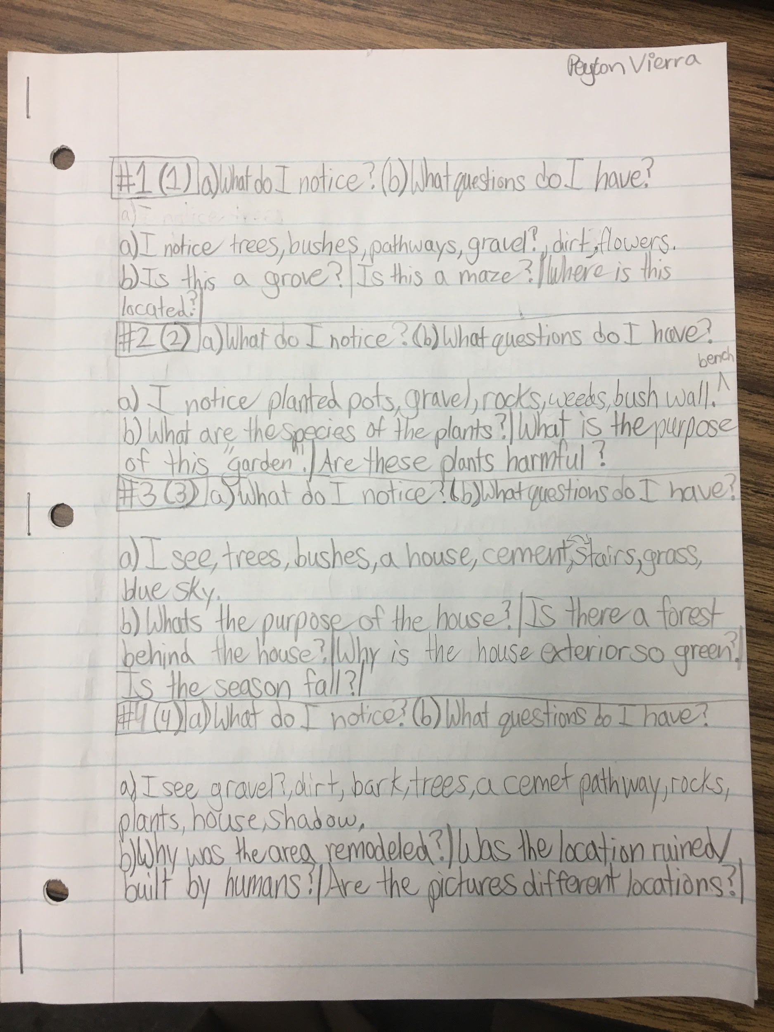  Student Sample of Phenomenon Observations | 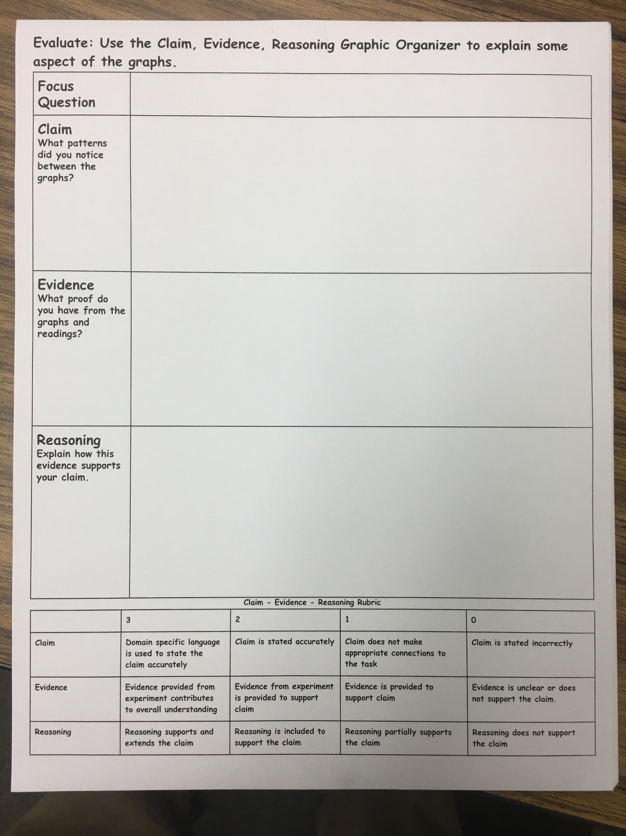  Claims, Evidence, Reasoning Organizer | 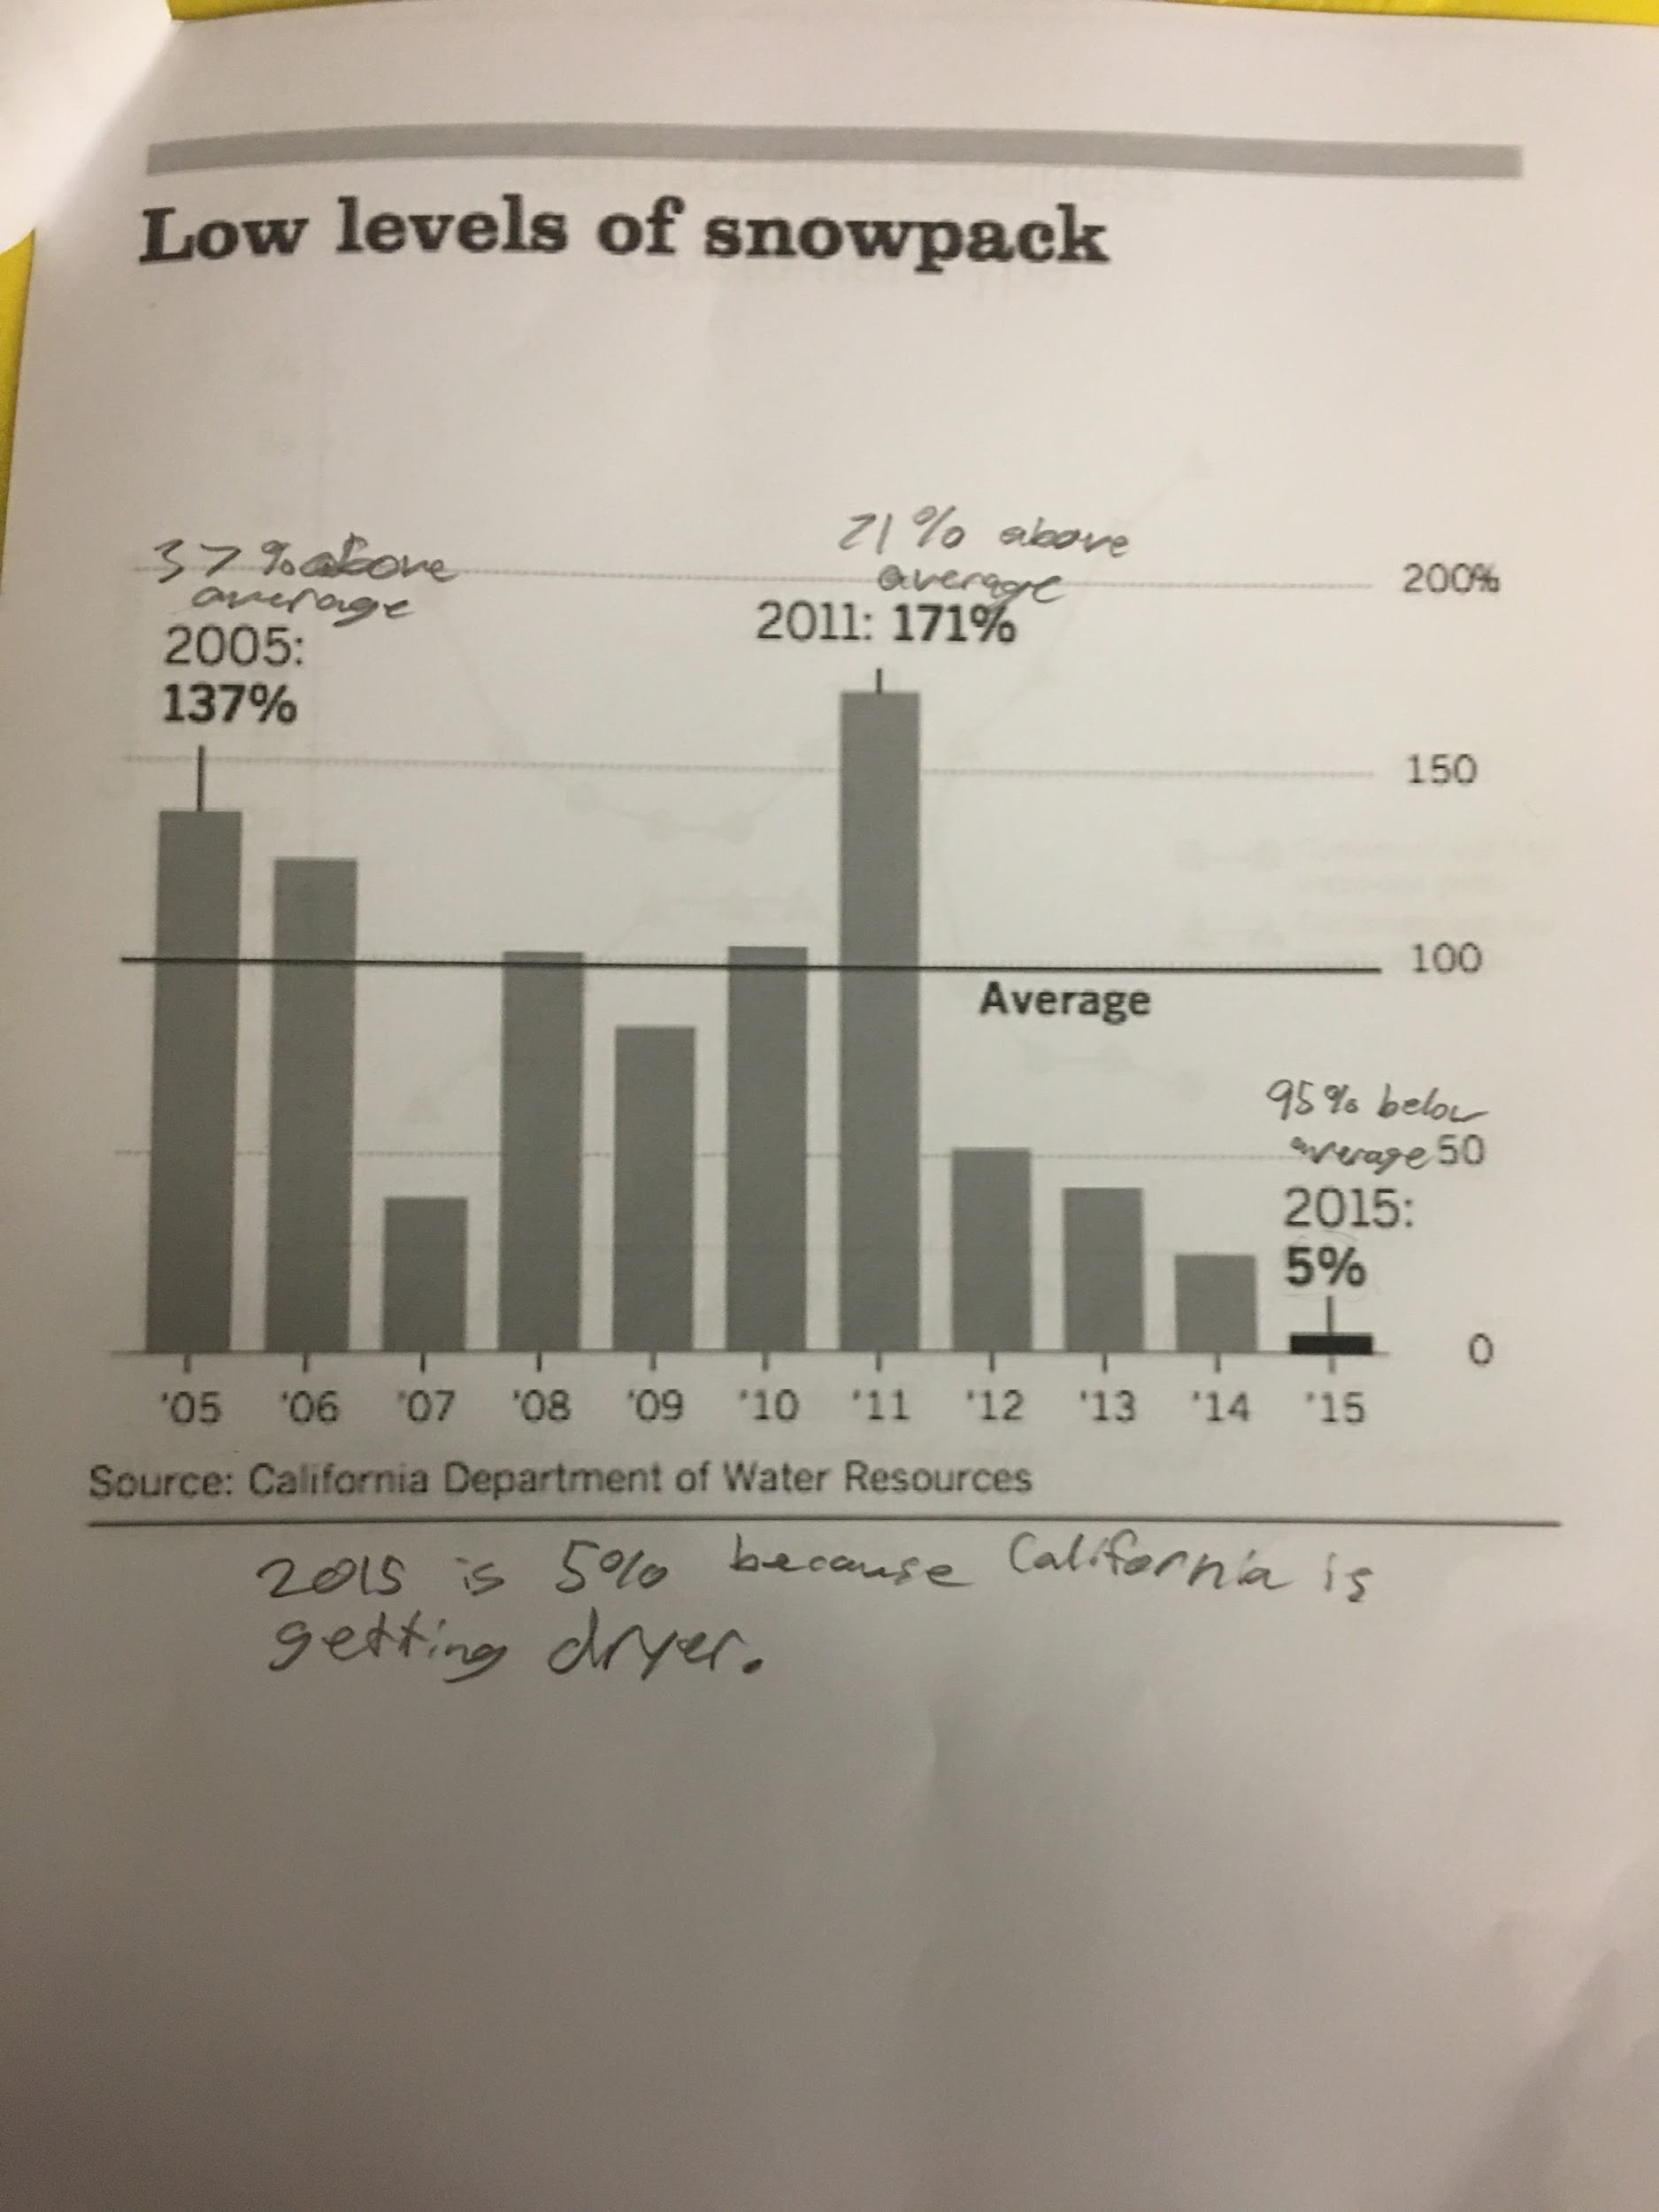  Student Sample of Graph Evaluation 1
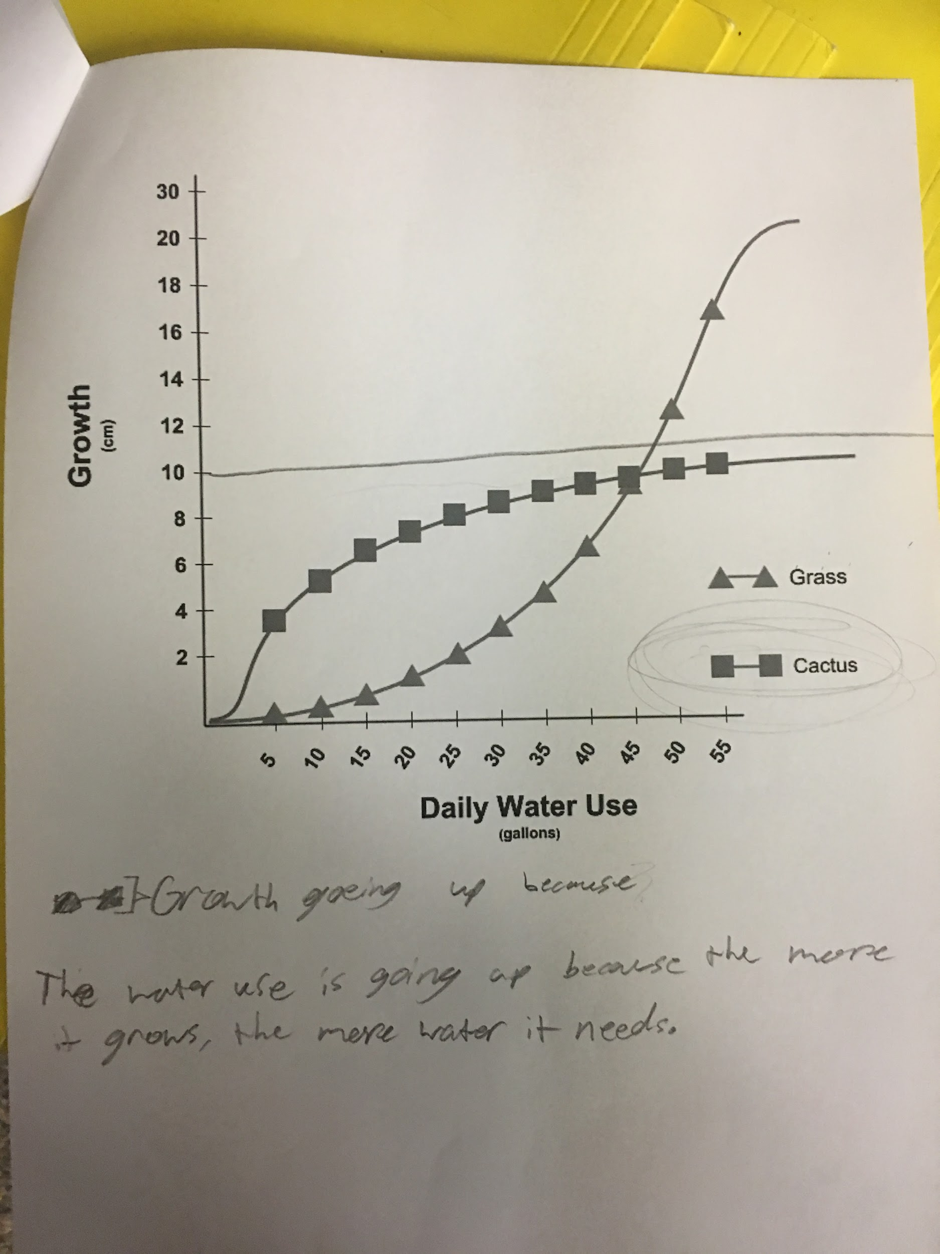  Student Sample of Graph Evaluation 2 | 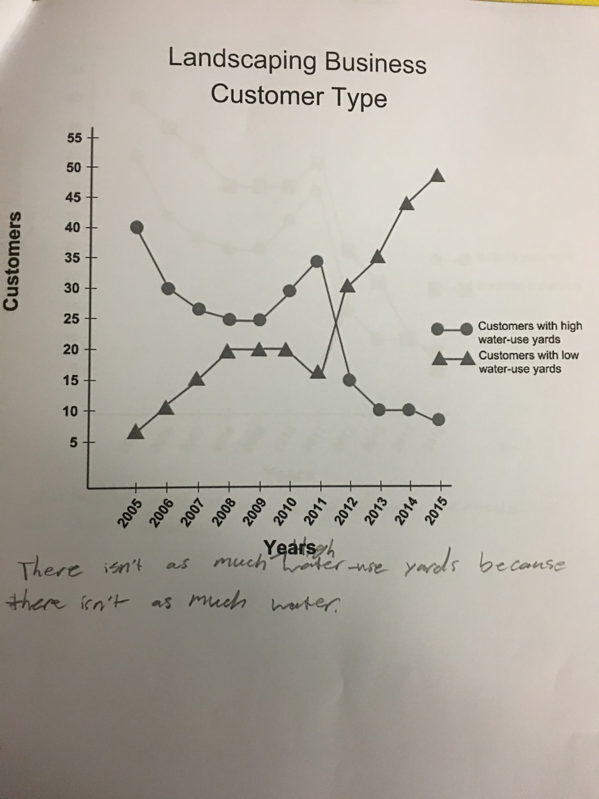  Student Sample of Graph Evaluation 3 | 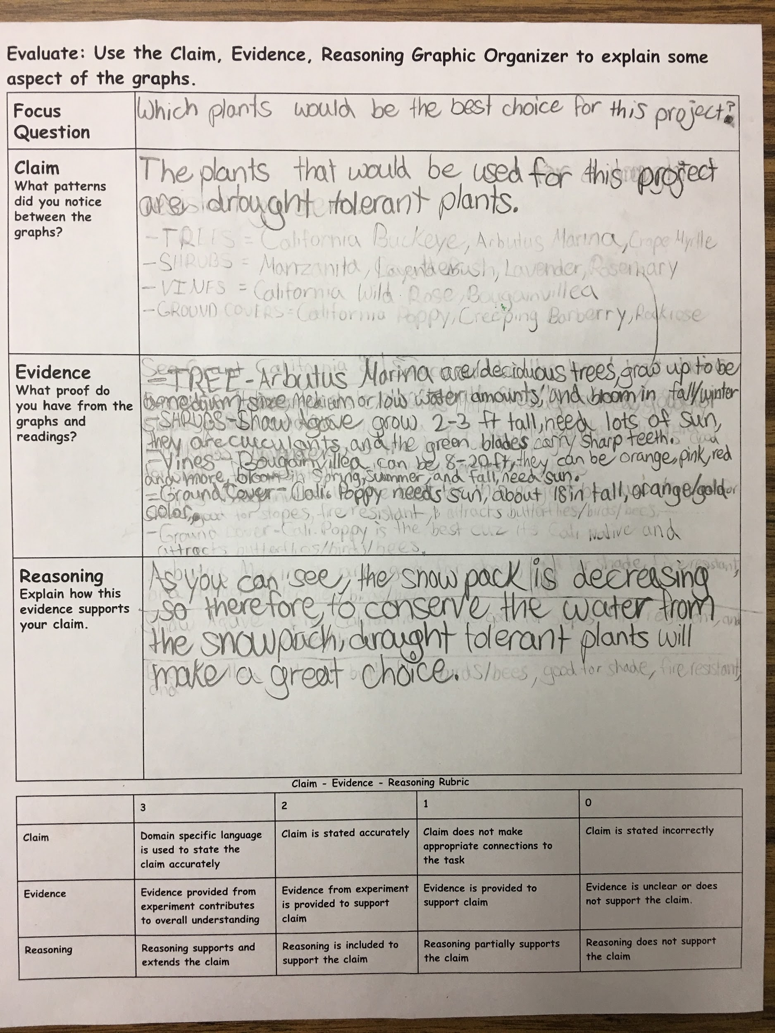  Completed Student CER Chart
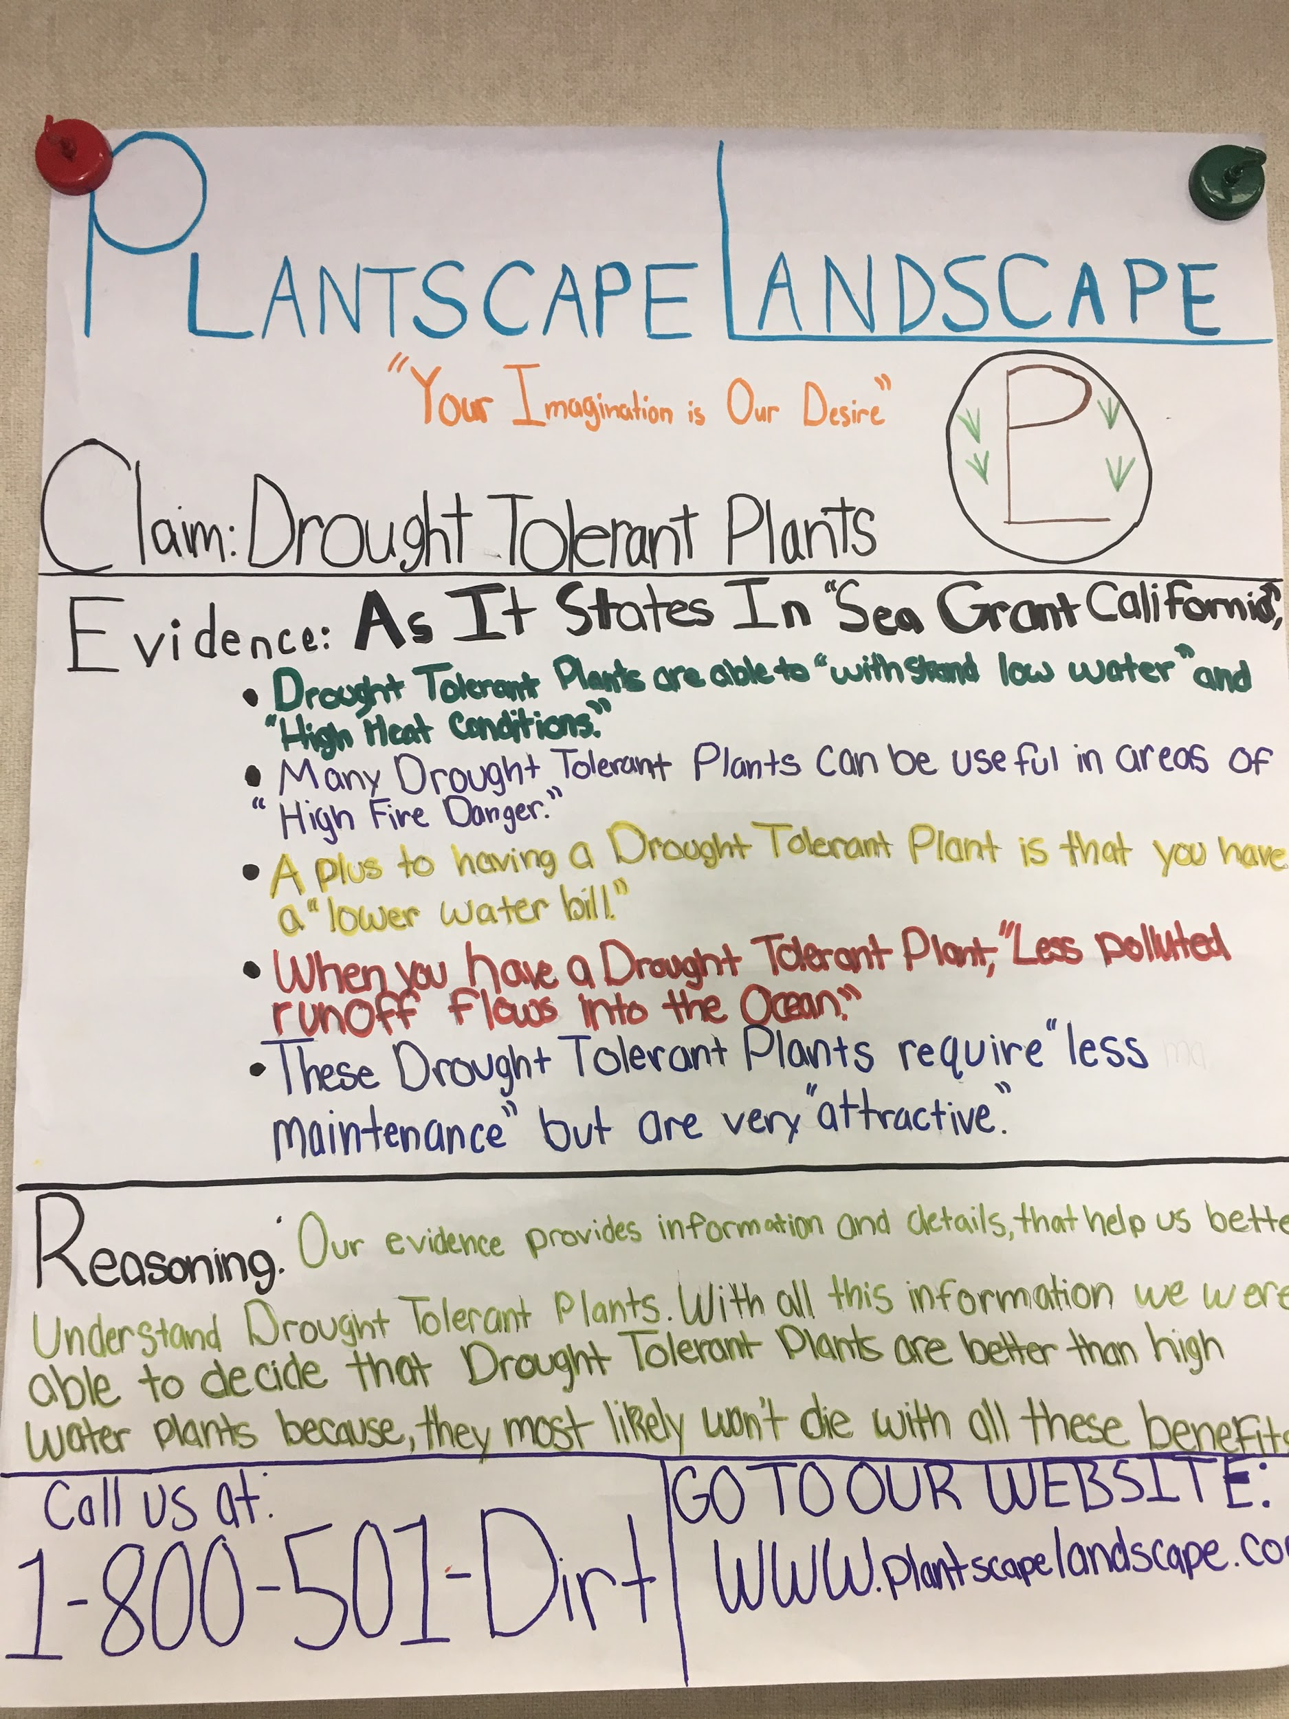  Landscape Poster 1 | 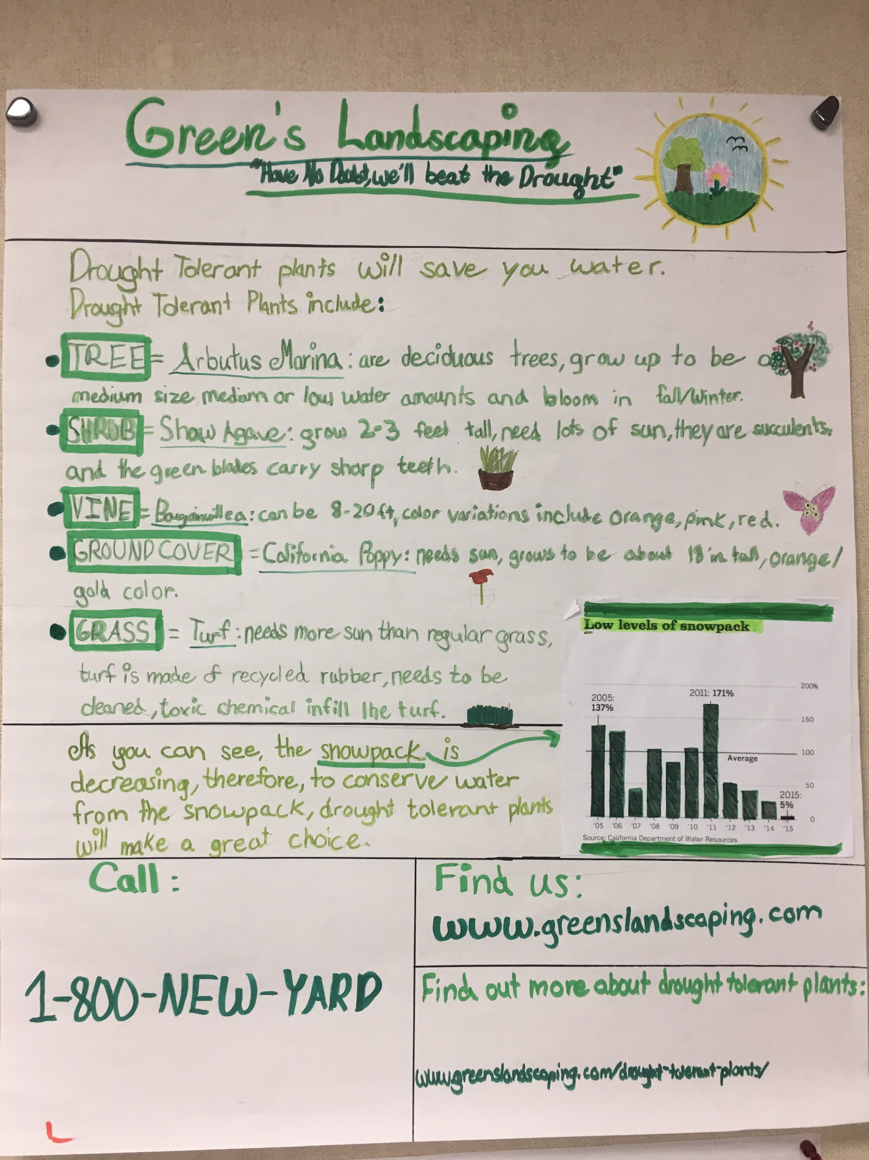  Landscape Poster 2

F. Summative Assessment
A family member of yours has recently come to you asking for advice. They bought a farm in the central valley, but does not know what to plant. Based on the data given, can you create a CER to convince your family member of what they should grow.

Rubric:
0 - Nothing was written.
1 - They wrote something.
2 - They have a clear claim.
3 - They have a claim that has been backed up by evidence.
4 - They have a claim that has been backed up by evidence and they have clear reasoning for what
Revised Summative assessment:

You need to design a proposal to the client that will inform them about what plants for a drought-tolerant yard. Students will create a poster that has the required elements to make their proposal.