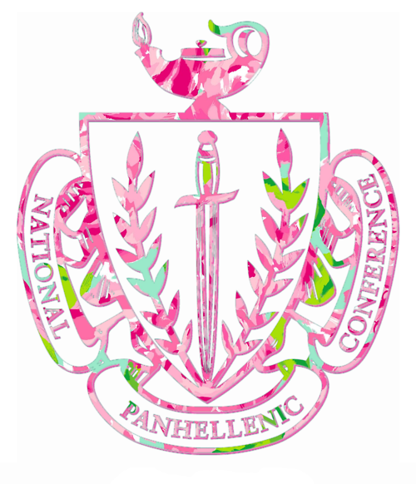
The College Panhellenic Council at CSU Stanislaus WELCOMES YOU!
ΑΞΔ & ΦΣΣ

Do you want to make new friends? Are you interested in gaining leadership experience to use in your career? The College Panhellenic Council would like to take this opportunity to share with you the amazing benefits and rewards of National sorority life here at CSU Stanislaus.

At CSU Stanislaus there are currently two National sororities, Alpha Xi Delta and Phi Sigma Sigma. Each of these National sororities offer a wide variety of programs and events including scholarship, philanthrophy, leadership opportunities, educational and social programming, and risk management training. Membership in a National Sorority is a chance to experience the rewards of lifelong friendships and offers collegiate women a chance to get involved on campus. In addition, you will create bonds of sisterhood and experience a lifetime membership in a wonderful organization.

Want to learn more? Here’s how:

- Meet the ladies at a Fall Social on August 27th from 6 pm-7 pm at the Pergola on campus and on September 9th from 5pm-6pm in the Event Center.
- Attend our Informational Nights on August 30th from 5pm-6pm and on September 5th from 5pm-6pm. Both Info Nights will be held in the Event Center.

Recruitment activities will begin on Thursday, September 12, 2013 through Monday, September 16, 2013. During the recruitment activities, you will be able to attend events and meet the ladies of each sorority. You will be given the opportunity to learn information about each National organization and become acquainted with all the benefits of sorority life. This is also an opportunity for you to ask questions, as well as learn about time commitments and membership requirements.

Discover more details about our Formal Recruitment Weekend by attending our Mandatory Orientation on Thursday, September 12, 2013 in the Mary Stuart Rogers Building (MSR) Room 130 at 6 pm. ORIENTATION IS ESSENTIAL FOR THE RECRUITMENT EXPERIENCE!

If you are interested in finding out what a National Sorority has to offer, please fill out our Registration Application with your $20 application fee (includes a t-shirt!) by Friday, September 6, 2013 to the Office of Student Leadership and Development located in the Student Union Building.

If you and/or your parents have any questions regarding Greek Life, the recruitment activities, or sorority life in general, please do not hesitate to send us an email or visit our National webpage www.npcwomen.org. Contact Alexa Garcia—Vice President of Recruitment at csus.panhellenic@yahoo.com or our Greek Advisor, Nicole Turner at nturner2@csustan.edu or (209) 667-3778. Looking forward to meeting you!

Be the Brightest of the Bunch with Panhellenic
Fall Recruitment 2013

