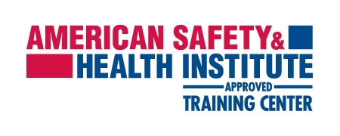
COURSE SUBMISSION COVER SHEET
Send this completed form to Safety & Risk Management along with the course roster to: KMarshall@csustan.edu
You MUST use the attached course roster form and type in participant’s information.
Instructor Name: | Department: | Phone:
Date: | Course: | Date of course:
Account # | # of attendees:

Certification charges | Equipment charges | AHSI Materials
Adult CPR: $6 pp | Adult Manikins $2 pp | Instructor Manual: $50
Adult CPR & First Aid: $10 pp | Infant Manikins $1 pp
Adult, Child, Infant CPR & First Aid: $10 pp | First Aid Equipment $1 pp
Blood Borne Pathogen: $6 pp
CPR for The PRO: $6 pp

FOR OFFICE USE ONLY

Entered in OTIS: | Invoice #:
Entered in Peoplesoft: | Course Code: | Session: #
Student Entry:
Charged account: | Amount: $ | AHSI Invoice Paid:
Equipment rental

Adult manikins: # | Infant Manikins: # | First Aid supplies: #

 | XX809
 | Class Upload Form
Student Last Name | Student First Name | Student Email

