CITI Program Ethics Training
All researchers who wish to conduct studies of human participants must complete ethics training. Please visit the Collaborative Institutional Training Initiative (CITI) Program website at: https://www.citiprogram.org/. You will need to create an account by clicking the “Register” button:
Type in California State University, Stanislaus, agree to the terms of service and affirm your affiliation with the university, and then select “Continue to Create Your CITI Program Username/Password”:
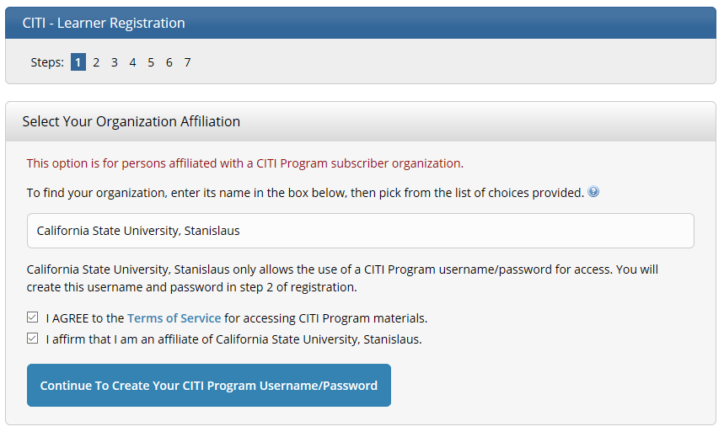

Enter the required information and select “Continue to Step 3” on the next page:
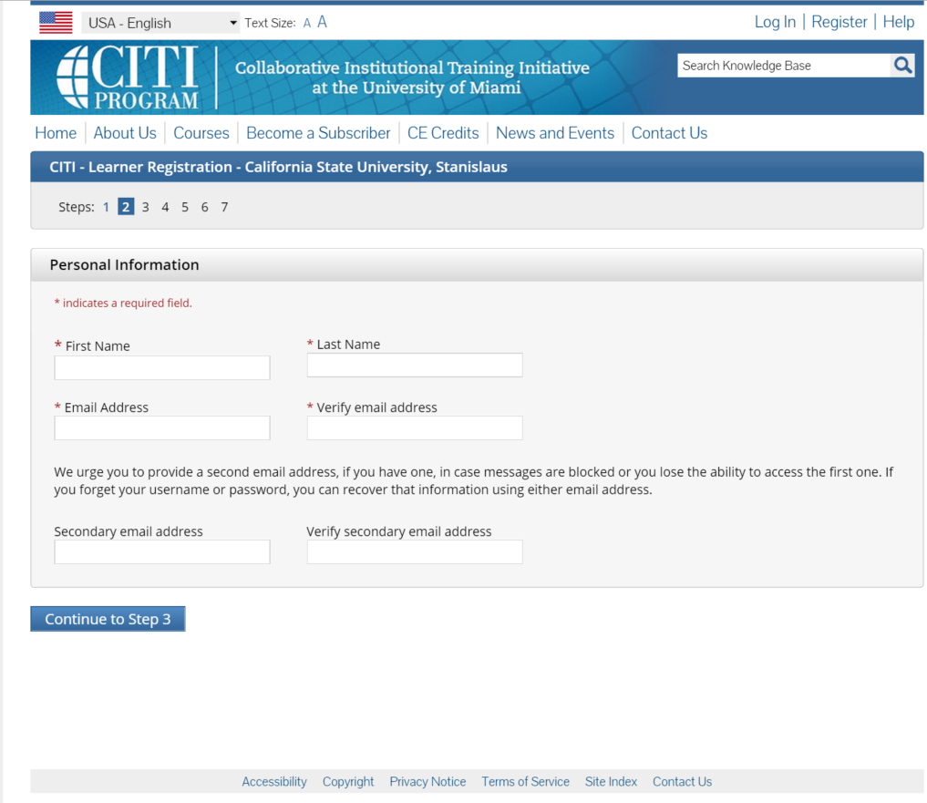

Create your user name and password, then continue to Step 4:
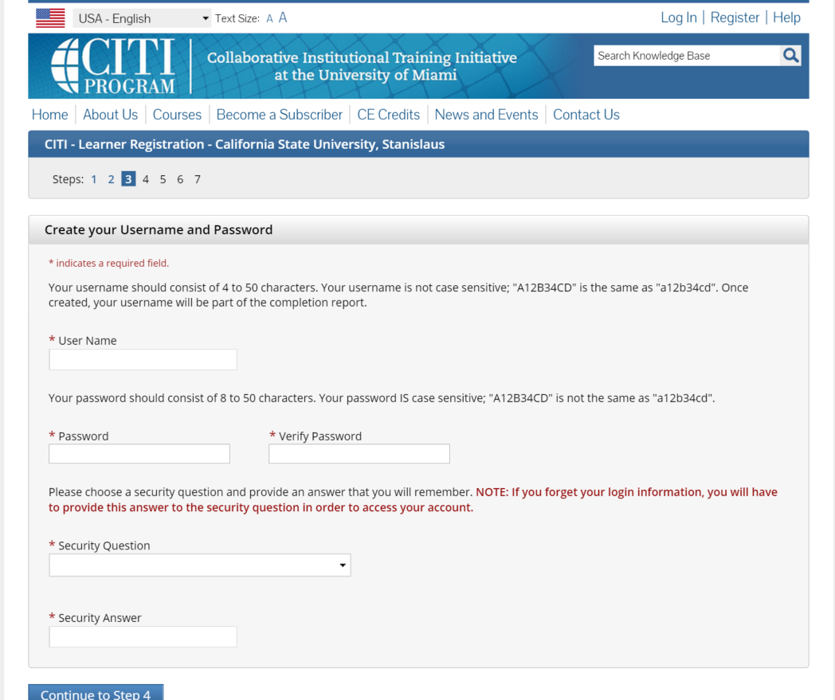

Enter “United States” and continue to Step 5:
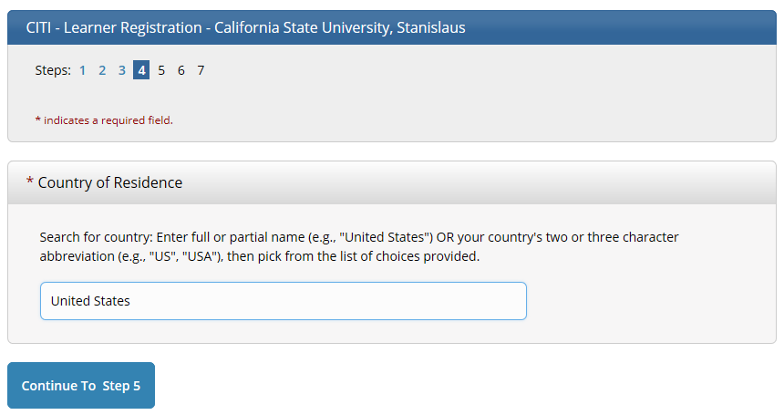
Select “No” when asked if you would like CEU credit. Answer the other two questions with stars as you please and continue to Step 6:
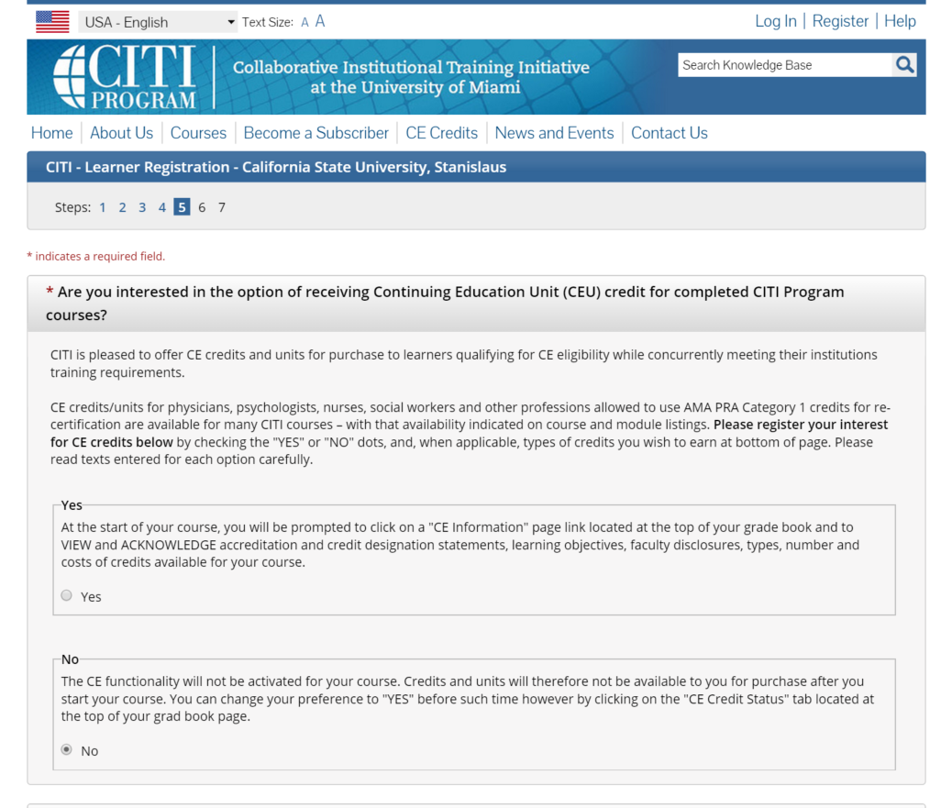

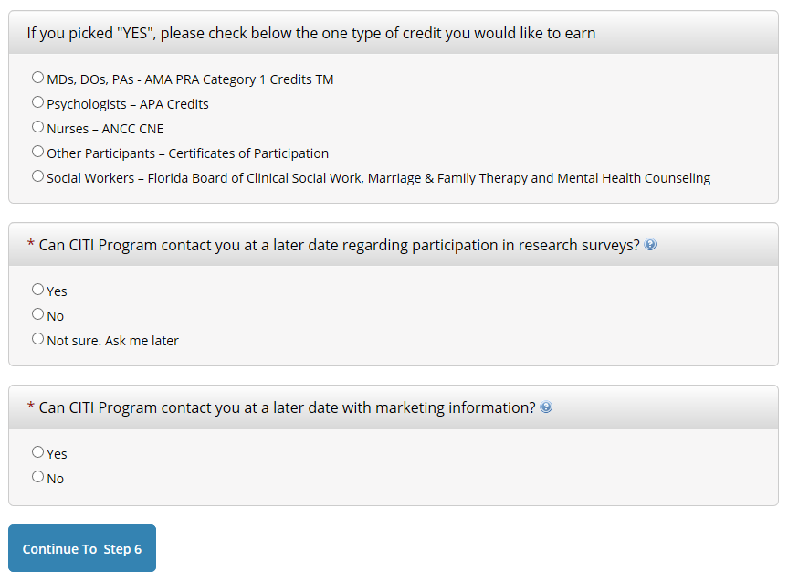
Complete the background information, selecting “Student Researcher – Undergraduate” from the “Role in research” menu, and continue to Step 7:
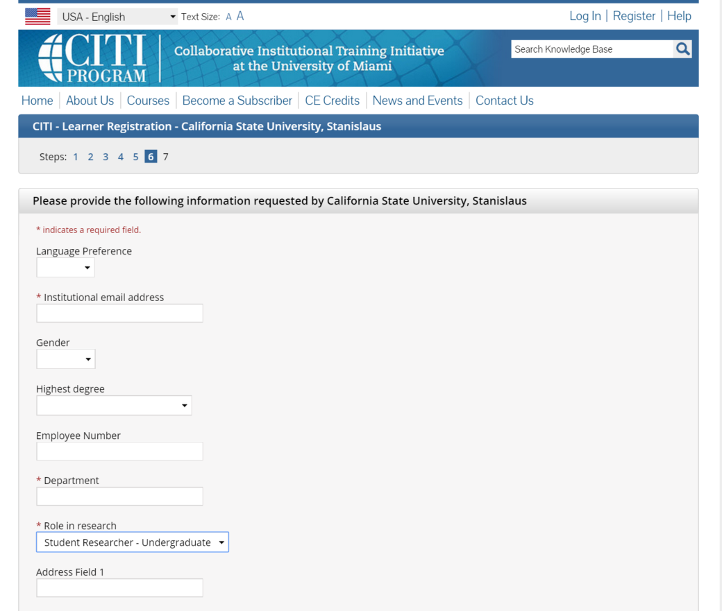

Click the option “Yes, I conduct research with live human beings, human samples or with data derived from human beings” and ALSO CLICK THE OPTION “Yes, I need/want to take the course on Responsible Conduct of Research (RCR)” then click the “Next” button:
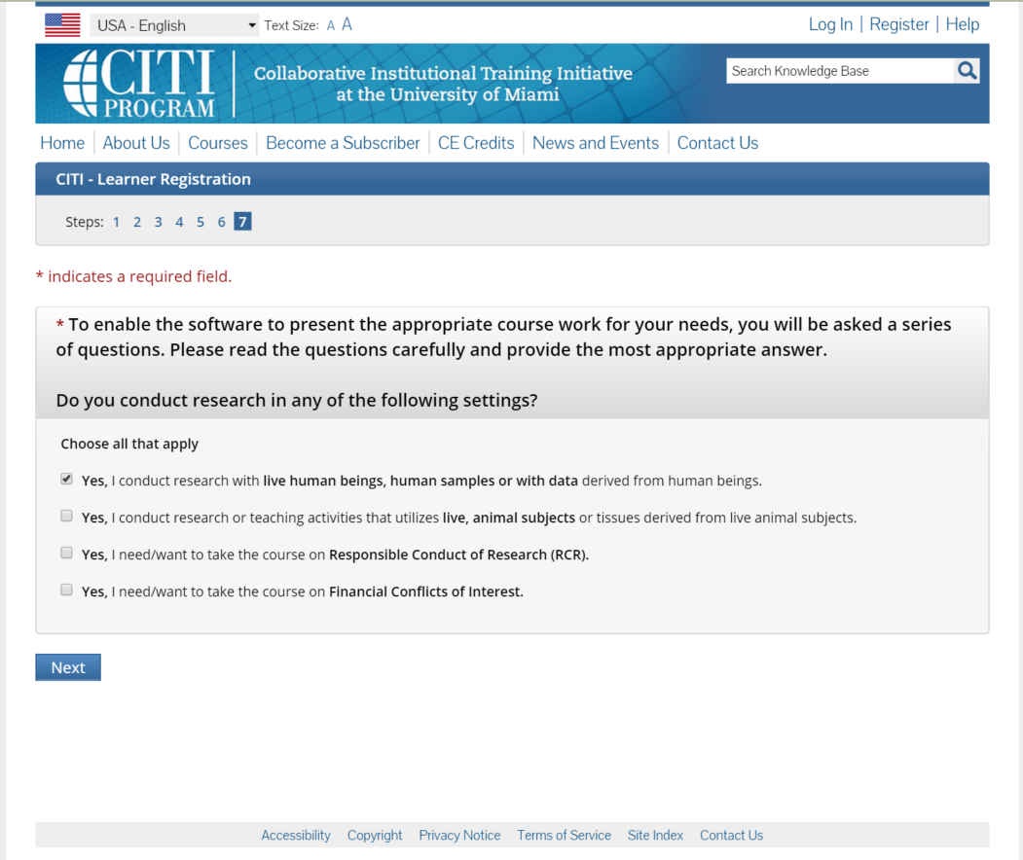

Select “NO, I have NOT completed the Basic Course,” and click the “Next” button:
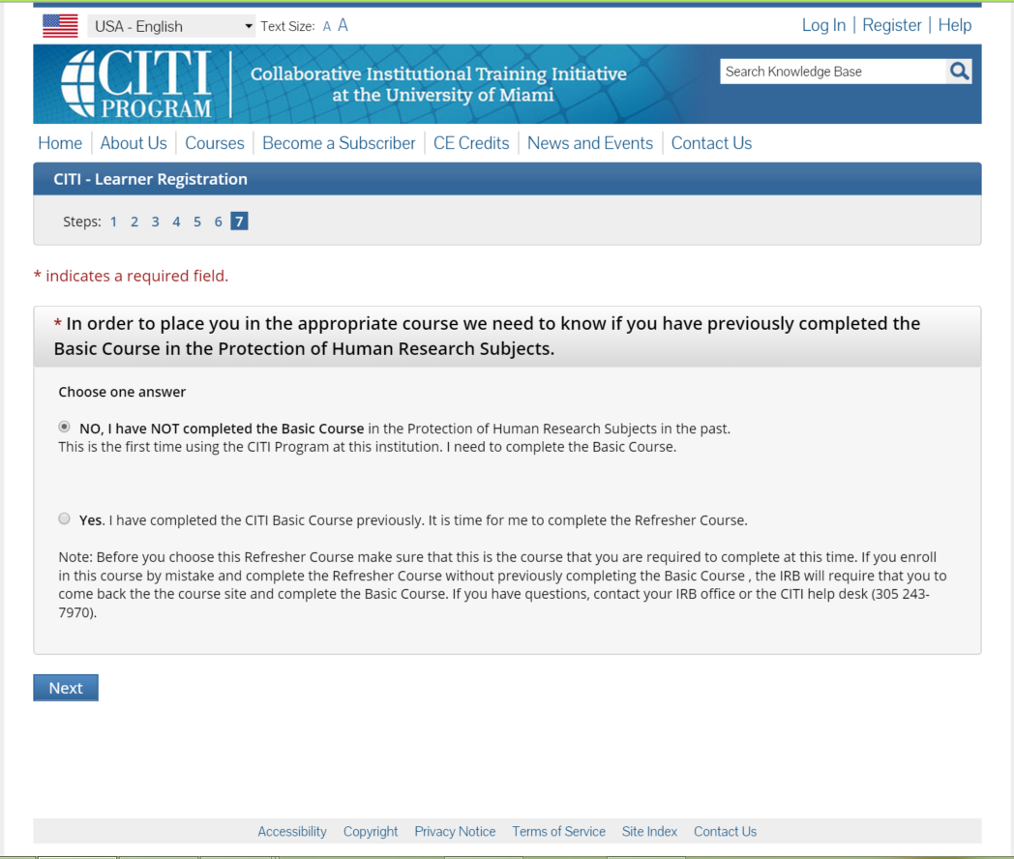
*Note: if you have already completed the basic course for a class, you may need to complete a refresher course. When you log in with your credentials you can select the “My Records” link. You will find information there on your currency for each of the required modules.

Select “Students” and click the “Next” button:
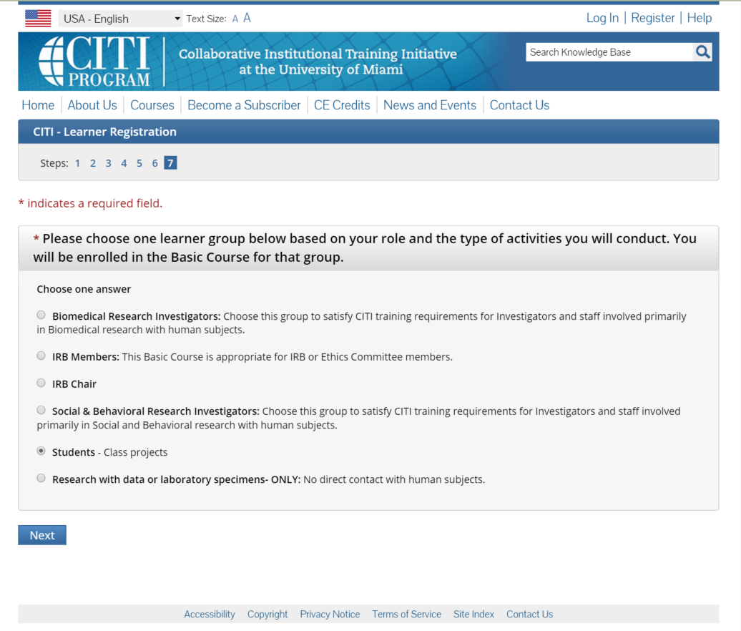

Select “Not at this time, thank you” and click the “Next” button:
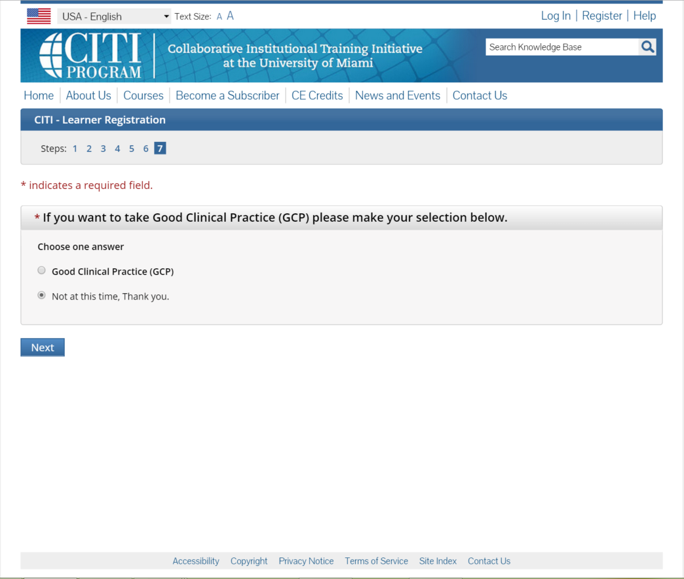

Select “Responsible Conduct of Research Course” and then “Next”:
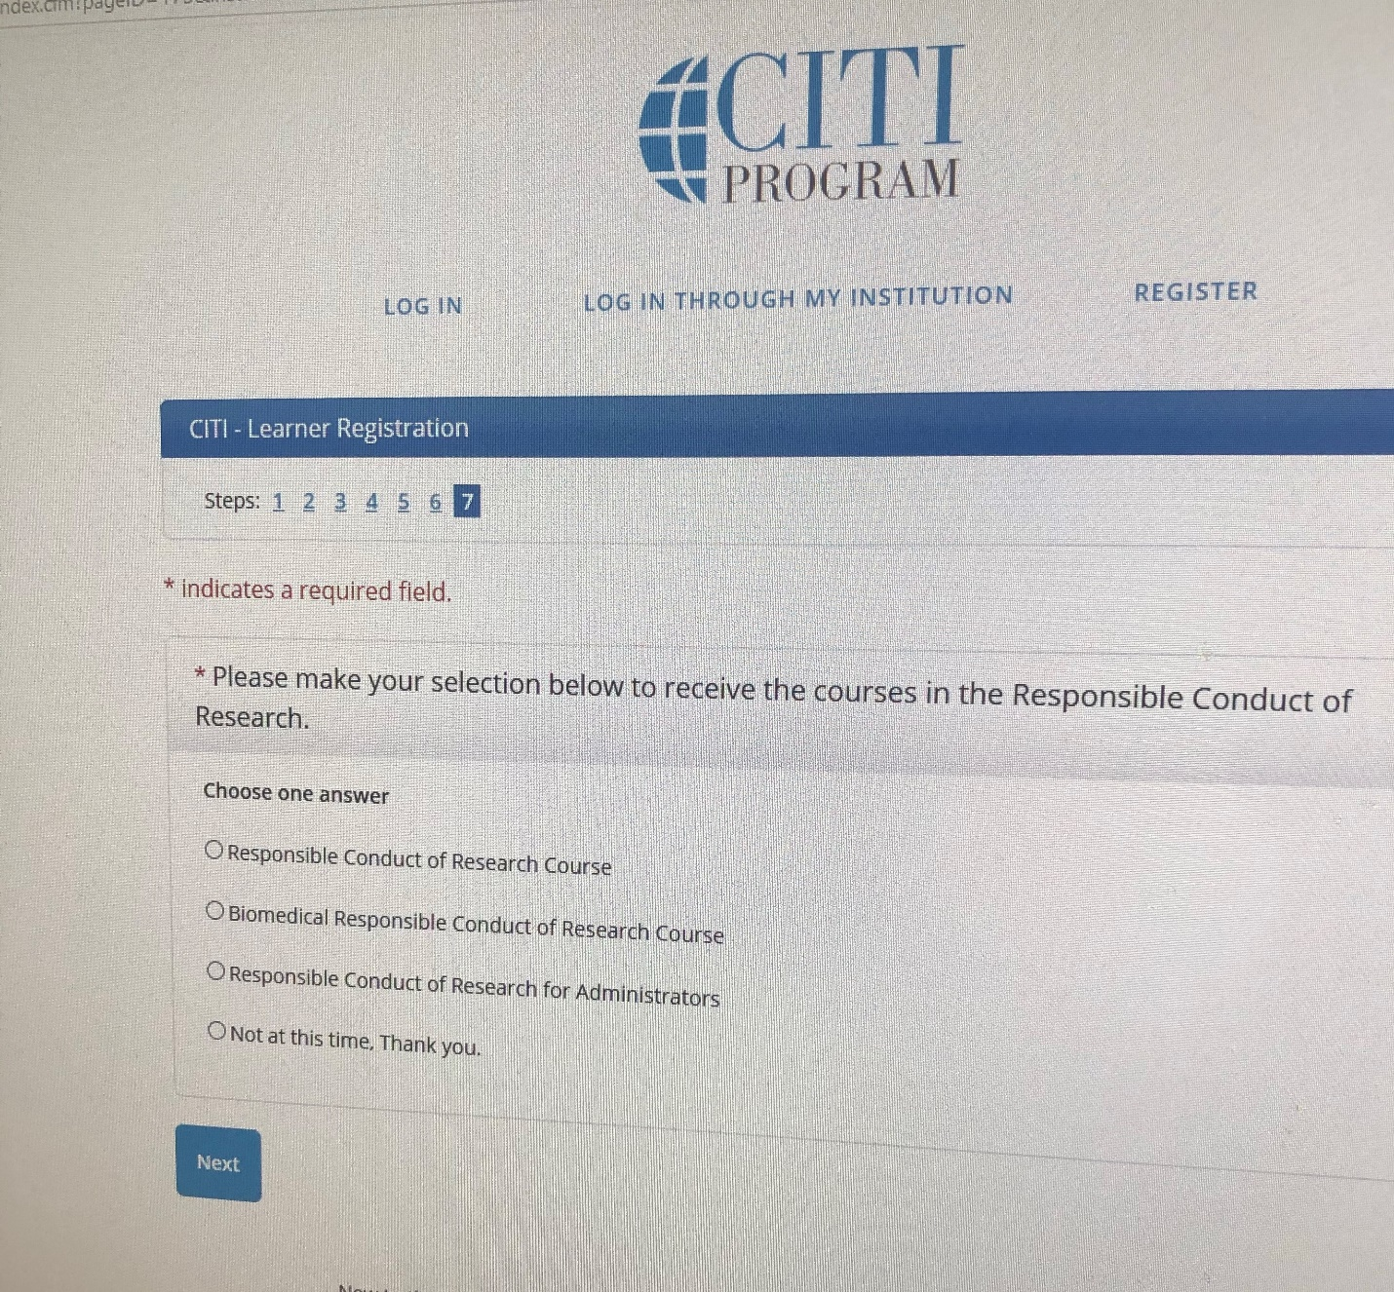

Finalize registration:
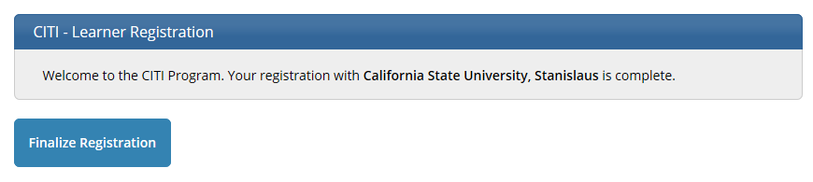

Select California State University, Stanislaus Courses:
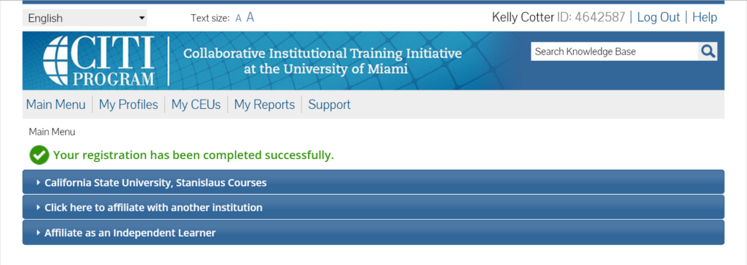
Select courses and complete all required modules for each course:
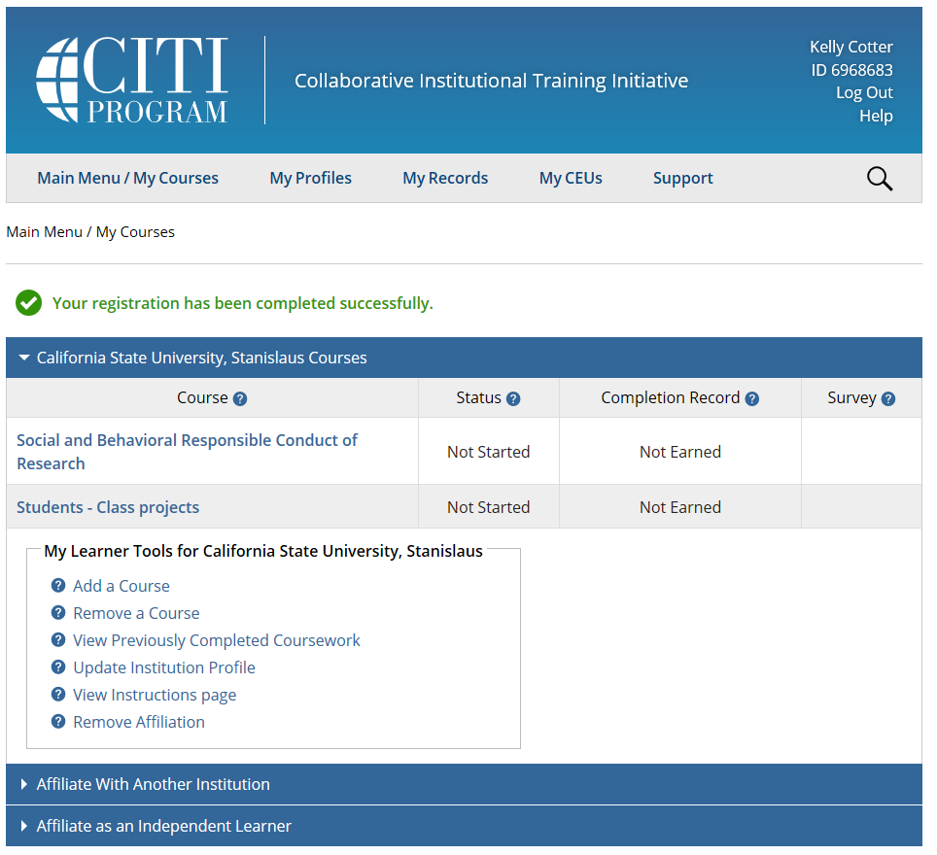

Once you have completed the modules you can click on the “My Records” link at any time to access your certificate:

Please provide a copy or screen shot of your report (showing your name) to your research supervisor. Your report will look like this until you have satisfactorily completed the modules:
