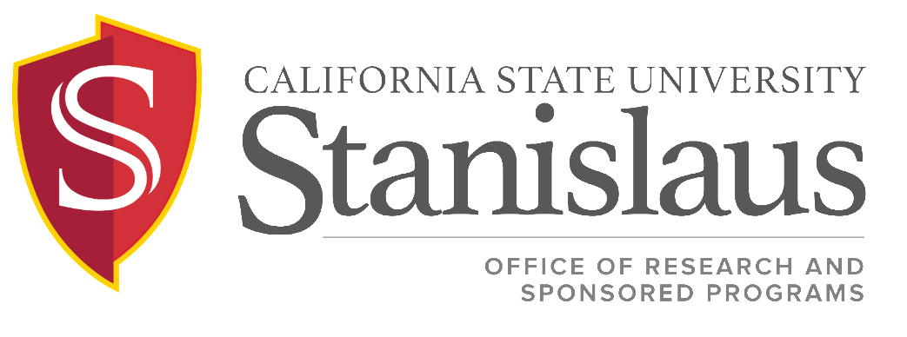

Sponsored Programs Indirect Cost/Facilities & Administrative Costs Procedure
In support of ICSUAM Policy 11003.03

Issued: July 2019

PURPOSE

California State University, Stanislaus (Stanislaus State) has a multi-year Facilities and Administrative (F&A/Indirect Cost) rate agreement with the federal government. This agreement specifies the F&A cost rates to be applied to awards from both federal and non-federal sponsors. The current rate agreement dated December 28, 2015 was negotiated with the Department of Health and Human Services (DHHS) and is effective from July 1, 2016 through June 30, 2021. The current rates are detailed in Table 1.

Table 1: Current DHHS approved F&A Rates
From | To | Rate | Location | Category
7/1/2016 | 6/30/2020 | 45.2% | On-Campus | All Programs
7/1/2016 | 6/30/2020 | 20.4% | Off-Campus | All Programs
7/1/2020 | 6/30/2021 | 45.2% (provisional) | On-Campus | All Programs
7/1/2020 | 6/30/2021 | 20.4% (provisional) | Off-Campus | All Programs

Exceptions to these rates do occur. Stanislaus State currently recognizes three categories of exceptions: (1) approved historical rates, and (2) rates for Centers and Institutes, and (3) restrictions placed on F&A by the funder.

1. Historical Rates. Stanislaus State recognizes that there are instances where it is in the institution’s interest to grant a subvention of the full federal F&A rate. A reduced rate of 10% is allowed on all contracts with K-12 school districts.

2. Centers and Institutes. All federal grants and contracts will use the current federally negotiated rate. All other grants and contracts are approved to use a rate of 20%.

3. Restrictions by Funder. Additional exceptions to the approved federal rate occurs when a funding agency places a cap on the F&A rate. In this case, upon the receipt of the written guidelines stating there is a limit on F&A costs, the Director of the Office of Research and Sponsored Programs (ORSP) will approve the reduced F&A rate.

Any variation from the rates described above must be approved by the Director of Research and Sponsored Programs. Approval will be documented on the Internal Proposal Routing Form. Please note that Principal Investigators are not authorized to negotiate F&A with sponsors.

RELATED DOCUMENTS
Facilities & Administrative Costs Rate Agreement

