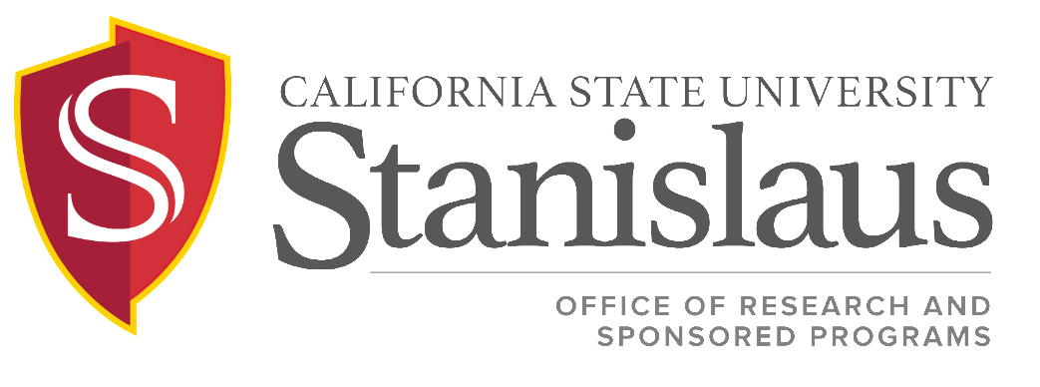

Sponsored Programs Award Acceptance & Negotiation Procedures
in support of ICSUAM Policy 11002.04

Issued: May 2020

DESCRIPTION
This procedure outlines the process that Stanislaus State follows to negotiate and accept a grant award or a contract. Typically, grants do not require negotiation, other than budget revisions because most federal awards incorporate standard terms and conditions that are not negotiable. Most negotiations conducted by Stanislaus State involve awards from private sponsors, and contracts and subcontracts from other institutions.

PROCEDURE
PROCEDURE
- The ORSP staff member responsible for that project forwards a copy of the award/contract to the Principal Investigator (PI) and initiates a conversation about deliverables noted in the document.
- ORSP reviews the terms and conditions of the award/subaward or contract/subcontract, focusing on:
a. The Schedule
b. General Terms and Conditions
c. Special Provisions
d. Scope of Work
e. Budgets and payment method
- ORSP staff will share a copy of the contract with the designated Procurement & Contract Services Buyer in Financial Services. She/he will review the contract to ensure the contract meets University standards in order to obligate the University in a binding contractual agreement. Final approval by the Procurement/Buyer will be documented in the award file.
- If any of the requirements concerning these areas are considered unacceptable by the Buyer, PI, or ORSP staff, the ORSP staff member shall discuss those requirements with the Director of ORSP. The Director of ORSP will negotiate acceptable conditions with the sponsor. Note: Unacceptable requirements are those that would cause an extreme burden on Stanislaus State administration, or are programmatic requirements that Stanislaus State could not fulfill. Examples may include:
a. Deliverable(s) requiring an infusion of resources greater than those provided by the award
b. Technical Reports due every two weeks
c. Final invoice or final financial report due less than 90 days after the project’s end date

Procedure for Awards
- For federal grants and private organization grants that have no extraordinary requirements, the ORSP staff member will initiate the grant start-up procedure.
- If the award requires Stanislaus State’s countersignature to accept the award, the ORSP staff member will forward the award document to the Provost for signature.

Authorization to Spend
There are some instances when a sponsor allows pre-award spending or when it is necessary to incur costs prior to the receipt of a fully executed award document. In very rare circumstances the Post Award Grant Manager, in consultation with the Director of ORSP, may allow for pre-award spending. The procedures for requesting and approving pre-award spending are as follows:
- Upon receipt of a notice of award the PI must send a request to the Post Award Grant Manager. The request will include:
  - A copy of the intent to fund
  - A description of the costs to be incurred prior to the final execution of the grant award agreement
  - A justification for why these costs must be incurred prior to the final execution of the grant agreement
  - Acknowledgement that if the funding does not materialize, all pre-award costs will be the responsibility of the PI’s department
- The Post Award Grant Manager will review the request, and based on the justification of need will make a determination to allow pre-award spending
- If approved, the Post Award Grant Manager will send the chartstring account information to the PI

