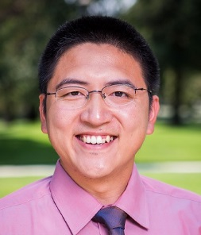

Xun (Peter) Xu, Ph.D.
Assistant Professor, Operations Management
Department of Management, Operations, and Marketing
College of Business Administration

Xun (Peter) Xu joined in California State University, Stanislaus as an Assistant Professor in the Department of Management, Operations, and Marketing in College of Business Administration in 2015.

Dr. Xu holds a Ph.D. in Operations Management from the Washington State University. He loves teaching and being with students very much. He teaches Operations Management, Management Science, Materials and Inventory Management, Quality and Productivity Management, Advanced Topics in Operations Management, Managing for Strategic Advantage in a Global Market, and other business courses. His teaching style is interactive and fun, which motivates students to learn with enjoyment.

His research interests include service operations management, supply chain management and coordination, sustainability, e-commerce, data and text mining, and interface of hospitality and operations management. His papers appear on international journals, international conferences proceedings, and book chapters.

