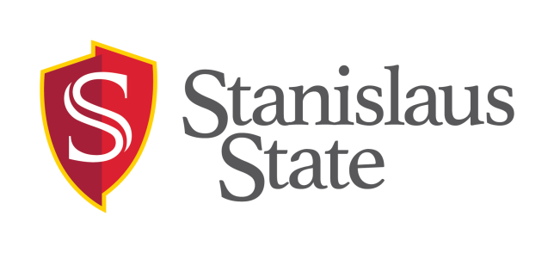 | Student Assistant Job Posting Request  (Non-Work Study)  Human Resources  MSR 320 · (209) 667-3376
~~~~~~~~~~~~~~~~~~~~~~~~~~~~~~~~~~~~~~~~~~~~~~~~~~~~~~~~~~~~~~~~~~~~~~~~~~~~~~~~~~~~~~~~~~~~~~~~~~~~~~~~~~~~~~~~~~~~~~~~~~~~~~~~~~~~~~~~~~~~
Section A: To be completed by Hiring Department
Department:
Contact Person & Title:
Building & Room:
Email:
Phone:
Student Assistant Job Title:

Check only one, if applicable; otherwise leave blank:
Instructional Student Assistant (Unit 11): Please consult with Faculty Affairs (x3392) to determine if your position is an Instructional Student Assistant position.
Spot Job: Position will work between 1 – 7 days only.

Duties (if characters exceed space provided, email text to psurratt@csustan.edu):

Experience/Skills Desired (if characters exceed space provided, email text to psurratt@csustan.edu):

- Will student(s) be responsible for the care, safety & security of people (including direct contact with children/minors), animals, & CSU property? Yes No
- Will student(s) have access to or control over cash, checks, credit cards, or credit card information? Yes No
- Will student(s) have responsibility or access/possession of building master or sub-master keys for building access? Yes No
- Will student(s) have access to controlled or hazardous substances? Yes No
- Will student(s) have control over or access to systems security? Yes No
- Will student(s) have access to any ‘Level 1’ confidential information? (For examples of Level 1, 2, and 3 Data, please see CSU Policy 8065.) Yes No
- Will student(s) be driving or operating vehicles, machinery, or equipment that could pose environmental hazards, or cause injury, illness, or death? Yes No

Number of total openings to be filled with this job posting: #

Of the above number of openings, # is/are NEW, and # is/are REPLACING the following vacated student assistants:

Hours per week: (May not exceed 20 hrs per week while classes are in session.)

Pay Rate: $ (Hiring Supervisor is responsible for ensuring compliance with student assistant classification and pay guidelines. See http://www.csustan.edu/hr/Apps-Forms-Policies-Procedures/Documents/Employment-Students/StudentAssistantClassification-PayGuidelines.pdf.)

Proposed Hire Start Date: (Must be after 5 working day posting period.) How long will the job last? (E.g. # of months, semester, AY, etc.)

Application Deadline Date: (Mandatory minimum posting period is 5 working days.)

How students are to apply (check all that apply): In Person Via Email Via Mail

Required application materials (check all that apply)*: Resumé Cover Letter Available Work Schedule
*Students MUST complete a CSU Stanislaus application to apply for on-campus jobs. All applications shall be kept on file in the hiring department, except those of the hired student employee, which goes to Human Resources/Payroll along with other hiring documents.

Funding source: Position reports to: Position works in:
Acct Fund Dept ID Program Prjct/Class Name Dept Name/ID
~~~~~~~~~~~~~~~~~~~~~~~~~~~~~~~~~~~~~~~~~~~~~~~~~~~~~~~~~~~~~~~~~~~~~~~~~~~~~~~~~~~~~~~~~~~~~~~~~~~~~~~~~~~~~~~~~~~~~~~~~~~~~~~~~~~~~~~~~~~~
Section B: Authorization

Department Head (must be MPP or Academic Department Chair) OR if position is grant-funded, the Principal Investigator/Project Director’s approval is required prior to posting a job to verify that departmental student assistant funds are available. By signing below, the Department Head/Department Chair/ Principal Investigator approves the hiring for the student assistant position(s) listed above.

Print Name & Position Title of Department Head / Dept Chair / P.I.:

Signature: Date:

~~~~~~~~~~~~~~~~~~~~~~~~~~~~~~~~~~~~~~~~~~~~~~~~~~~~~~~~~~~~~~~~~~~~~~~~~~~~~~~~~~~~~~~~~~~~~~~~~~~~~~~~~~~~~~~~~~~~~~~~~~~~~~~~~~~~~~~~~~~~
Section C: For Human Resources/Budget Use Only

Job Number: ____________________ Pay Class: _____ BGC req’d? __________ Date Posted: ______________ Confirmation Sent: _______________

Approved by: _______________________________ CMS Position #: _______________________________

