**Skillport® 8**

**Quick Reference Card**

**for Learners**



**QUICK LINKS:** Track your progress with the **Learning Transcript** and access Skillsoft 24/7 live help via the **Support** Quick Link.

**SEARCH:** Find any course, book, video, audio book and additional resources by using the **Search** feature. To filter your search, click the **Select** drop down.

**FIND CONTENT:** Find content of interest to you by using **Browse** or **Search**, or by selecting content presented on the page.

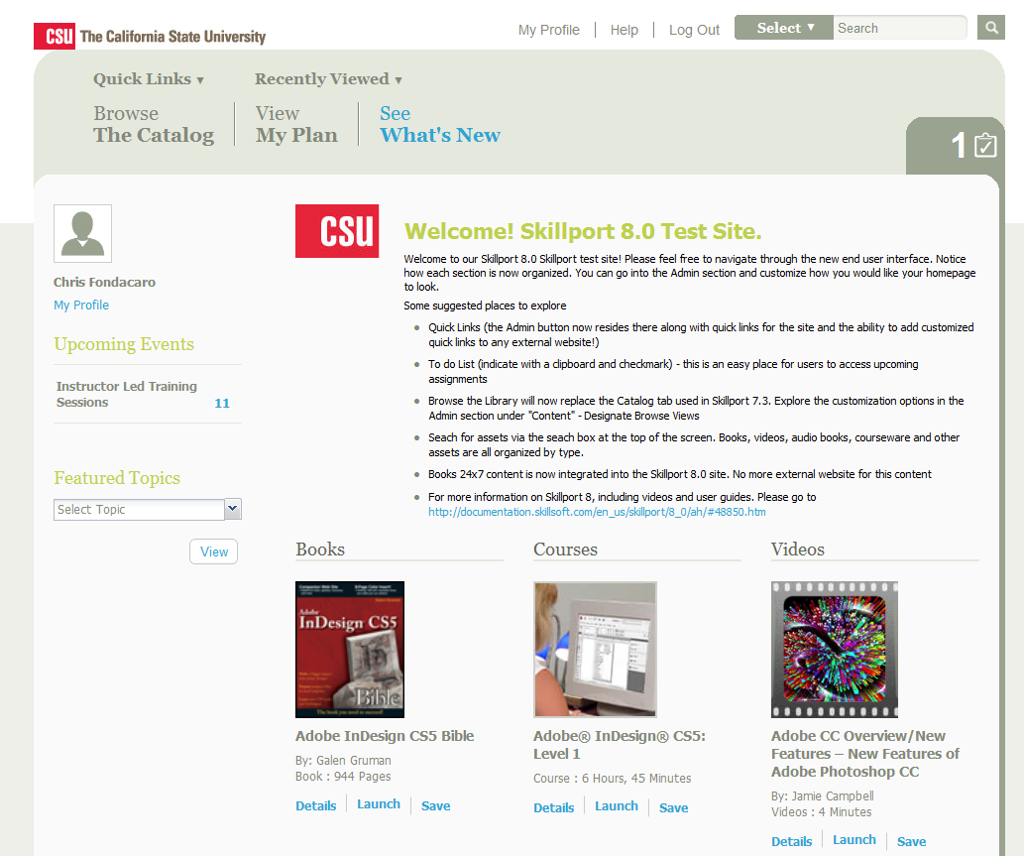+

**LAUNCH:** Launch any course by simply clicking on the “Launch” button. Make sure your internet browser’s pop-up blocker is disabled or the course will not launch.

**CHECK YOUR TO DO LIST:** Click the **To Do List** to find out if you have upcoming or overdue items in your learning plan.

**VIEW UPCOMING EVENTS:** Find out about upcoming Live Events and Instructor Led Training (ILT) sessions under **Upcoming Events**.

**EXPLORE FEATURED TOPICS:** Content that your organization wants to feature can be listed in the **Featured Topics** dropdown. Click on a selection in the drop down to view more details.

**SAVE CONTENT:** Found some great learning content? Click **Save** to save it to your My Plan so that you can easily return to it later. Users can also create sets in their learning plan to help organize their content.