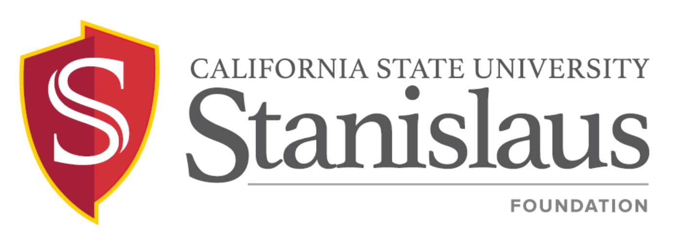
Finance and Investment Committee Meeting

Thursday, September 19, 2019
2:00 p.m. - 4:00 p.m.
President’s Conference Room, Suite 390
Mary Stuart Rogers Educational Services Gateway Building

PUBLIC NOTICE AND AGENDA

- CALL TO ORDER  - APPROVAL OF MINUTES  - May 30, 2019  - DISCUSSION ITEMS  - Update on Workgroup Activity  - CSU Foundation Partnership  - Account Executive Change  - Retaining an Educational Consultant/RFP Coordinator  - Request for Proposal Timeline (Attachment III-B)  - MSSB Capital Markets Commentary Report as of June 30, 2019  (Attachment III-C)  - MSSB Endowment Fund as of June 30, 2019 (Attachment III-D)  - MSSB Non-Endowment Fund as of June 30, 2019 (Attachment III-E)  - Audited Financial Statement as of June 30, 2019 (To Be Distributed)  - ACTION ITEM  - Educational Consultant Contract  - ANNOUNCEMENT  A. Next Meeting Date: Thursday, November 21, 2019, 2:00 p.m. – 4:00 p.m., President’s Conference Room, MSR Suite 390  - ADJOURNMENT | Bizzini  Bizzini  Bizzini  Stephens/Lahti  Stephens  Nelson  Nelson  Nelson  Nelson  Bizzini  Stephens  Bizzini  Bizzini

