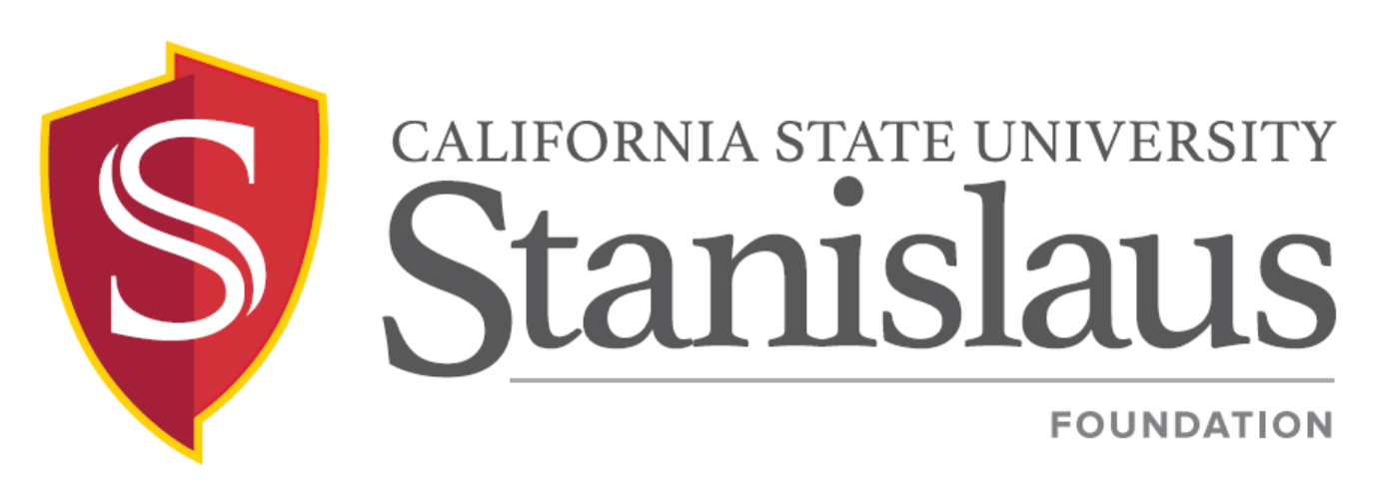
Finance and Investment Committee Meeting

Thursday, November 21, 2019
2:00 p.m. - 4:00 p.m.
President’s Conference Room, Suite 390
Mary Stuart Rogers Educational Services Gateway Building

PUBLIC NOTICE AND AGENDA

- CALL TO ORDER  - APPROVAL OF MINUTES  - Foundation Finance & Investment Committee Meeting - September 19, 2019  (To Be Distributed)  - DISCUSSION & REPORTS  - Update on Workgroup Activity  - MSSB Investment Report as of September 30, 2019  - Financial Statements as of September 30, 2019 (To Be Distributed)  - Endowment Report as of September 30, 2019 (To Be Distributed)  - NACUBO and Fee Administration Policy  - ANNOUNCEMENT  A. Next Meeting Date: Thursday, March 5, 2020, 2:00 p.m. – 4:00 p.m., President’s Conference Room, MSR Suite 390  - ADJOURNMENT | Bizzini  Bizzini  Bizzini  Stephens/Lahti  Au  Stephens  Nelson  Nelson  Bizzini  Bizzini

