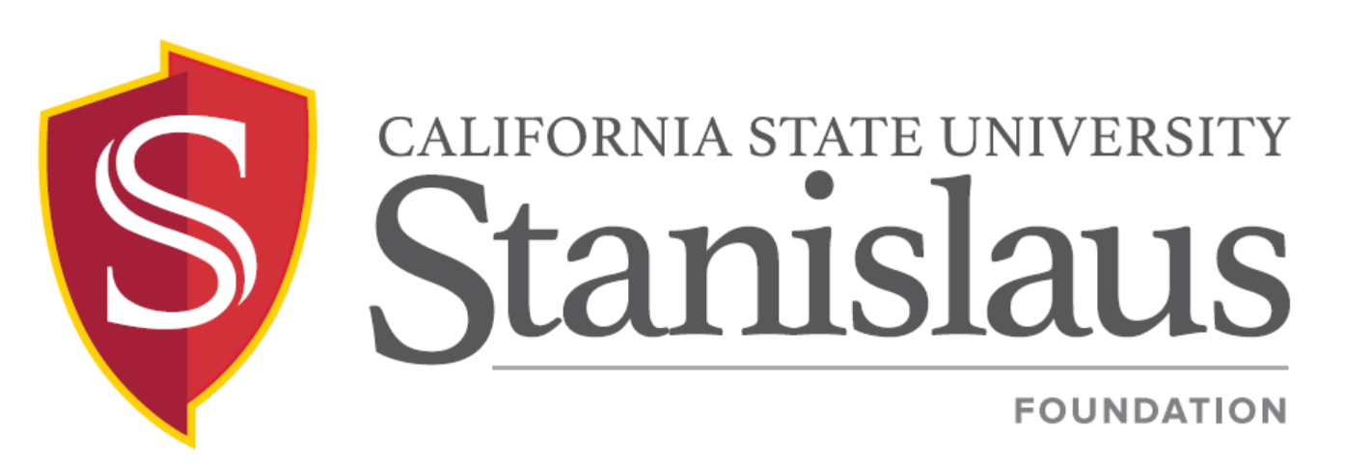

Board of Directors Meeting

Thursday, September 27, 2018
3:00 p.m. – 5:00 p.m.
Del Rio Country Club
801 Stewart Road, Modesto, CA 95356
(Meeting Hosted by John Jacinto)

PUBLIC NOTICE AND AGENDA

- CALL TO ORDER AND INTRODUCTIONS | Jacinto
- APPROVAL OF MINUTES  Foundation Board Meeting – June 7, 2018 (Attachment II-A)  - UNIVERSITY INITATIVES/UPDATES  - In Memoriam  - Warrior All Sport Scholarship Athletic Campaign: Preparing to Compete  - International (Asia) Partnerships/Alumni Events  - 2018 Honoring the Past, Forging the Future Award  - Comprehensive Campaigns in Higher Education | Jacinto  Junn  Bizzini/Donovan  Junn/Bee  Jacinto  Lahti/Losquadro
- UNIVERSITY PRESIDENT’S REPORT  - ACTION ITEMS  - Resolutions to Approve Emeriti (To Be Distributed)  - COMMITTEE AND DESIGNATED DIRECTOR REPORTS  - Finance & Investment  - Audit  - Alumni  - Associated Students  - Faculty  - SPECIAL ANNOUNCEMENTS  - 2018 Gala Benefitting Central Valley First Generation Presidential Scholars:  Saturday, September 29, 2018  - Dr. Marvalene Hughes Student Leadership Conference:  Saturday, October 6, 2018  - John Jacinto Tennis Fundraiser:  Thursday, October 18, 2018  - Foundation Board Planning Meeting/Retreat:  Friday, October 26, 2018  - Foundation Board Directory Information Sheet (Attachment VII-E)  - INFORMATIONAL ITEMS  - Audited Financial Statements for Fiscal Year Ended June 30, 2018 (Attachment VIII-A)  - Morgan Stanley Smith Barney Investment Report as of June 30, 2018 (Attachment VIII-B)  - Endowment Reports as of June 30, 2018 (Attachment VIII-C)  - 2018/19 Meeting Schedule (Attachment VIII-D)  IX. ADJOURNMENT | Junn  Jacinto  Bizzini  Ireland, Jr.  Harrell  Marquez  Robbin/Petrosky  Harrell  Lahti  Jacinto  Jacinto  Borba  Jacinto  Jacinto

