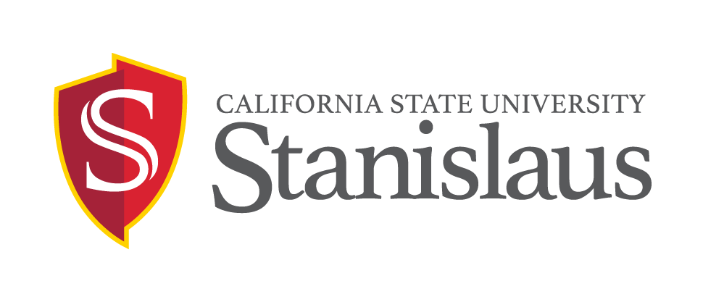
FEDERAL WORK STUDY EMPLOYMENT OPPORTUNITY

POSITION: Community Service Assistant
Temporary hourly-intermittent position available on or after January 25, 2019 and ending on or before May 30, 2019 in Office of Service Learning.

DUTIES: Under the supervision of the Director, this position will perform duties to include, but not limited to:
- Provide administrative/research support to the Office of Service Learning.
- Assist staff with community-based service programs that includes coordinating student volunteer recruitment for on- and off-campus community volunteer events.
- Create and maintain computerized database for on- and off-campus student/faculty/community volunteers for community-related events.
- Develop materials for promotion of service and service learning community events in coordination with Service Learning staff.
- Compose letters and memoranda for departmental correspondences.
- Provide on-site support at off-campus community related events.
- Frequently drive to campus and community sites.
- Perform other duties or projects as assigned.

QUALIFICATIONS:
- Undergraduate students must be registered/enrolled in a minimum of six (6) Fall/Spring Units.
- Post-baccalaureate students must be registered in a minimum of four (4) Fall/Spring units in a graduate program.
- Must meet all other eligibility requirements per the Student Employment Policies (see http://www.csustan.edu/hr/EmployeeResources/HiringStudentAssistants.html
- Ability to work with community-based programs and events.
- Able to work on a few Saturdays for campus-community events.
- Able to provide transportation to community sites as needed.
- Working knowledge of English grammar, spelling, and punctuation.
- Strong writing and verbal communication skills.
- Microsoft Office XP or higher and Excel desired.
- Possess accurate typing/word processing skills.
- Basic knowledge of office procedures including proper phone etiquette.
- Demonstrate ability to use independent judgment and initiative.
- Must be reliable and punctual.
- This is a sensitive position that will require completion of a background check (which may include: checks of employment records, criminal records, civil records, motor vehicle records, and sex offender registries, as position requires) be completed satisfactorily before finalist may start work. Failure to satisfactorily complete the background check may affect the application status of applicants or continued employment of current CSU employees who apply for the position.

SALARY: 12.00 per hour.

APPLICATION DEADLINE: Open until filled

APPLICATION PROCEDURE: Qualified candidates should submit a completed Student Assistant employment application (download electronic application at https://www.csustan.edu/hr/employment-opportunities/student-assistants) and a résumé, and cover letter in person to:

Brett Forray
Office of Service Learning
John Stuart Rogers Faculty Development Center, Room 106
Phone: (209) 667-3311
Email: bforray@yahoo.com

All sensitive positons will require that a background check (which may include: checks of employment records, criminal records, civil records, motor vehicle records, and sex offender registries, as position requires) be completed satisfactorily before any candidate can be offered a position with the CSU. Failure to satisfactorily complete the background check may affect the application status of applicants or continued employment of current CSU employees who apply for the position.

Applicants requiring necessary accommodations to the application process may contact the Human Resources Department at (209) 667-3351. California Relay Service is available at (800) 735-2922 voice and (800) 735-2929 TDD. As a federal contractor, we are committed to attracting a diverse applicant pool. Please consider completing the Voluntary Self-Identification of Disability form (your response will not be shared with the search committee) at: http://www.dol.gov/ofccp/regs/compliance/sec503/Voluntary_Self-Identification_of_Disability_CC-305_SD_Edit1.24.14.pdf.

The university is an Equal Opportunity Employer and does not discriminate against persons on the basis of race, religion, color, ancestry, age, disability, genetic information, gender, gender identity, gender expression, marital status, medical condition, national origin, sex, sexual orientation, covered veteran status, or any other protected status. All qualified individuals are encouraged to apply. CSU STANISLAUS HIRES ONLY INDIVIDUALS LAWFULLY AUTHORIZED TO WORK IN THE UNITED STATES. THE PERSON HOLDING THIS POSITION IS CONSIDERED A ‘MANDATED REPORTER’ UNDER THE CALIFORNIA CHILD ABUSE AND NEGLECT REPORTING ACT AND IS REQUIRED TO COMPLY WITH THE REQUIREMENTS SET FORTH IN CSU EXECUTIVE ORDER 1083 AS A CONDITION OF EMPLOYMENT.

iNFORMATION CONTAINED IN THIS ANNOUNCEMENT MAY BE SUBJECT TO CHANGE WITHOUT NOTICE
[01/15/19]

