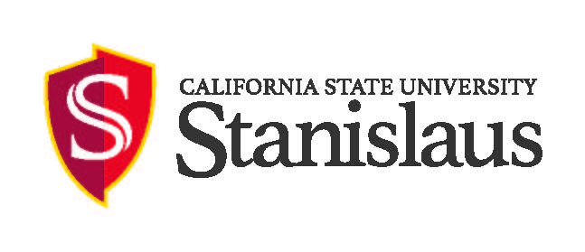
Faculty Employment Opportunity
POSITION:
Job Summary /Basic Function box on the CHRS Recruiting system
MINIMUM
QUALIFICATIONS:
PREFERRED
QUALIFICATIONS:
HOW TO APPLY  & DEADLINE: Special Conditions box on the CHRS Recruiting system | To apply for this position, please click the "Apply Now" button on this page.  If you have questions regarding the position, please contact:  Dr. [Last Name], Chair  Department of [Dept Name]  [College Name]  California State University, Stanislaus  One University Circle Turlock, CA  email: [email address]  Phone: [phone number]  This appointment begins [date or term]. Screening of applications will begin [date screening will begin] and will continue until the position is filled.  An application must include a statement of your demonstrated commitment to working with faculty, staff, and students from diverse ethnic, cultural, and socioeconomic backgrounds in addition to any other required documents as indicated above.
COMPENSATION: | Commensurate with qualifications and experience. As a member of the 23-campus CSU System, we offer an extremely competitive benefits package.
ABOUT THE DEPARTMENT and THE COLLEGE:
CAMPUS & AREA: | California State University, Stanislaus serves the San Joaquin Valley and is a critical educational resource for a six-county region of approximately 1.5 million people. The University is fully committed to creating a culture of diversity and inclusion – one in which every person in the University community feels safe to express their views without fear of reprisal. Widely recognized for its quality academic programs, the University has 10 nationally accredited programs and 662 faculty members. 94 percent of full-time faculty holds doctorates or terminal degrees in their fields. The University offers 43 undergraduate majors, 16 master's programs, 7 post-graduate credentials, a doctorate in education and serves more than 10,000 students. New instructional facilities have been built for the unique pedagogy of professional programs, laboratory sciences and performing arts.  Stanislaus State continues to receive national recognition with its ranking as one of the best 384 colleges in the nation by The Princeton Review. The University was one of 12 public universities in the nation to be recognized by the American Association of State Colleges and Universities for demonstrating exceptional performance in retention and graduation rates. In addition, U.S. News and World Report ranks Stanislaus State in its top 10 among public universities in the West, while Washington Monthly honored Stanislaus State as the West’s No. 1 university for the money. Stanislaus State also is recognized as a Hispanic-Serving Institution (HSI) by the U.S. Department of Education.  CSU Stanislaus values shared governance: Handbook statement on shared governance
EQUAL EMPLOYMENT OPPORTUNITY | The university is an Equal Opportunity Employer and does not discriminate against persons on the basis of race, religion, color, ancestry, age, disability, genetic information, gender, gender identity, gender expression, marital status, medical condition, National origin, sex, sexual orientation, covered veteran status, or any other protected status. You can learn more about federal equal employment opportunity protections by accessing the Department of Labor’s notices: http://www.dol.gov/ofccp/regs/compliance/posters/pdf/eeopost.pdf and http://www.dol.gov/ofccp/regs/compliance/posters/pdf/Supplement_English.pdf.  Individuals with disabling conditions who require accommodation during the recruitment process may contact the ADA Coordinator at (209) 667-3159.  In compliance with federal law, all persons hired will be required to verify identity and eligibility to work in the United States and to complete the required employment eligibility verification document form upon hire.
MANDATED REPORTER PER CANRA | The person holding this position is considered a ‘mandated reporter’ under the California Child Abuse And Neglect Reporting Act and is required to comply with the requirements set forth in CSU Executive Order 1083, revised July 21, 2017, as a condition of employment.
CLERY ACT DISCLOSURE | In compliance with the Jeanne Clery Disclosure of Campus Security Policy and Crime Statistics Act, Stanislaus State annually posts the Campus Security Report. The annual report includes statistics for the previous three years concerning reported crimes that occurred on campus; in certain off-campus buildings or property owned or controlled by Stanislaus State; and on public property within, or immediately adjacent to and accessible from the campus. The report also includes institutional policies concerning campus security, such as alcohol and drug use, crime prevention, the reporting of crimes, and sexual assault. You can obtain a copy of this report at: https://www.csustan.edu/annual-campus-security-report .  Or you may request a printed copy by calling: (209) 667-3572; fax: (209) 664-7011; or email: compliance@csustan.edu.  Information regarding campus security reports at other locations can be found at: https://ope.ed.gov/campussafety/#/
CRIMINAL BACKGROUND CLEARANCE NOTICE | The university requires a criminal and/or child abuse background check to be completed for many of its new employees, current employees seeking promotional or transfer opportunities, and current employees assigned new duties. Satisfactory completion of a background check (including a criminal records check) is required for employment. CSU will make a conditional offer of employment, which may be rescinded if the background check reveals disqualifying information, and/or it is discovered that the candidate knowingly withheld or falsified information. Failure to satisfactorily complete the background check may affect the continued employment of a current CSU employee who was conditionally offered the position. Failure to consent to any background check will disqualify an applicant from further consideration. Additionally, an applicant who fails to provide the necessary information or who provides false or misleading information may also be disqualified from further consideration. Later discovery of false or misleading information related to the background check may result in the offer of employment being withdrawn or subject the employee to disciplinary action, up to and including termination.

