Read&Write Study Tools Software

Overview.
Read&Write by texthelp is a toolbar with study tools that assist with reading, comprehension, and writing. This program was purchased by Stanislaus State for its students, faculty, and staff, and is free for you to use. All you have to do is download it to your computer and sign in with your CSU Stan email address.
Here’s some of the study skills tools Read&Write has to offer:
- Text-to-speech (Read your documents and the web out loud to you)
- Dictation
- Dictionary/Picture dictionary
- MP3-Maker
- Highlighting, collecting highlights in a separate document
- Contextual spelling and grammar check

How to download Read&Write for desktops and laptops.

Beginning Steps (same for Windows and Mac)
- Visit the Read&Write download page, and navigate to and select the “Try Now” button.
- Your browser will automatically scroll down and give you a list of platforms to choose from. The options are: Android, Ipad, Windows, Mac OS, Chrome, and Edge. If you use a PC laptop or desktop that uses windows, select “Windows”.
- A dropdown menu will appear, asking you to choose which version of Read&Write you wish to download. Select, “Read & Write for Windows”, US, then select “Install”.
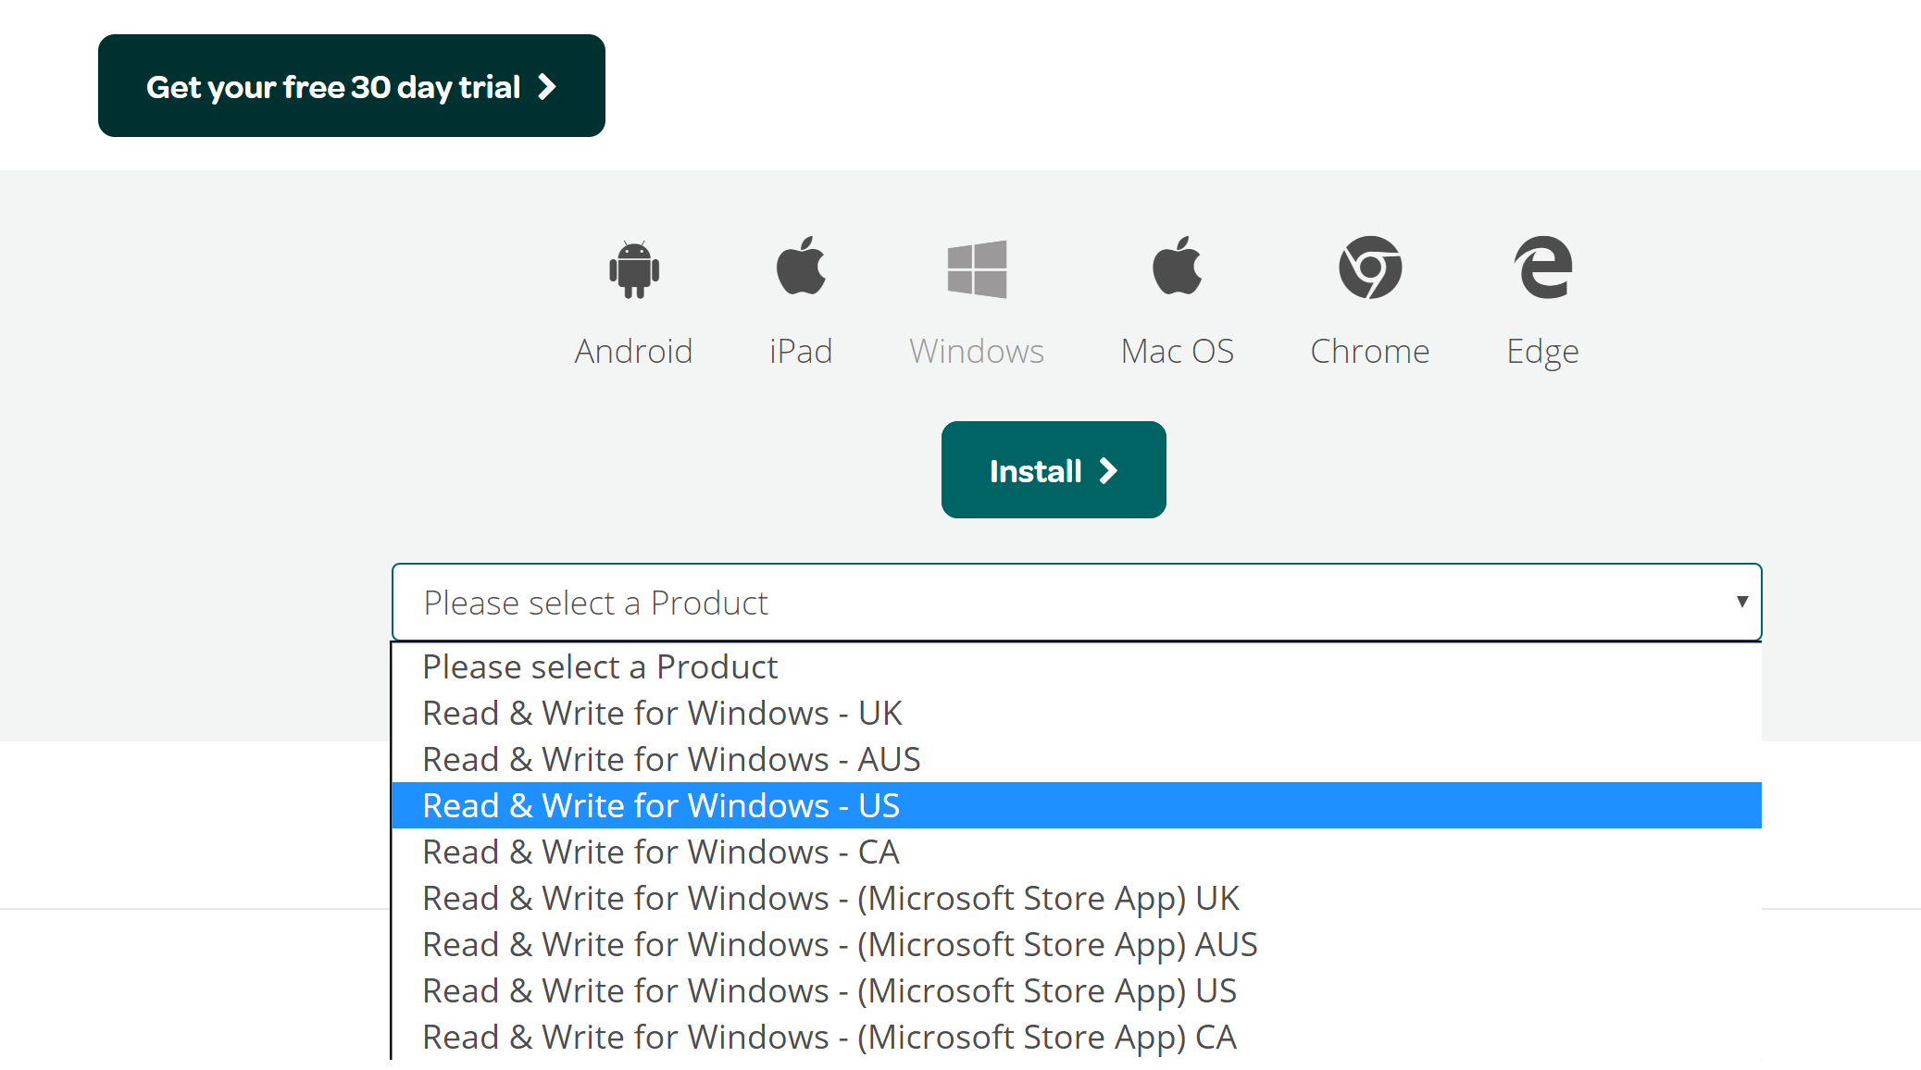
- Your download will begin automatically. 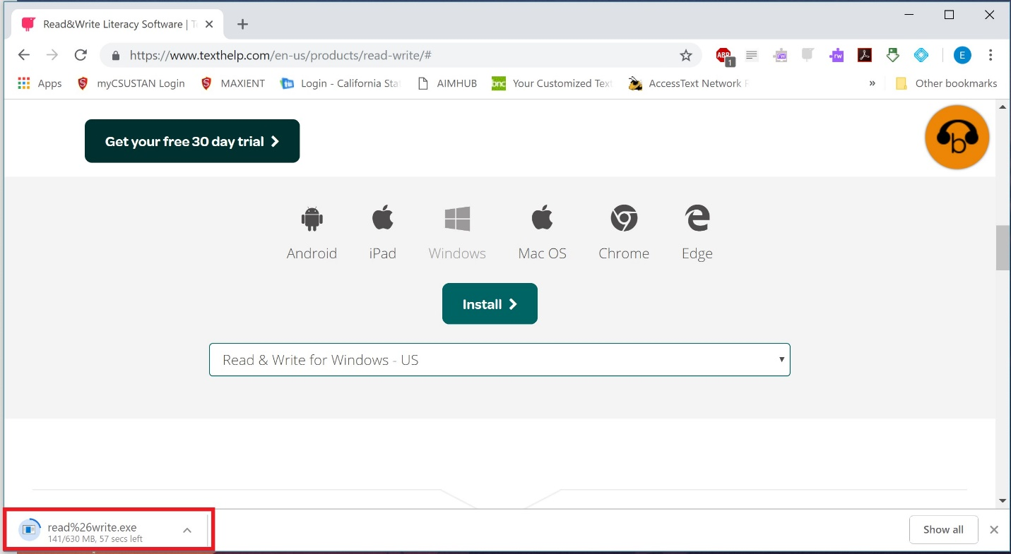
- Once your download has completed, open and run the program. 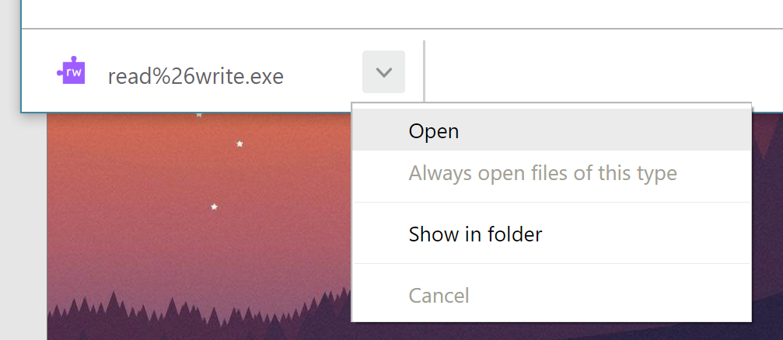
- The download wizard will automatically prepare the program for download. If you are using Windows 10, a popup will ask you if you would like to allow the program to make changes. Select “Yes”.
- You will be asked to read the terms and conditions before installing. When you are finished, select “Accept and Install”. 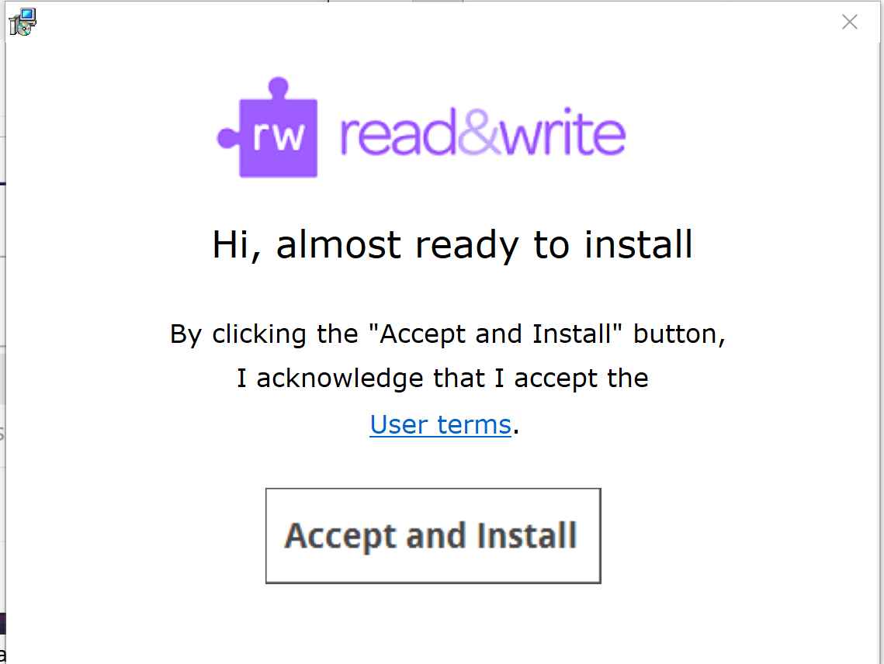
- Wait while the software installs. 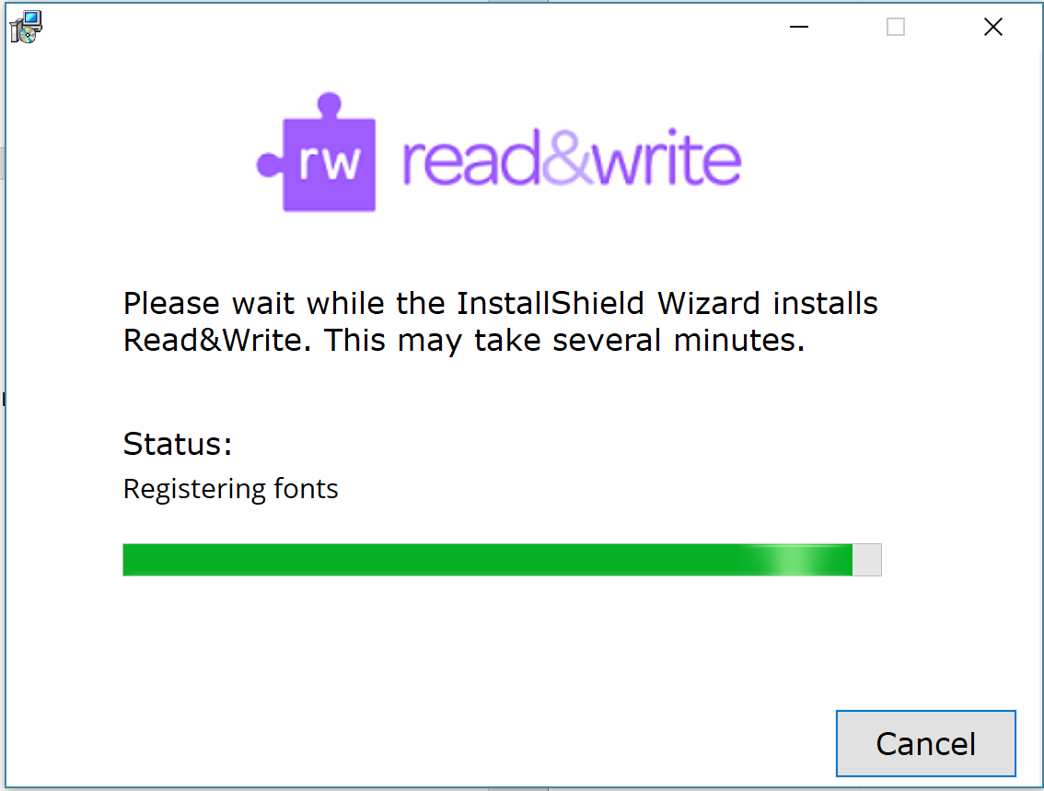
- When the installation dialogue box disappears, a shortcut should be installed on the desktop. Read&Write should also appear in your applications. Find the program and open it.

Final Steps (Same for Windows and Mac)
- When you open the program for the first time, it will prompt you to sign in. 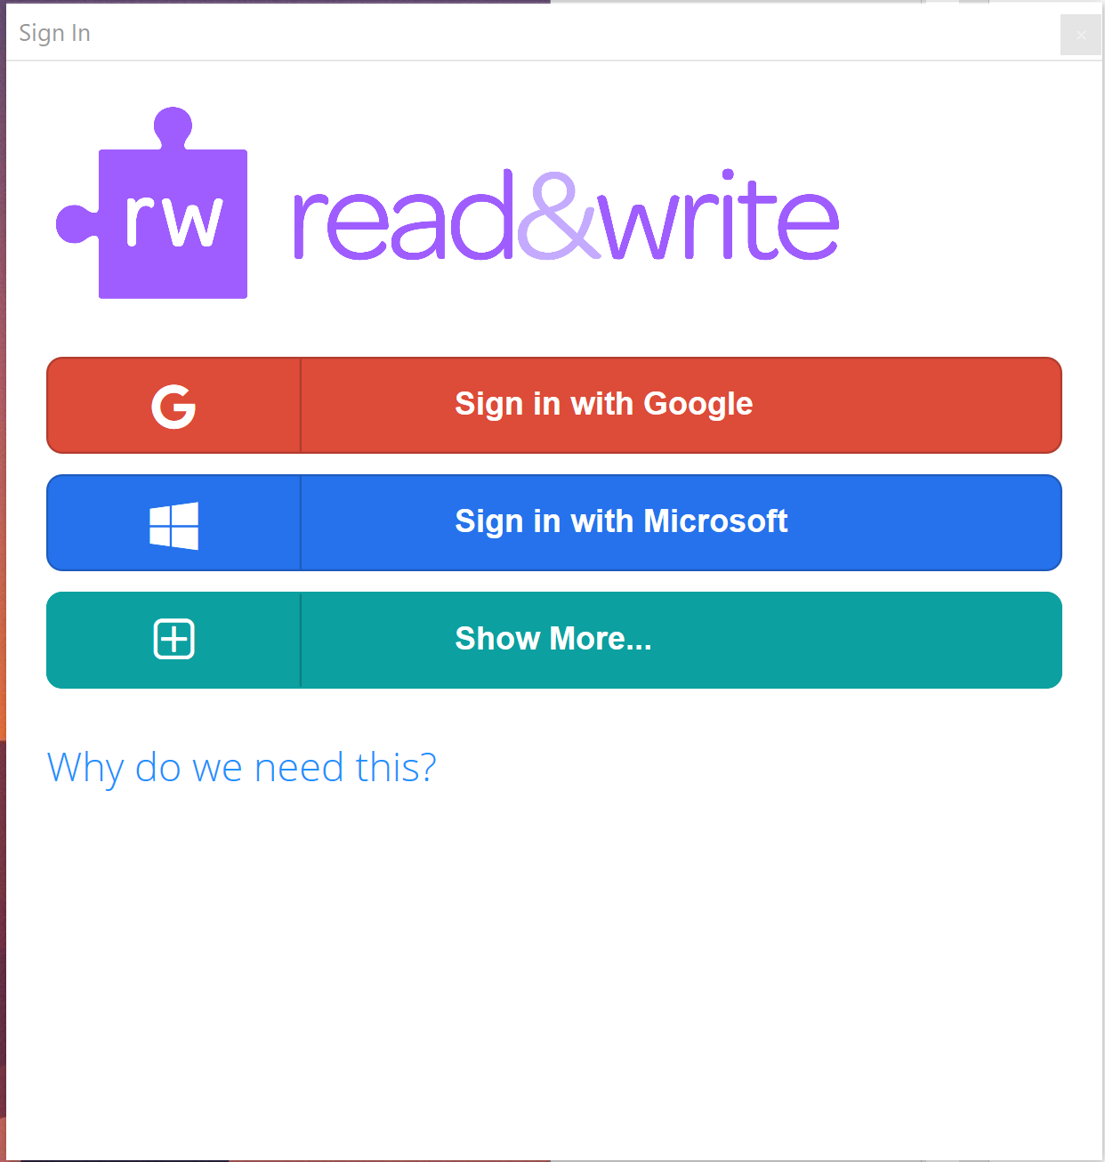
- If you are a student, you can select either Google or Microsoft. Selecting Google will open a browser page for you to sign in. Please type in your FULL CSU Stan email address, complete with “@csustan.edu”. After initial sign-in, you will be re-directed to sign in again on the Stanislaus State website. For this sign in, please enter your CSU Stan ID (Email address without the “@csustan.edu”).
- If you are a staff or faculty member, you MUST sign in with Microsoft. 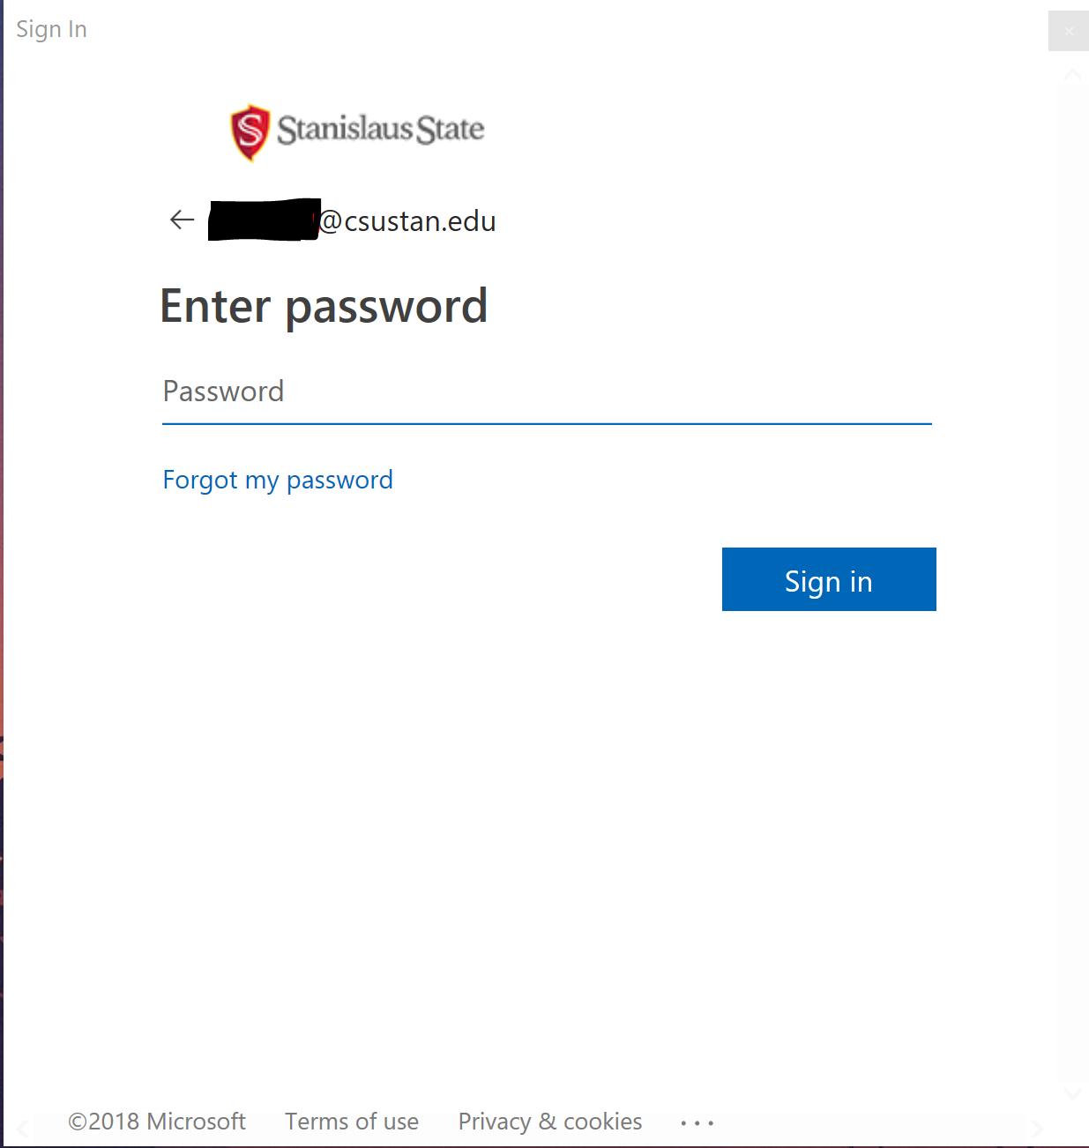
- When you are signed in, you will receive a message saying you are ready to start using the program.

