Read&Write Study Tools Software

Overview.
Read&Write by texthelp is a toolbar with study tools that assist with reading, comprehension, and writing. This program was purchased by Stanislaus State for its students, faculty, and staff, and is free for you to use. All you have to do is download it to your computer and sign in with your CSU Stan email address.
Here’s some of the study skills tools Read&Write has to offer:
- Text-to-speech (Read your documents and the web out loud to you)
- Dictation
- Dictionary/Picture dictionary
- MP3-Maker
- Highlighting, collecting highlights in a separate document
- Contextual spelling and grammar check

How to download Read&Write Mac.
- Visit the Read&Write download page, and navigate to and select the “Try Now” button.
- Your browser will automatically scroll down and give you a list of platforms to choose from. The options are: Android, Ipad, Windows, Mac OS, Chrome, and Edge. If you use an Apple computer or laptop, such as iMac or Macbook Pro (etc.), select “Mac OS”.
- Your download will begin automatically. 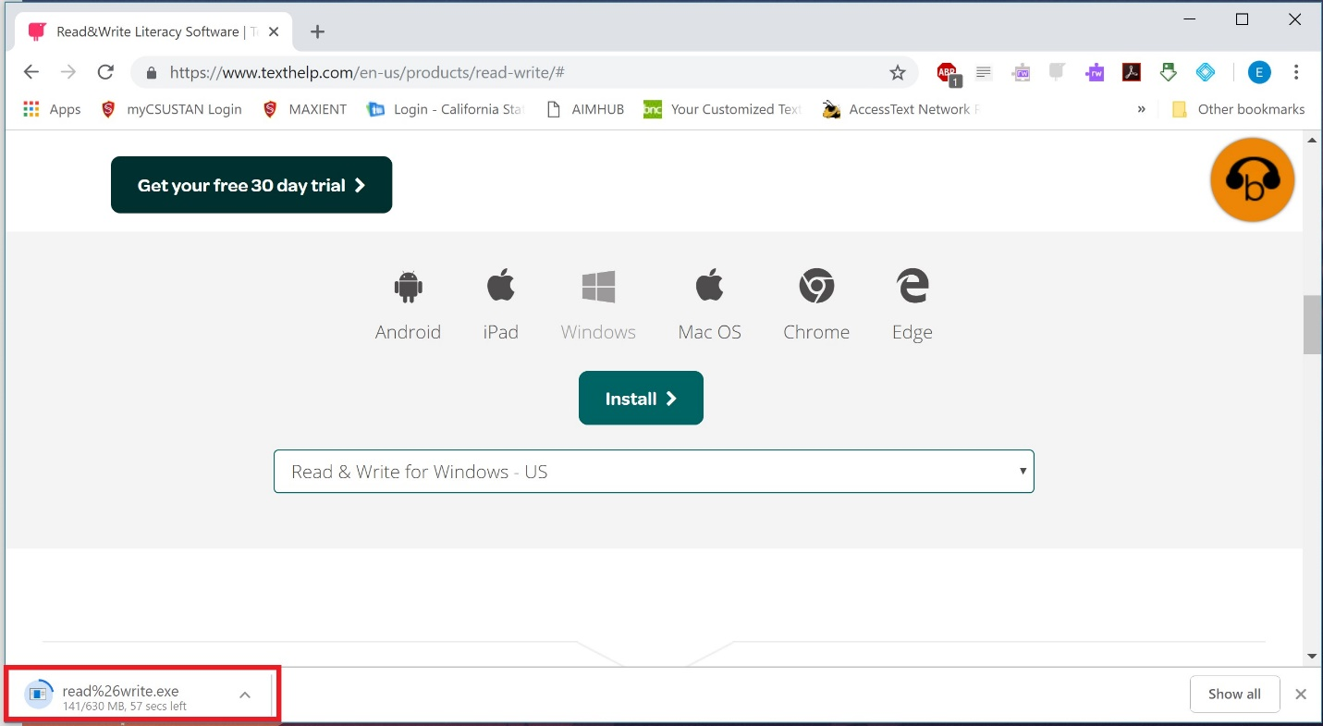
- Once your download has completed, open and run the program. 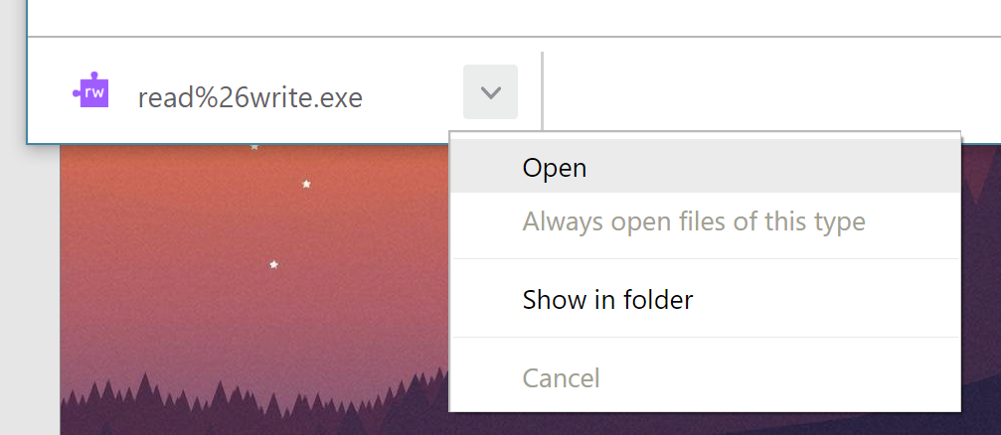
- When you open the program from your downloads on a Mac, a dialog box will pop up prompting you to drag the Read&Write Icon in to the Applications folder. Use your mouse to select the Read&Write icon. Hold down the mouse button, drag the icon to the application, and let go of the mouse. 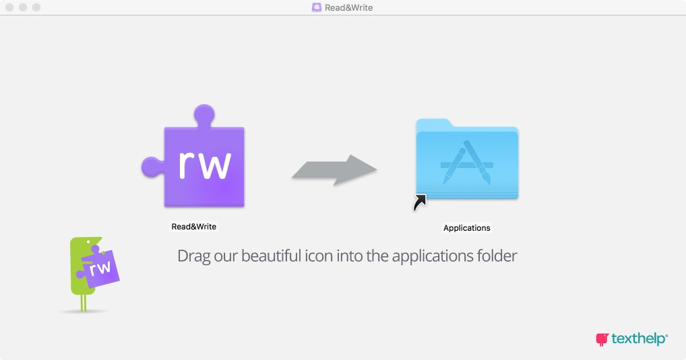
- Once this has been done, locate the Read&Write program by accessing your Launchpad and open it.
- You will be asked if you are sure if you want to open the program. Select “Open”.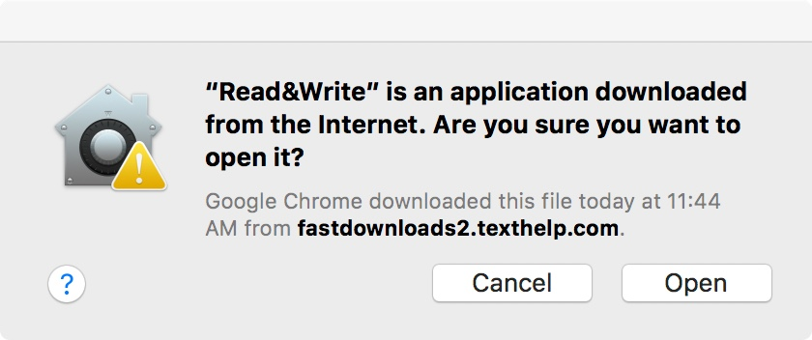
- Read&Write will appear as a small button at the top of the screen.
- Select it to expand the entire toolbar.
- When you open the program for the first time, it will prompt you to sign in. 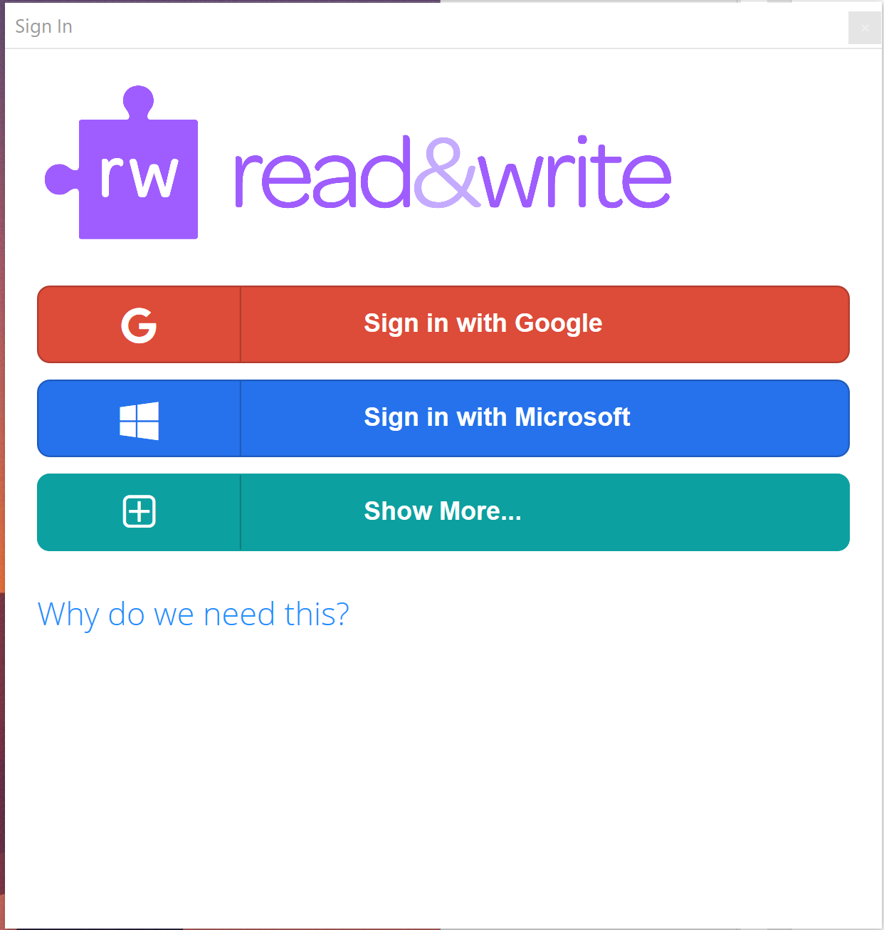
- If you are a student, you can select either Google or Microsoft. Selecting Google will open a browser page for you to sign in. Please type in your FULL CSU Stan email address, complete with “@csustan.edu”. After initial sign-in, you will be re-directed to sign in again on the Stanislaus State website. For this sign in, please enter your CSU Stan ID (Email address without the “@csustan.edu”).
- If you are a staff or faculty member, you MUST sign in with Microsoft. 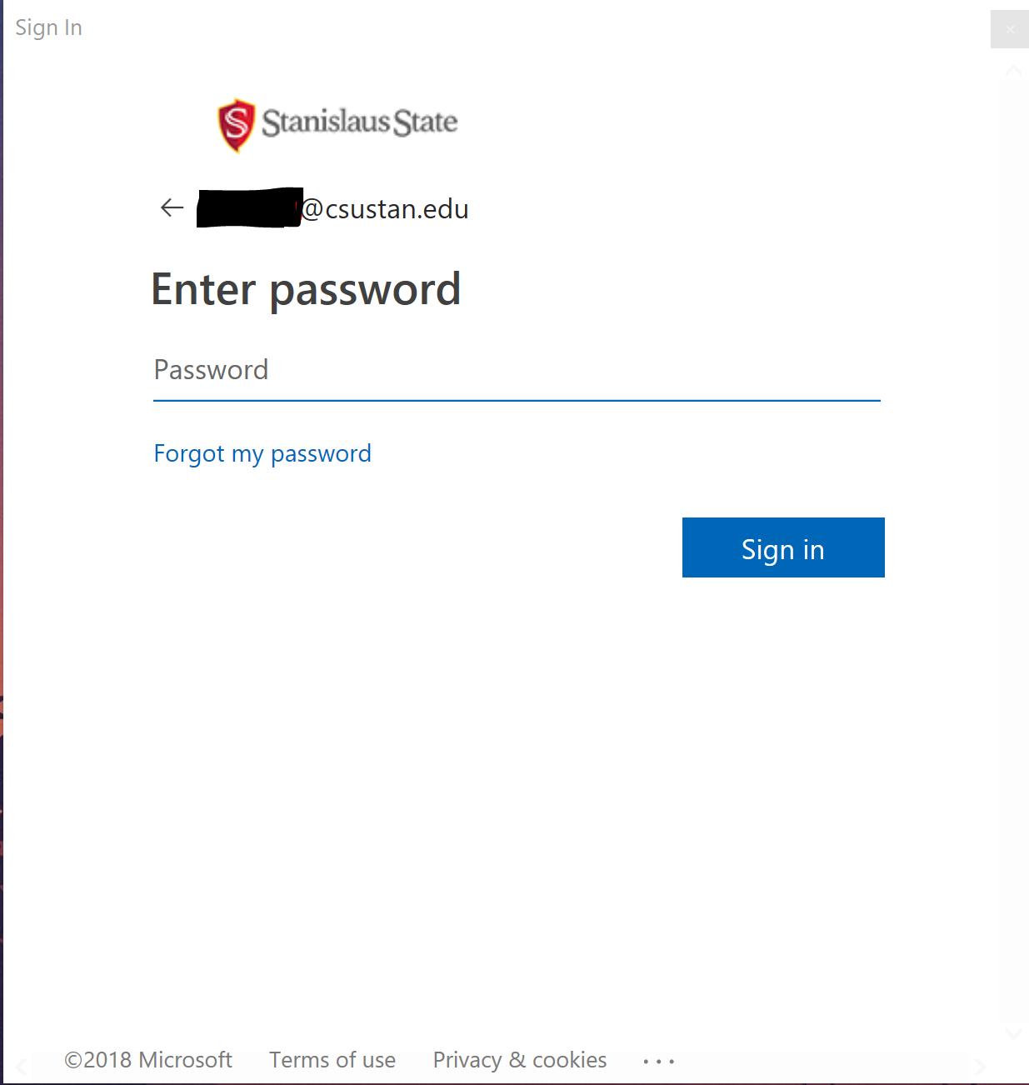
- Once you’re signed in, that’s it! You’re all set to start using Read&Write!

