Dear Student,

Welcome to the online course, ALEKS: Essential Business Skills for Business. The course covers 220 topics that the faculty of the CBA believe are essential skills for students to know for business. No tests, quizzes or homework assignments will be assigned by the instructor. You must complete all 220 topics to meet the BUS 103 prerequisite.

Before you start the course, I wanted to give you some information about what to expect throughout the course.

ASSESSMENTS
You will take an Initial Assessment when you first start the program. This assessment will gauge what topics you already know and which topics you need to learn. This will be reflected on the pie chart.

Throughout your time in the course, you will take Progress Assessments. These assessments (20-25 questions) will cover the topics you have learned. If you get the equation correct in the progress assessment, the topic will remain mastered. If you get the equation wrong in the assessment, that topic will be “unlearned” or “unmarked,” and you will have to learn it again.

I have been told by previous students that progress assessments are triggered after every 5-6+ hours you spend in ALEKS.

TOPICS/EQUATIONS
After the initial assessment is complete, you will receive a pie chart showing you which topics are already learned and which topics you need to learn. You will work on equations connected to the topic you are learning. It takes 2-3 correct answers in a row without help or explanation to have the topic marked complete or mastered.

I have a suggestion: If you are unsure of how to answer the problem or work the equation on the first problem, use the “explain” button to show you how to answer the question. This may help in getting the answers correct in a row.

Also, this program is very picky in how you present your answers. If you do not answer it completely as it asks, it will mark it wrong. Examples:

- If the answer is to be written to the hundredth position (21.01) and you write the answer to the tenth position (21.0), the answer will be wrong.
- If the problem has decimals to the tenth position and the answer is to be rounded up, but you write the answer in the tenth position (32.1) but it is to written as (32), your answer will be wrong.
COMPLETION
ALEKS is considered complete when the pie chart is 100% or you are marked as 220/220 topics learned. The instructor receives a notice from ALEKS when have completed the course, but you may contact the instructor to let him or her know you are done.

The instructor of the course will review your ALEKS record and then send an email with confirmation that the course has been completed and the BUS 103 prerequisite has been met.

OTHER INFORMATION/SUGGESTIONS
Students have asked if they have to purchase the 18-week version. This option is the recommended option to give students time to complete the course, but it is not required. (You may purchase the 6-week option if you choose.) Also, the time on your time for the course begins the moment you register, not when you take the first assessment. Take note of when you register so you do not miss the deadline of the course.

This is recommended: spend blocks of time in the program (such as 2-3 hours at a time). This may help to work through the program faster and remember the problems for progress assessments.

ALEKS: Essential Math Skills for Business

STEPS TO REGISTER FOR CLASS

- Sign into the Course
  - Go to www.aleks.com
  - Enter the Course Code: E9Y33-PLWYF
  - Hit Continue

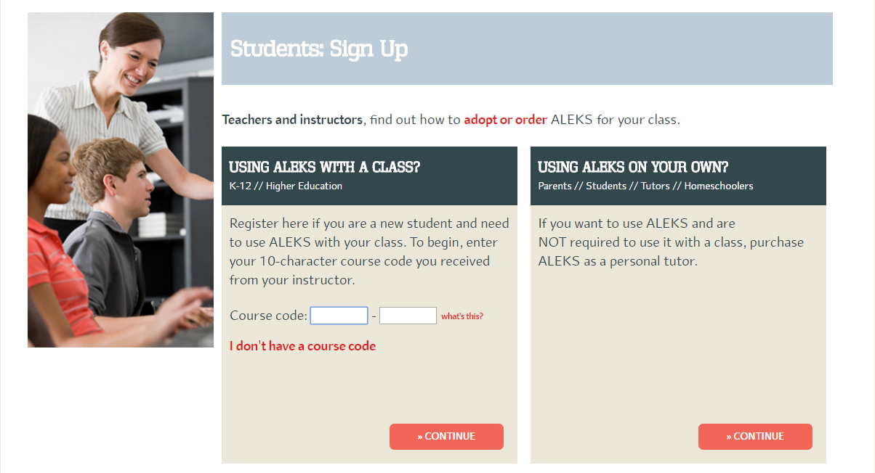

- Confirm Enrollment Information page – please make the page says the following:

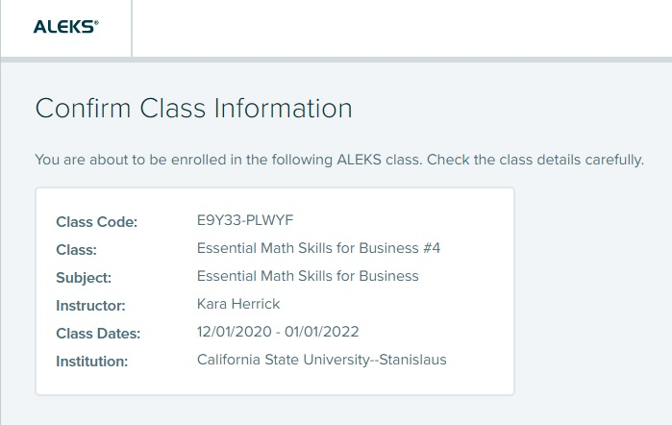

- Chose the Option: “I have never used ALEKS before”.
- Fill out the registration page with your information. Agree to the Terms of Use and continue.
- Click on “No, I need to purchase an Access Code”

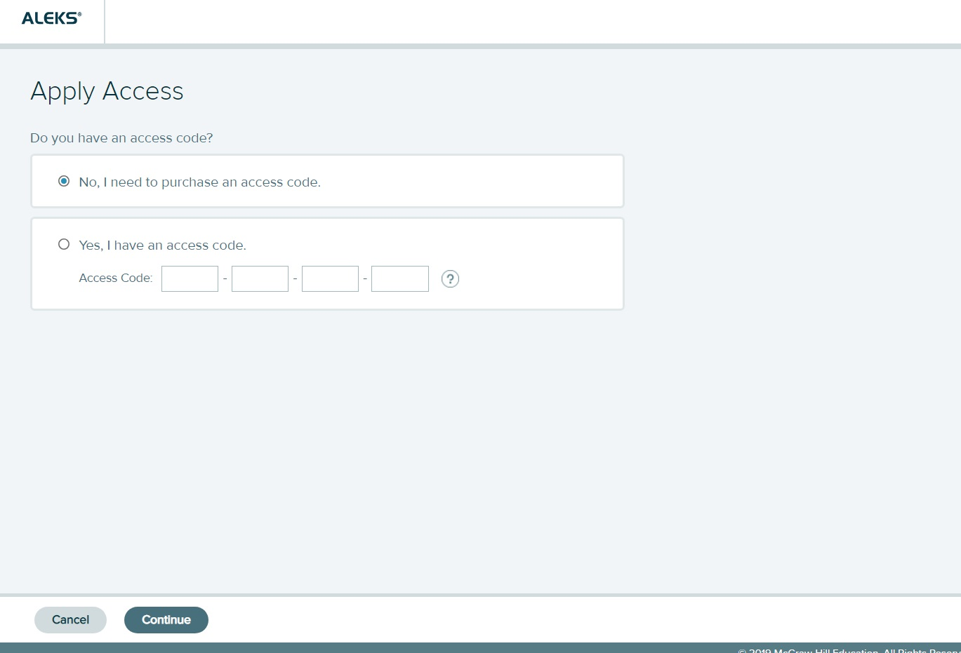

- Choose your access code here. The recommended access length is 18 weeks, but you may purchase the 6 weeks option. Costs of the product will vary depending on the time length option. Prices are subject to change by the company.

Any questions: Contact Kara Herrick at kherrick@csustan.edu or 209-667-3282

