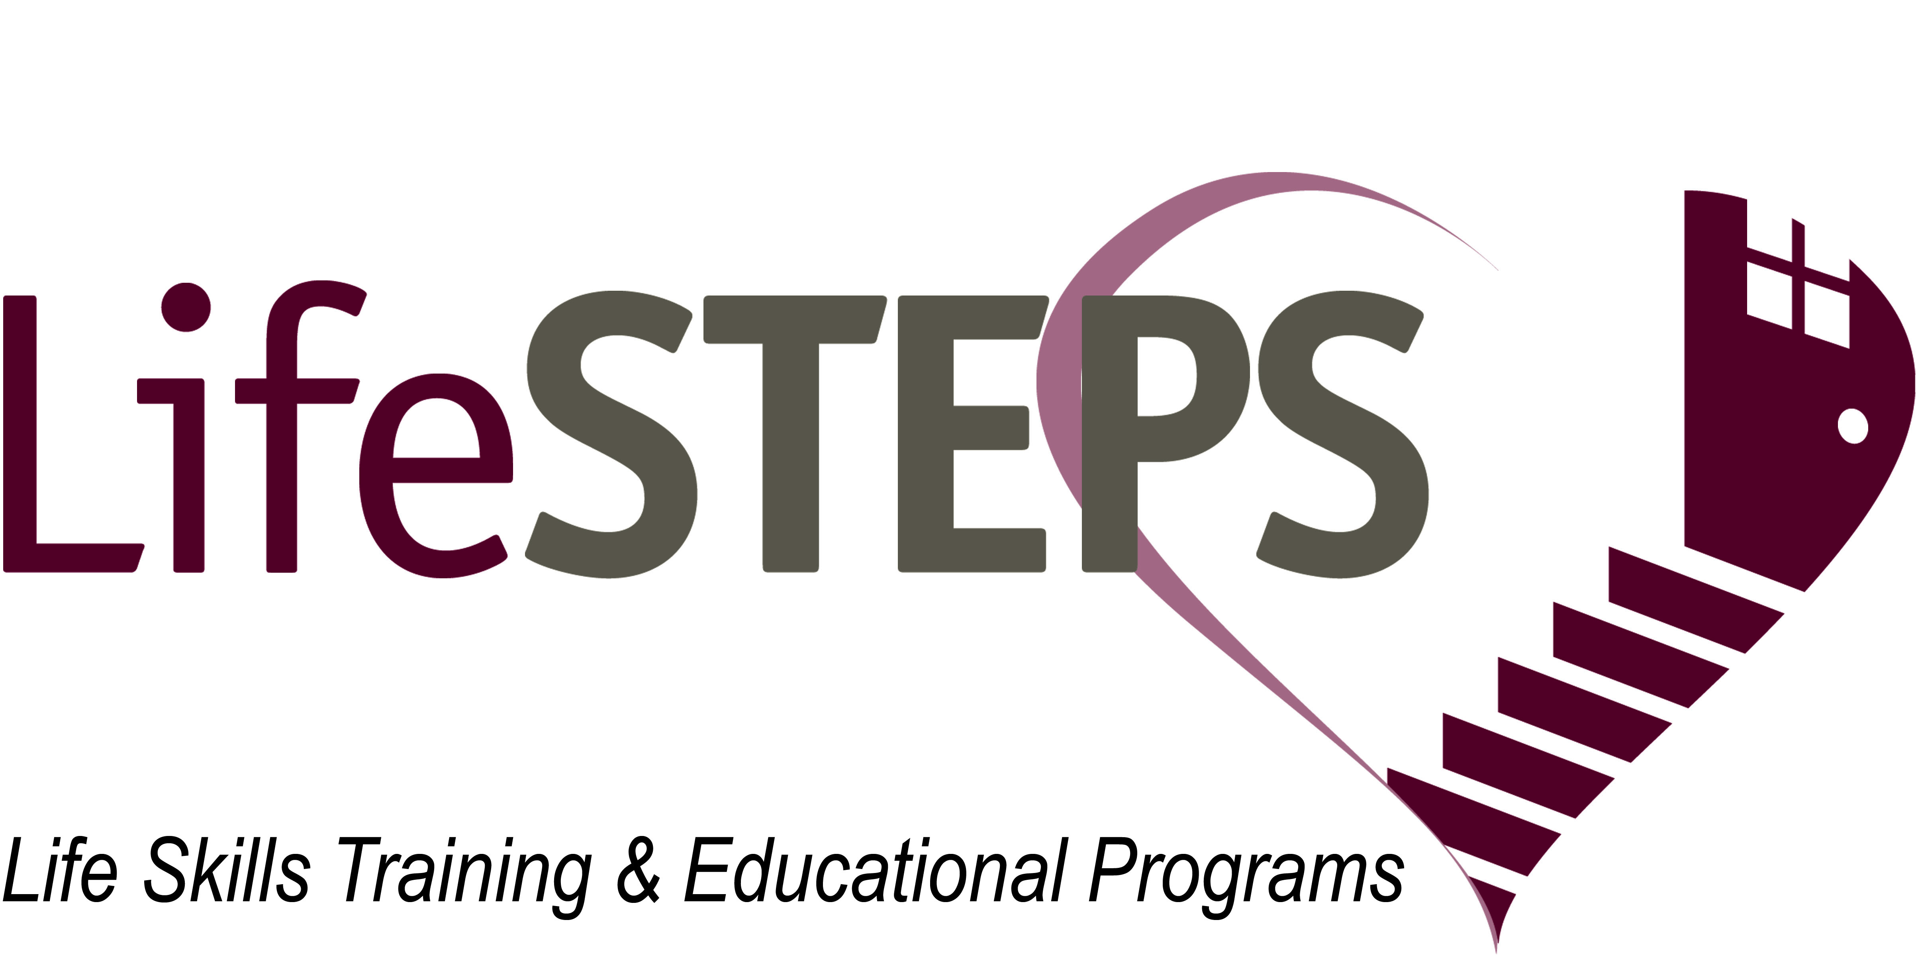

WE ARE HIRING!
PROGRAM COORDINATOR
We are LifeSTEPS: Life Skills Training & Educational Programs. We are a provider of social services to seniors and families residing in affordable housing communities. Our commitment is to provide consistent, professional, and caring educational and social serivce programs that empower and impact the community.
The PROGRAM COORDINATOR – YOUTH LEADER designs, implements, and coordinates activities following the After School Program and/or Teen curriculum for program participants within assigned affordable housing complexes.

WE ARE HIRING FOR THE FOLLOWING PROPERTY LOCATIONS:
Mustang Peak

APPLY TODAY!

To apply, please email resume and cover letter in PDF format to centralrecruit@lifestepsusa.org
For more information please contact Michelle at 510-909-1874 or michelle@lifestepsusa.org

Visit our website www.lifestepsusa.org

MINIMUM

requirements:

HS Diploma Required

Degree Preferred

Computer Skills

2 Years of Experience

Providing Services to Children

SACRAMENTO | CENTRAL | BAY AREA DESERT | LA SOUTH | LA VALLEY | SOUTH BAY

