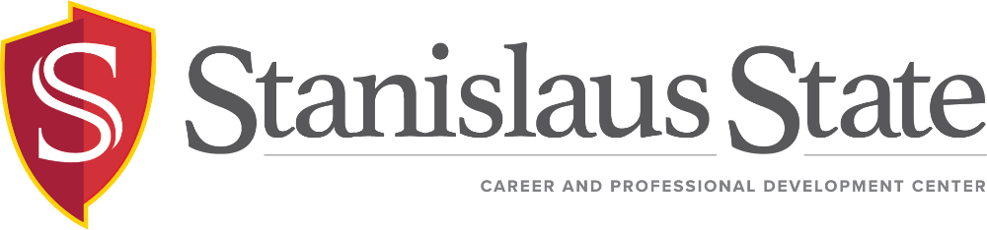 SPRING 2018 Program & Event Calendar
Career Coaching | Career Education | Career Connections
Drop-In  - Need quick career tips? Career Coaches provide coaching on a variety of topics including: job/internship search strategies, interviewing tips, grad school, choosing a major, finding a career with your major, career planning, enhancing your resume, and more.  TU & W 1:30 – 3PM  Due to other events, there will be no drop-ins on 2/27, 2/28, 4/12  By Appointment  - Schedule an appointment by  calling (209) 667-3661 or  emailing career@csustan.edu.  Stockton Campus  - Drop-In is available on Thursdays from 1pm-2:30pm  - By Appointment – follow above instructions and indicate Stockton Campus. Appointments held at Stockton campus are currently available on Thursdays only.  - Workshop Series – Thursdays 3:30-4:30pm (see workshop schedule) | Workshop  - RESUME 101: Discover these proven strategies for effectively presenting yourself on paper to employers.  - Career Fair Success: Get ready to impress! Learn helpful tips and valuable skills to prepare for the Career & Internship Fairs  - Exploring Majors & Careers: Discover a major that’s a good “fit” for you, along with methods and resources for exploring areas of study at Stan State.  - Start Smart Salary Negotiations: Learn to negotiate your salary and resources to conduct market research to benchmark a target salary. In partnership with AAUW.  - Job & Internship Search: Gain job search strategies and techniques that are key to finding a job or internship.  - Interviewing Success: Preparation is key to interview success. Learn how to prepare for answering difficult interview questions, and manage your anxiety so you can focus on answering interview questions with confidence.  - Virtual Networking | Your On-line Brand (LinkedIn): Learn how to utilize LinkedIn to showcase your skills and experiences and network with alumni. | Career & Internship Fairs  Get Connected! – Stanislaus State students and alumni are invited to meet with employers anticipating career and/or internship opportunities.  - Warrior Career & Internship Fairs  Tuesday | February 27 | 11am-3pm | MSR 130  Wednesday | February 28 |11am-3pm|MSR 130  - Spring Job Fair – Stockton Campus  Thursday | April 12 | 3pm – 6pm | Courtyard  - HIREStanState | Exclusive for Stan State Students & Alumni – An online 24/7 job and internship bank that includes part-time, full-time, summer, internship and career positions. Check frequently – New opportunities are added daily. Log in today!  - JCPenney Suit Up Event - Everything you need to finish your look for the next interview, career fair or new job – including suits, dresses, sport coats, dress pants, shoes and accessories. Exclusive discounts for Stan State students and alumni.  Saturday | April 12 | 8am – Noon | Modesto  Vintage Fair Mall

SPRING 2018 Workshop Schedule
January/February | March | April/May
Career Fair Success  - Succeed at the Teacher Recruitment Fair  Tuesday | January 30 | 3:30-4:30pm | MSR 200  - Prepare for the February Fairs  Thursday | February 22 | 3:30-4:30pm | MSR 200  Friday | February 23 | 10:00am-11:00am | MSR 130C  Monday | February 26 | 2:30-3:30pm | MSR 200  Resume 101  Thursday | February 8 | 3:30-4:30pm | MSR 200  Thursday | February 8 | 3:30-4:30pm | Stockton Ctr  Wednesday | February 14 | 11am – Noon | MSR 200  Job & Internship Search  Thursday | February 15 | 3:30-4:30pm | Stockton Ctr  OPEN HOUSE  - Stop by the Career & Professional Development Center to meet the team, discover available resources and enjoy some morning refreshments.  Thursday | February 1 | 9:00-11:00am | MSR 230 | Exploring Majors & Careers  Wednesday | March 28 | 11am – Noon | MSR 200  Resume 101  Monday | March 12 | 2:30-3:30pm | MSR 200  Thursday | March 22 | 3:30-4:30pm | Stockton Ctr  Interviewing Success  Thursday | March 15 | 12:15pm-1:15pm | MSR 200  Career Fair Success  - Prepare for the Spring Job Fair @ Stockton Campus  Thursday | March 29 | 3:30-4:30pm | Stockton Ctr  Virtual Networking-Your On-line Brand  Thursday | March 8 | 3:30-4:30pm | Stockton Ctr  Tuesday | March 20 | 10:30-11:30am | MSR 200 | Exploring Majors & Careers  Monday | April 16| 2:00pm-3:00pm| MSR 200  Thursday | April 26 | 11am – Noon | MSR 200  Job & Internship Search  Wednesday | April 8 | 11:00am-Noon| MSR 200  Resume 101  Monday | April 23 | 2:00pm-3:00pm| MSR 200  Equal Pay Day:Salary Negotiations  - April 10th is Equal Pay Day 2018, representing the additional calendar days that the typical woman must work to earn the same amount as the typical man. All are welcome to attend.  Tuesday | April 10 | 2:00-4:00pm | MSR 130  Interviewing Success  Thursday | April 19 | 3:30-4:30pm | Stockton Ctr  Networking  Thursday | April 26| 3:30-4:30pm | Stockton Ctr

