Permission Numbers Guide

Contents
Introduction 2
When to use Permission Numbers 2
Permission Numbers Process 3
Navigating to PeopleSoft 4
Navigating to the Permission Numbers 5

Introduction

This guide provides instruction on navigating to the PeopleSoft and accessing Permission Numbers.
Permission Numbers are used to allow students add themselves to your courses. This guide explains how to use this feature through myStanState. Permission numbers expire on the last day to register for classes due to the students being assessed a late registration fee.
When to use Permission Numbers
Permission numbers should be given to students at any point in the registration period until the last day to add for the following:
- Any course that is flagged for “Instructor Consent Required” and is not a class that requires a Special Registration or Individual Study form.
- Any course for which the student does not meet the major or class level prerequisite.
- Classes that are full. If the class is not full, students can continue to register without a permission number based on dates outlined for that term.
- During the Instructor Signature Required period, until the Last Day to add date.

Permission Numbers Process

Enrollment Services generates 30 permission numbers for every class/section prior to the beginning of each term. Each faculty member will be able to see the permission numbers for their classes/sections through myStanState Faculty Center.
If a faculty member runs out of permission numbers, they can contact Enrollment Services at 667-3264 for additional numbers.
Once the student registers using the permission number, the student’s name will be seen in the Faculty Center tool. Permission numbers can only be used once per student.

Navigating to PeopleSoft

The Enrollment Requirement Rosters are accessible from within PeopleSoft. You can navigate to PeopleSoft using the links found on your myStanState dashboard.
Using your preferred internet browser, navigate to my.csustan.edu and log in using your Stanislaus State credentials. You will be prompted to log in using Multi-Factor Authentication (MFA). For more information or help with issues involving MFA, please contact OIT.
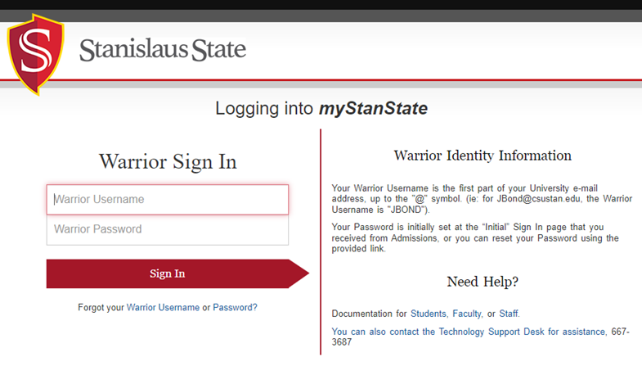
Upon logging in, you will see your Employee Dashboard. Scroll down and locate the box within your Employee Dashboard with the header labeled PeopleSoft. Within the Peoplesoft box will be a header labeled PeopleSoft Single Signon. Click the link below this header labeled MyStanState Student Center to navigate into PeopleSoft.
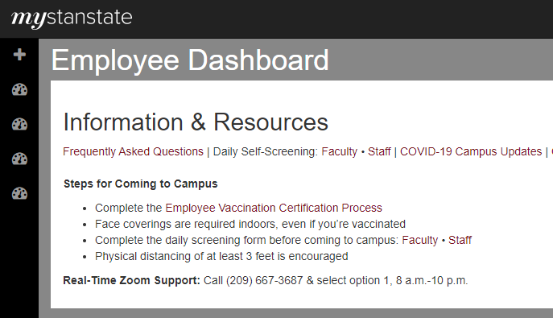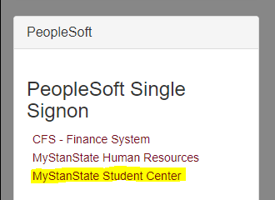

Note that the PeopleSoft link will open a new tab or window. If you have a pop-up blocker, you may need to disable it in order to allow the window to open. You may also be prompted to log in again with your Stanislaus State credentials.

Navigating to the Permission Numbers

After logging into PeopleSoft, you will land on the Instructor Homepage. Click on the tile labeled Classic Home.
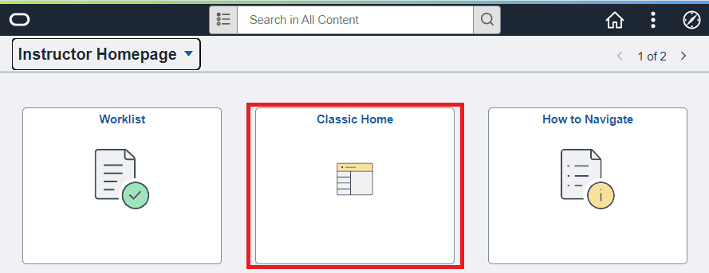
By clicking Classic Home, you will be navigated to your Faculty Page. Click the link in your Faculty Center labeled Class Roster.
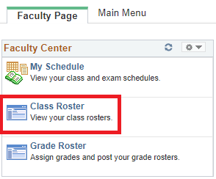
The Class Roster page will display information for your class section, including the Term, class subject and catalog number, section number, and schedule.
Confirm the information on this page, double-checking to ensure you are on the class roster for the section to which you want to provide permission numbers for.
If you are not seeing the section you intend to provide permission numbers for, click the Change Class button located to the right of the section information.
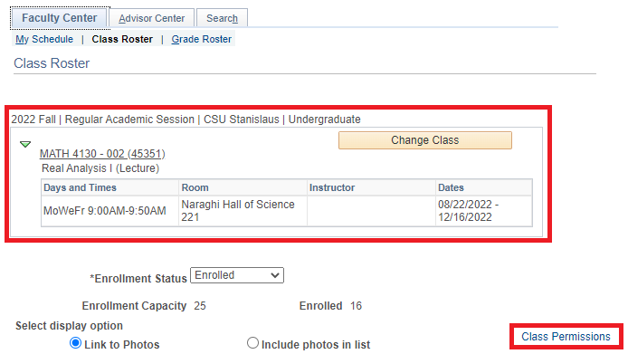
Once you have confirmed you are on the correct class roster, click the Class Permissions link to access the permission numbers for this section.
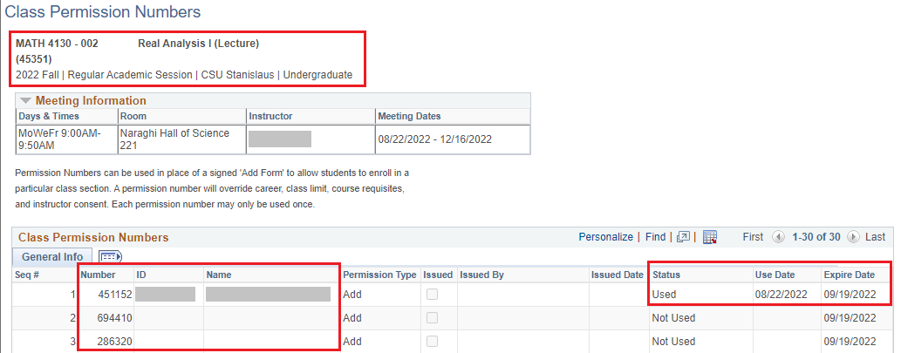
Once again, confirm the section information at the top of the page. Permission numbers are displayed in the table at the bottom of the page. The 6-digit permission number is located in the Number column—this is the number you would give to a student for enrolling in your section.
Permission numbers can only be used once. When a permission number has been used by a student, the student’s information will populate in the ID and Name columns. Additionally, the Status of the number will change to Used. The date the permission number was used by a student will populate in the Use Date column. Permission numbers cannot be used after the date displayed in the Expire Date column.

