Humboldt State University
SPA
(Schedule Planning and Analysis)
Users Guide

Contents
Introduction 3
Users and Permissions 3
Start the Program 3
Term and Department 4
Pre-Poluated Date from Prior Terms 4
Add or Delete Pre-Loaded Classes – not available to read only permissions 5
Add a New Class 5
X-List Box 5
Title Field 6
GE Field 6
Units Field 6
Instructor Field 6
Faculty Type 8
Team? Box 8
Mode Field 9
Cap and Estimated Fields 10
Enrollment Field 10
Calculations 10
Show Notes and Show Times Button 10
Show Notes Field 10
Show Times Field 11
Days 11
Hour 11
Minutes 11
Weeks 11
More 11
Hybrid 11
Online 11
Conformation to scheduling guidelines 12
Assigned Time and Collateral Duties Form 12
Update from CMS 13
Reports 13
Shortcuts and Other Tools 15
REVISION CONTROL: 17

Introduction
SPA, Schedule Planning and Analysis, is a Database designed to replace the college scheduling workbook used in the past. Effective with the start of 2013/14 academic year planning all departments will enter their proposed courses and assigned time into the database, which will produce reports based on this data.

Users and Permissions
In order to access SPA, a user must first log into a campus workstation using an HSU username that has been added to SPA by an Administrator. By default, every SPA users has View-only permission for all departments. This allows them to see the class schedule for any departments and to run a number of reports. However, unless a user has specifically been granted Read or Write permissions for a particular department, they may not make any changes to the schedule or view prospective instructor assignments.
Administrators are special SPA Users who have the ability to add other users to SPA. Ordinarily, college budget analysts are the administrators for the departments within their college. In addition to creating users, administrators have the ability to grant Read-only or Write permission to other users for the departments that they control.

An administrator may grant Write permission for the departments in their college to any users. A user with Write permission may view and change any part of the schedule of classes for their department(s). They also may add or change instructor data and assigned time/collateral duties. All reports about their departments are available to users with Write permissions. Generally, department coordinators are granted Write permission to the departments they manage.

An administrator may designate a user’s permissions to particular department(s) to be Read-only. In this case, the user can see all the data and reports for the department(s) specified, but may not make any changes. This access may be given to department chairs or others who use the program infrequently and are more likely to make accidental changes.

Start the Program
To start the program, click the shortcut on your desktop to launch. (Instructions for creating this shortcut will are available from your administrator.) The program will detect who is logged onto your computer and open in the class schedule form, to the term, college, and department associated with your user ID. The screen you will see depends upon your permission; examples:

Read-only and Write Permissions (read only permission will not have the + and – buttons on the left):
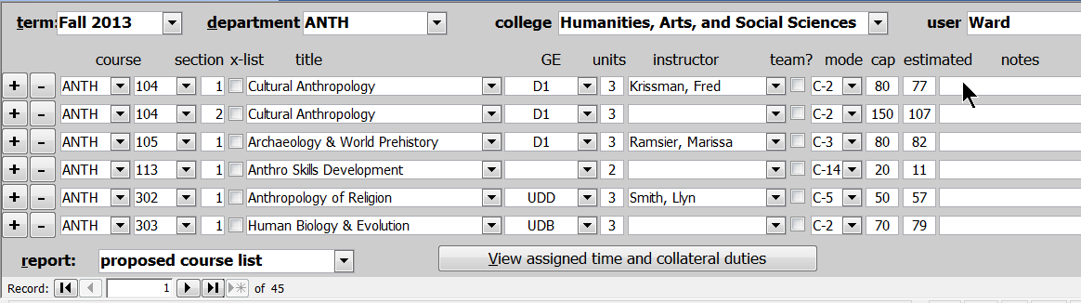
Courses for the department for the semester are reported on this form.
Users without Read-only or Write permission will have limited data available:

Term and Department
This field is found in the upper left of the form. You may change the term field to work/view Fall or Spring term. You may also change the department field, which is to the right of the term field.

Pre-Poluated Date from Prior Terms
Around mid-September of each year, the following academic year’s data will be populated with prior-term data that has enrollment; prior term data will be ‘rolled’ from PeopleSoft. For fall semesters, this means that prior fall term will populate next year’s fall data. For spring semesters, this means that two prior spring terms will populate next year’s spring data.

For example, in mid September 2014, SPA will roll fall 2014 data into fall 2015 and will roll spring 2014 data into spring 2016. It does not roll spring 2015 data to spring 2016 because spring 2015 does not yet have any enrollments.

Add or Delete Pre-Loaded Classes – not available to read only permissions
The database will roll entire year’s schedule from past year in SPA, fall to fall term and spring to spring term, during the last week of September of current year. Prior to roll, SPA data will need to be cleaned up (more will be coming separately about what this means).

You may add or delete classes by clicking the + and – buttons to the left of each row. If you add a class, Access will copy the class from the row next to the + button, change the section to the greatest section number for that class plus one, and position the cursor in the instructor field, so that you can choose who will teach the new section.

Each course consists of a unique combination of subject, number, and section. You may only select subjects taught by the department selected. You may select from any class number that has been taught in the past; if you wish to enter a new number (add a new class) see next step.

Add a New Class
When entering a new class, enter the course number, title, GE requirements met by this class, units, mode, enrollment cap, estimate of enrollment, and any notes that you wish to make. Details on all fields are discussed on the following pages.

X-List Box
Cross-listed classes are those that have two or more entries (classes) in the database, but are actually only a single class. Click the x-list checkbox on a line to create a cross listing. You will see a form like this:
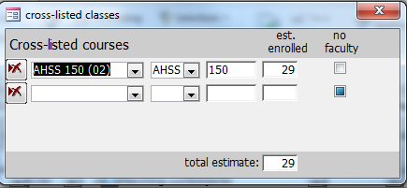
You may choose an existing class to cross-list by selecting it from the drop down menu in the next row. If the other class does not yet exist in the database, you may simply enter the subject and number. Enter the estimated enrollment for the other section. The estimated enrollment on the main schedule form should be the estimate for that part of the cross list. For example, a class with a cap of 30 that expects to have 20 students from your department and 10 from another will have 20 entered on the main schedule form and 10 entered on the cross-list form for the other section. The actual estimate will be the sum of the two numbers. The FTES generated will split between the departments; the WTUs will be split between the departments/classes that do not have a check in the “no faculty” box.
If a class is taught by more than one professor, see guidelines for the “team?” box further in this manual.

Title Field
Clicking on the drop down arrow in this field displays all titles that have been associated with the course number in the past. You may choose one of the titles displayed or enter a new title by typing in the title box.

GE Field
This field designates all course attributes, including GE (general education) and others. For pre-loaded courses, this field should automatically populate. The only time you should change this field is when you enter a new course or the GE designation changes due to a curricular change. It is important that the GE is correctly identified and matches with the course catalog in PeopleSoft. To determine the GE designation in PeopleSoft, go to the following location in PeopleSoft:
Main menu; Curriculum Management; Course Catalog; Course Catalog (again); enter subject area (example ANTH); enter Catalog Number (example 104); click ‘search’ ; the page that appears is the Catalog Data – at the bottom of the screen in the Course Attributes section, “GE” will be listed if the course is a GE course. The data in the Course Attribute Value column is the GE designation you enter in the database. In this example the GE Designation is D1.
If the course has no GE designation, then “GE” does not appear as a course attribute and you leave the GE field blank on the database.

Units Field
The units shown in this database are the component student credit units (SCU), which may not match the SCU for the entire course. For pre-loaded courses this field should populate correctly as long as you enter each component associated with the course. For example, a course with both a lecture and a lab will be entered as two lines with total course units divided between the lines.
When entering a new course, you must enter each component in this spreadsheet with the appropriate mode or C-classification (mode field is discussed later in this guide).

Instructor Field
Note:
If you anticipate hiring current lecturers in both fall and spring semesters up to a certain workload, but do not know exactly which courses they will teach, assign them to some courses up to their anticipated workload, even though their actual course assignments may differ from the courses initially proposed. This will be useful for college budgeting purposes. Leave instructor name field blank as little as possible.
The instructor field may be automatically populated with the name of the instructor who previously taught the course. You may change the instructor by opening the drop down menu and selecting from among the instructors who are pre-loaded to the current department. Leave the field blank if the instructor is not yet known (do not enter “staff” as instructor). You may also type in the name of a new instructor. You will be asked if you want to add this instructor to the database. If you answer yes, you will see the faculty form:
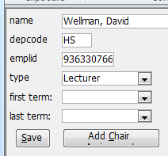
The instructor name and department code will already be filled out. If you do not know the HSU ID for the instructor, leave the ID field blank and it will automatically populate with “Dept-1” (example BIOL-1). The field can be updated at a later time once the faculty ID is known. Faculty type is automatically assigned ‘lecturer,’ change as needed to correct type.
If you want to have more than one faculty type associated with existing faculty, open the faculty table by double-clicking the faculty name; select the type you want to add. A pop-up window will appear which you should answer. This will allow multiple faculty types in SPA; please make sure you choose the correct faculty type when associating the faculty with the workload. Figure 1 shows the pop-up window for adding a volunteer. Figure 2 shows the window when changing from TT to FERP.
Figure 1: When adding a volunteer type to an existing facultt, this window appears:
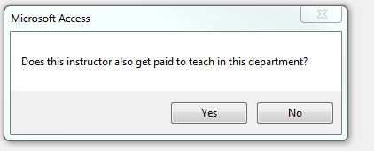

Figure 2: When adding a paid assignment to an existing paid assignment (example: TT to FERP), this window appears:
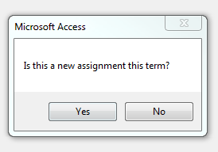
Generally, with the exception faculty who are also department chairs, there should be only one type for each faculty member in each department. There will be occasions when multiple faculty types are needed. The chair faculty type should only be used on the assigned time and collateral duties form when reporting chair time. The Last Term field is used to identify the last term a faculty member will teach. You will not be able to assign a faculty member to a class in a term following their last term.

Faculty Type

Field | Class Schedule Page | Assigned Time & Collateral Duties form | Use
Chair | No | Yes | Use this designation only on the assigned time and collateral duties form to indicate WTU assigned to chair duties only.
FERP | Yes | Yes | Use to identify FERP faculty
Lecturer | Yes | Yes | Use to identify lecturer faculty
GA | possible | no | Do not use unless instructed to by your college
TT Faculty | Yes | Yes | Use to identify tenure & tenured-track faculty
TA | Yes | No | Use to identify Teaching Associates; should not have assigned time.  For an unknown TA, list “TA” as the instructor of record because leaving the instructor field blank defaults to ‘staff’ designation.
Volunteer | Yes | Yes | Use to identify  Faculty and lecturers whose volunteering has been approved by the Dean.

Team? Box
If a class is taught by more than one professor, enter the primary instructor on the main form and check the team? checkbox. This will open up the Team Teaching form and automatically add the primary instructor.
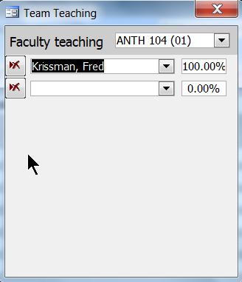
You may add and delete faculty who will be teaching the course and enter a percentage for each. If you don’t enter a percentage, the program will offer to divide it evenly between the faculty when you close this form. If only one faculty member is entered on this form, they will be deleted when the form is closed.

Mode Field
The teaching mode (aka c-classification) determines how the WTU for a particular course gets calculated. For pre-loaded classes, this field will self-populate and you will not need to enter or change this, since it has already been imported from last year’s schedule and will be copied if you create a new section. However, you can change this field if necessary due to curricular changes changing the mode or if creating a new class.
When entering a new class, you should verify the c-classification with PeopleSoft by going to the following PeopleSoft location:
Main menu; Curriculum Management; Course Catalog; Course Catalog (again); enter subject area (example ANTH); enter Catalog Number (example 104); click ‘search’ ; click third blue tab “Components”; in the right center of the page under the Course Component section is a blue hyperlink CS Number, click it; a pop-up window appears – the CS Number is the c-classification. In this example the CS Number is 02 which translate to mode C-2 on the scheduling database.
If the instructor is electing to teach the courses on a completely volunteer basis, change the mode to be S-99 in SPA and the WTU value will calculate 0 and the FTES generated will count as FTES. Please check with your college before using this feature.

Cap and Estimated Fields
For pre-loaded courses, this data will self-populate with the prior semester data. Change as needed depending on room size (cap) and estimated enrollment. If an x-listed class, refer to notes on x-listing and how to correctly enter the estimated enrollments.
For a zero enrolled course, make a note in the notes field of ‘zero enrolled’.

Enrollment Field
Enrollment Field is autopopulated. As a semester opens for enrollment, SPA will pull actual enrollment from CMS if the section and course number in SPA match the section and course number in CMS. If they do not match, SPA should be updated with the same course section number that is in CMS.

Calculations
WTU: Weighted Teaching Unit (WTU) values are calculated based on the class mode.

For C- mode courses a ‘k-factor’ multiplier is used. The k-factor varies depending on the classification.
The C-Class WTU calculation formula is: Units*k-factor=WTU.

For S- modes courses the calculation is based on the number of students in the class. Before census, the calculation is based on the greater of estimated or enrolled students. The amount of WTU per student varies depending on the classification.
The S-Class WTU calculation formula is: (# of students)*(per-student WTU value)=WTU.

FTES: Census enrollment is used for FTES calculations in past terms, and the greater of estimate or enrolled for current terms before census or future terms.

Show Notes and Show Times Button
‘Show notes’ and ‘show times’ can be accessed via the toggle button at the bottom of the screen. The button displays either ‘show notes’ or ‘show times’ depending on the screen currently active. To move between these displays, depress the button to toggle back and forth.

Show Notes Field
Use this field to make comments as useful to the department and college. These notes will print on the reports; some examples are:
- Zero enrolled (make sure to change cap and estimated enrollment to zero)
- Volunteer - TT faculty who is volunteering to teach courses as an overload and is not being balanced out in a subsequent semester.
  - Example: TT faculty teaching a 499 course
- Sabbatical replacement lecturer

Show Times Field
Use this field to enter the days, hour, minutes of class; the weeks and “more” can be utilized for partial term & online/hybrid courses. Class times must conform to the scheduling guidelines.

Days
Day combinations available from the drop down box conform to the day options currently available from the scheduling working group. Courses that are completely online can be indicated from this menu by selecting ONL.

Hour
All classes must begin at the top of the hour, except for 1.5 hour classes beginning at 7:30 AM. If you have a 7:30 AM course you should select 7AM; you will need to keep internal notes that it actually begins at 7:30.

Minutes
Keep in mind that the class should end 10 minutes before the hour (or before the half-hour for a 1.5 hour class). Enter minutes for the class; if in doubt about the amount of time the class should meet per week, guidelines are available at http://www.humboldt.edu/academicprograms/curriculum-guidelines , under course credit heading, select CSU Course Classification System.

Weeks
If a course is less than full term, indicate the total number of weeks the course is offered.

More
When you click More?, a form opens up that allows you enter multiple schedules, such as meeting at a different day or time or a hybrid course that has both online and face-to-face components.

Hybrid
Hybrid courses should utilize the ‘more’ field: enter the day-time when the class meets face to face, check More, and add the online component.

Online
Courses that are completely online can be indicated from this menu by selecting ONL from the “Days” drop down window.

Conformation to scheduling guidelines
Please conform to the percentage distribution of courses (per the scheduling guidelines) within your department prior to room scheduling activities begin (large lecture, lab, disabled faculty, schedule 25).
If a class did not get placed in a room and needs to move to a different day/time in order to have a room, then it is okay to change to an alternate schedule and the department will not be held accountable if the change results in a skewed percentage distribution.
Acceptable reasons that a class may have to change from the projected schedule are:
- Requesting a large lecture, lab, and/or disabled faculty room and not receiving the room at the day/time requested, requiring the course’s schedule to change in order to secure a room.
- Not receiving a room after Schedule 25 runs, requiring the course’s schedule to change in order to secure a room.
The coordinator should reflect any/all changes in SPA because course day/times are included in various reports, such as the course group schedule, faculty schedule grid, and schedule conflicts report.

Assigned Time and Collateral Duties Form
Assigned time (including excess enrollment), collateral duties, and leaves are reported on the assigned time and collateral duties form.
You may switch to the assigned time and collateral duties form by clicking the button at the bottom of the class schedule form. Tenure track faculty and Chair duties have been prepopulated on this form with a default of 3 collateral WTUs.
All the pre-populated WTU values should be reviewed and changed as needed.
Screenshot example:
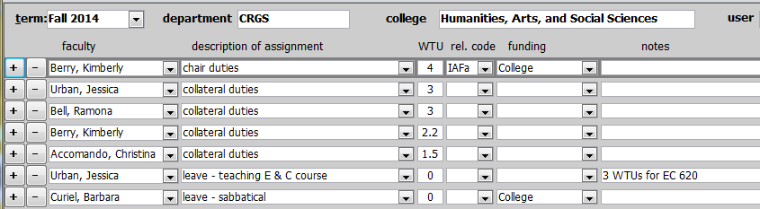

Like the class schedule form, the + and – buttons will add or delete rows. From the description of assignment drop down menu select between assigned time, collateral duties, or leave option.
Assigned time:
- The most important thing to know is that the combination of faculty and description of assignment must be unique. When you add a row, the description will say “assigned time.” You must modify this description before you can add a second assigned time row for the same instructor (example, modify to “assigned time UFPC”).
- Any data on the assigned time form with a release code will appear on the Assigned Time Approval Form, which replaces APS form 121.
- For reporting assigned time, completing the WTUs, rel. code (release code), and funding are mandatory fields. The dropdown on the release code will show the meaning of each code.
- For a list of assigned time codes, definitions, and commonly used funding associated with the codes, refer to Assigned Time Appendix (a separate .pdf document).
Collateral Duties:
- The WTU field is mandatory, release code and funding should remain blank.
- Data reported as collateral duties will not be included in the Assigned Time Approval form.
Leave:
- Indicate WTU value of 0
- Data reported as leave will not be included in the Assigned Time Approval form
- In notes, indicate reason for leave: sabbatical, DIP, LWOP, FERP semester not teaching, other

Update from CMS
Because SPA is used for both planning purposes and as a way to easily retrieve certain historical information, it will be updated with actual data from CMS at some point in time. Much of the data (instructor, units, cap, est, enroll) can be automatically updated as long as the course and section number are the same as in CMS. Your administrator should remind you of the timeline below.
Timeline for update:
- The week following census of each semester, make sure course and section numbers in SPA match those in CMS. Run the SPA-CMS Differences report to determine where discrepancies exist. Have SPA updated within five business days following census date.
- The programmer will automatically update SPA after five business days have passed from census date.

Reports
The report drop-down window at the bottom of the class schedule form may be used to select one of the reports built into the database. Users without Read-only or Write permission have limited report options.
To access a report, open the drop-down window and select a report. A preview of the report for the department (or college) and term will appear on your screen.
The semester, department, and college criteria will be used in generating the report. If a department is selected, the report displays department data. If the department field is left blank and a college is indicated, then you will obtain college-wide data. If both the department and the college field is left blank, you will obtain a report of all three colleges.
Reports and report descriptions are listed below:
Assigned Time Approval Form is for reporting assigned time to Academic Personnel Services. This report contains only assigned time that has the release code field populated; it does not include collateral duties or leave.
Assigned Time report contains assigned time, collateral duties, and leaves.
Changes Since Last Year reports changes from currently selected term to same term of prior year.
Changes Since Shapshot lists changes that have occurred since the snapshot (snapshots are done by the administrator)
Class Schedule Grid provides a visual representation of the projected course schedule. It also provides a breakdown by day usage and by time zone percentages. In determining zone usage, a 1.5 hour class counts as two hours because the classroom is utilized during the second hour. Online class ‘hours’ are based on the class unit value (3 unit class = 3 hours ‘online’ time).
Course Group Schedule allows users to create custom groups of courses and view for schedule conflicts samong the group. This report may be used to generate a printable schedule of courses in other departments; may be used as a way for interdisciplinary programs to show all courses offered per semester.
Cross-Listed and Dual-Level Classes provides a list of courses that are cross-listed with each other, the primary instructor, estimated enrollment, cap enrollment, and scheduling information.
Faculty Load List is an inclusive report that includes course assignments and non-course workload such as assigned time, chair duties, collateral duties, leave. The report is listed in instructor order.
Faculty Schedule Grid provides a per faculty list of courses, assigned time, and collateral duties along with each faculty members course load on a weekly schedule grid, one page per faculty. If faculty prefer, they may cut the grid portion from the report and post it on their door.
GE Data reports remedial, GE, DCG, human integration, and institution requirements
Online/Hybrid class report identifies courses which are fully online or a combination of online and face to face (hybrid).
Proposed Classes is a report of all courses, listed in course order, with instructor, and other information course-related. This report does not include any assigned time, chair duties, or collateral duties.
Proposed Classes w/o faculty is a report of all courses, listed in course order, without instructor, and other information course-related. This report does not include any assigned time, chair duties, or collateral duties.
Schedule Conflicts: This report is designed to highlight scheduling that could prevent students from registering for a class. If a class with a single available section overlaps the day and time of another class with a single available section, these classes may appear on the report. One to four *s will appear next to each conflict, indicating the number of times this particular combination of classes has been taken by students in the past. Classes which have never been taken in the same semester by students will not be listed. As enrollment reach the cap during registration, more conflicts may appear, as there will be more classes with a single available section.
The mode of the class is considered. If a single course has multiple components such as one lecture section and four lab sections, the single lecture section is considered for the purposes of checking for schedule conflicts.
SPA-CMS Difference compares differences in SPA versus PeopleSoft courses. For SPA to work correctly, all of these differences should be corrected. Often, these are caused by the section number in SPA not matching the one in CMS. These will appear as two unmatched records with all other data matching. Change the section # in SPA to match the one in CMS.
Student Faculty Ratio shows current year SFR compared with prior year SFR, by term, separated into teaching WTU and assigned time/collateral WTU, with totals. This is a simplistic calculation of SFR and designed to be used for planning purposes only. True SFR numbers are provided from the Institutional Research department sometime after APDB (FAD) reports have been reviewed and finalized.
In order for the actual enrollment to update in SPA every night, the course, number, and section must all match CMS exactly. After correcting mistakes, the enrollment will appear in SPA the following day.
For all reports, you can click to zoom in. Choose Print from the menu or type Ctrl-P to send the report to the printer. To save a report as a .pdf document, select print, then from the print window that opens, select printer name “adobe pdf” from the options.

Shortcuts and Other Tools
In an effort to make your data entry as easy as possible, a couple of keyboard shortcuts have been created. Press the space bar to open a drop-down or jump to the end of a text box. Press the arrow keys to move up and selections in an open drop-down or to move around the spreadsheet.
You may also use the filtering and sorting tools built into Access by right-clicking on various fields and selecting from the shortcut menu. (Sort by course #, sort by instructor fields can be accomplished).
Please let me know if you have any problems or suggestions with this database: ward@headstrom.net or ward@humboldt.edu

REVISION CONTROL:
Document Title: SPA Users Guide
Author: W. Headstrom / G. Pierce
File Reference:
Date | By | Action | Pages
10/8/12 | W. Headstrom &  G. Pierce | Release of New Document | All
2/14/13 | W. Headstrom &  G. Pierce | X-list box, GE field, units field, mode, collateral duties, show times form, class schedule grid, assigned time report, | Multiple
9/3/13 | W. Headstrom &  G. Pierce | Major Updates:  Added users & permissions & screenshots  Updated Assigned Time, Collateral Duties, & Leave; updated reports | 3, 4  10-12
3/21/14 | W. Headstrom &  G. Pierce | Added enrollment field, calculations, pro-populated data from prior tersm, update from CMS.  Added or revised reports: Changes since last year, course group schedule, faculty schedule grid, student faculty ratio | 2, 4, 9, 11, 12, 13
10/01/14 | G. Pierce | Instructor field; mode field; cap & estimated; calculations; show times field; conformation to scheduling guidelines; reports cross-listed & dual level classes, online/hybrid, schedule conflicts | 8-9; 10; 11;  11; 12-13;  13; 15-16

