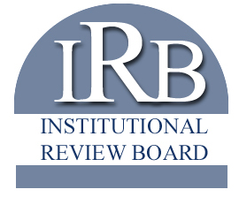

California State University, Stanislaus
Institutional Review Board
Study Status Form
For use by research approved as exempt (all)
or expedited (student investigators only)

Office of Research & Sponsored Programs, MSR 160
Telephone (209) 667-3493
Email: IRBAdmin@csustan.edu

For Official Use Only

Protocol Log # _________ -- _______

Applicant Information
Principal Investigator |  |  |  |  | Co-Investigator(s)
Department |  |  |  |  | Faculty Sponsor
Phone: |  | ( )
Email:
University Affiliation |  |  | STUDENT STAFF FACULTY
University Affiliation (student) |  |  | Currently enrolled graduated/completed
Master’s Thesis/Project? |  |  | YES NO
Doctoral Dissertation? |  |  | YES NO
Sponsored Project? |  |  | YES NO | Source of Funds

Study Status Questions
Current Project Status. The PI must check one of the following to indicate the overall status of the study:
- Active and open to enrollment; participants are undergoing interventions per approved project.

- Closed to enrollment; participants continue to undergo interventions per protocol.

Date Closed to Enrollment:
- Closed to enrollment; participants are in follow-up only and data being accessed is only from interventions as described in approved protocol

Date Participant Intervention Ended:
- No further participant interventions or follow-up; data analysis of private identifiable information only ongoing.

Date Follow-up Ended:
- Study is a data analysis only study; there are no interventions and data analysis is ongoing

Certification and Signature
 | By submitting this protocol renewal request, I certify under the penalty of professional misconduct the attached statements are accurate and true.

