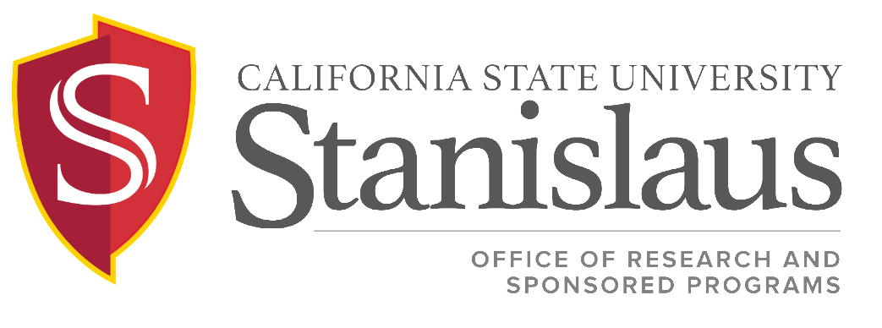

Sponsored Programs Procedures for General Policy Standards and Requirements
in support of ICSUAM Policy 11002.01

Issued: May 2020

DESCRIPTION
This procedure outlines the process that Stanislaus State follows to implement the Sponsored Programs General Policy Standards and Requirements.

PROCEDURE

External Award Recipient
The University shall be the primary Sponsored Programs Administrator and the recipient of external grant and contract awards.

State Agreements
Stanislaus State shall use the California Model Agreement (CMA) for all state grants and contracts unless an exemption is granted by the Chancellor’s Office. If a contract received from a state agency does not adhere to the CMA or use the currently approved University Terms and Conditions, the ORSP staff member will contact the agency and request that the CMA with University Terms and Conditions be used. If the state agency refuses to use the CMA, the Director of ORSP will escalate the matter to the Chancellor’s Office following the procedures below:

CMA Agreement Exemption Request
On occasion, a state agency may take the position that their agreement with the UC/CSU is not subject to CMA. For such cases, a CMA Exemption is required. The exemption request will be reviewed by the CSUCO, UC, and the State Department of General Services (DGS). All parties must approve the request to exempt the agreement from CMA. If the State agency does not directly initiate an exemption with DGS, the campus may initiate the request by submitting a CMA Exemption Request.
- The Director of ORSP will submit an email to cmarequest@share.calstate.edu requesting a CMA Agreement Exemption
- The request will include appropriate documentation supporting the exemption.
  - Describe the agency’s position why this agreement is believed to be outside the parameters of AB20, CMA.
  - Include communication from State Agency (solicitation, correspondence, etc.) AND project summary.
- CSUCO Review
  - Upon receipt of the exemption request, SPA will coordinate review with the UC and DGS
  - SPA will coordinate review with CSUCO EVC/Chief Financial Officer (CFO), when applicable.
  - The review will take approximately 5-10 days.

Stanislaus State will follow the Chancellor’s Office guidance on the standard F&A rate to be applied to State Agreements. The ORSP staff will budget the F&A on a state contract using either the university’s federally negotiated indirect cost rate (if the funding is federal flow-through) or the current F&A rate for State Agencies as published by the Chancellor’s Office. The following procedures are to be followed if an alternate F&A rate is to be used:

CMA IDC Exception Request (for contracts and grants)
Acceptance of an IDC rate that is lower than the rate approved by the CSU requires system office approval in accordance with ICSUAM Policy 11003.03. Sponsored Programs Administration (SPA) in the Office of the Chancellor will coordinate with the CSUCO EVC/CFO for CSU approval – and, when applicable, with the UC Office of the President (UCOP) Research Policy Analysis and Coordination (RPAC) office – to ensure both systems are in agreement when or if a lower rate would be appropriate.

CMA IDC Exception Process:
- The Director of ORSP will send a CMA Exception request by email to cmarequest@share.calstate.edu.
- The request will include appropriate documentation supporting the deviation.
  - Documentation
    - Describe the restriction (both the rate and base).
    - Provide documentation of the IDC restriction (i.e. published policy document, agency website, or solicitation).
    - If the agency asserted that there is a statutory or regulatory reason for the limitation of indirect cost recovery, please provide links, citations, or other documentation of the regulatory or statutory reason for this limitation.
The reduction for indirect cost must be instigated by a state agency policy or regulation. An agency's publication of a policy does not guarantee that it will be accepted. Requests that voluntarily reduce indirect cost will not be considered.
- The request will provide a response to the following questions.
- How has your campus sought to apply the appropriate campus/CSU Rate for this proposal?
- What differentiates this project from other projects at your campus to merit exceptional treatment?
- Has the agency indicated that it would consider use of the campus/CSU Rate in the future?
- President Approval
  - A request must include evidence of the President or official designee’s approval. (The official designee is the individual with authority to approve a reduced IDC rate on behalf of the campus.)
- CSUCO Review
  - Upon receipt of the exception request, SPA will coordinate its review with the UC, when applicable.
  - SPA will coordinate its review with the CSUCO EVC/Chief Financial Officer (CFO).
  - The request will only be approved with support from the CFO.
  - The review of exception requests will take approximately 5-10 days

Principal Investigator
The qualifications to serve as a Principal Investigator shall include employment by the University. Limited exceptions may be allowed for the appointment of Principal Investigators who are not employees of the University but who are officially affiliated with the University, such as individuals with emeritus status or visiting professors or researchers, as recommended by a dean, following appropriate consultation, and as approved by the Provost.

In the case where the incumbent Principal Investigator resigns, becomes incapacitated, or fails or refuses to perform the duties adequately, the Principal Investigator’s responsibilities may be reassigned. Reassignment or other resolutions may be determined in one of the following ways:
1. Resignation/Retirement:
a. When a faculty member resigns from his/her position at the University and where the nature of the investigation/project is best served by the unique research strengths of the faculty member, a negotiation between the Principal Investigator, the Funding Agency, Director of Research and Sponsored Programs, and Provost, will occur and a mutually satisfactory resolution will be reached.
b. When a faculty member resigns/retires from his/her position at the University as Principal Investigator of a grant and where the University has provided “Extraordinary Support or Compensation” to develop the grant initiative (see Intellectual Property Rights Policy), OR where the nature of the grant is one that is uniquely designed to meet the regional needs of the University, then the University will retain the grant/contract.
2. Incapacitation: When a Principal Investigator becomes incapacitated during administration of a grant/contract, the Funding Agency, Provost, and Director of Research and Sponsored Programs, will consult and a satisfactory resolution will be reached. In the event that the PI is able to communicate, the Director of Research and Sponsored Programs will consult with the PI prior to contact with the funding agency.
3. Failure to Perform Duties Adequately: When a Principal Investigator fails to perform the requisite duties within a grant/contract, the University will implement an inquiry process. The inquiry will be set forth as follows:
a. Initial Inquiry: When a complaint about Principal Investigator performance is lodged by the funding agency, financial services, members of a grant, or other stakeholders, the Research Integrity Officer will assess whether the allegation has substance and determine if an investigation is warranted.
b. Investigation: If the Research Integrity Officer determines that an investigation is warranted, a committee will be assembled, comprised of the following individuals:
i. Two campus faculty, preferably with grant experience, one of whom is from the PI’s discipline
ii. Financial Service Officer
iii. Director Research and Sponsored Programs
c. Decision: The committee conducting the investigation will recommend a corrective action to the Research Integrity Officer. The Research Integrity Officer will inform the Principal Investigator, the funding agency, Research and Sponsored Programs, and Financial Services of the final decision and corrective action taken. Corrective actions may be recommended that could include benchmarks related to Principal Investigator performance on the grant or may involve removal of the Principal Investigator from the grant. Regardless of the outcome, the Research Integrity Officer will present his/her findings and recommendations to the funding agency and shall complete the investigation and decision within one semester.

4. Grant Employee Complaints: Any employment-related issue or complaint, including harassment, discrimination, and threat of violence that could arise between a PI and another grant employee will follow current Human Resource Procedures that include discovery of all relevant information, and safeguarding the rights of both the person making the complaint and the person who is the subject of the complaint. Both parties will be assured that the investigation and its resolution conform to all legal requirements, institutional policies, and good business practice commitments of each party.

5. Sexual Harassment Reporting: At the time of receipt all grant and contract agreements will be reviewed for specific reporting requirements related to harassment. If award language requires reporting on sexual harassment, the Director of Research and Sponsored Programs will forward names of all key project personnel to the Senior Associate Vice President for Human Resources or his/her designee. That official will be responsible for informing the Director of Research and Sponsored Programs, in the timeframe mandated by the funding agency, if a reportable claim is made or action is taken against key personnel.

When projects call for the distribution of responsibilities among Principal Investigators for multi- institutional Sponsored Programs, these responsibilities shall be clearly specified in the grant or contract proposal, shall be agreed upon in advance by the Principal Investigators, and approved by the appropriate campus administrators.

The University shall be the employer of the Principal Investigator and other employees with regard to work performed in furtherance of each grant or contract. In all matters related to the fulfillment of the grant or contract, the Principal Investigator will work in concert with the funding agency and University to ensure that the integrity of the grant is maintained. Should problems fall within the scope of existing campus policies for the conduct of research, CSU Stanislaus shall follow the appropriate policy and procedures (e.g. research misconduct, human subjects, animal welfare, and intellectual property). Additional employment is addressed through the Collective Bargaining Agreements for both faculty and staff.

Externally Funded Projects in Tax-Exempt Bond-Funded Facilities.
At the time of award, the Office of Research and Sponsored Programs will make a determination if the project does or does not comply with the Safe Harbor Exemptions using the criteria below:
Safe Harbor Exemptions (does not have a specific commercial objective)
(a): Corporate Sponsor
- CSU permits license or other use of the resulting technology (can be exclusive) to sponsor or non-sponsor on the same terms
- The price paid for use is at market rates
(b) Industry Sponsor
- The CSU determines the subject and manner of research
- The CSU retains exclusive title to any patent or other product
- The sponsor or sponsors receives no more than a nonexclusive, royalty-free license
(c) Federal Government Sponsor
- The CSU determines the subject and manner of research
- The CSU retains exclusive title to any patent or other product (compliant w/Bayh-Dole)
- The sponsor or sponsors receives no more than a nonexclusive, royalty-free license
A notice of determination and a copy of the proposal routing form will be filed with the Stanislaus State Office of Capital Planning and Facilities Management.

