Inside Sales Representative

**Currently in pursuit of a sales career? Then apply at Nobel Biocare - a world leader in the field of dental implants.**

We are currently seeking dynamic Inside Sales Representatives to join our Sales Development Program where you will build your sales foundation within our Yorba Linda Regional Office and upon successful completion of the program transition into an outside Professional Sales Representative position in Fresno, California or Sioux Falls, South Dakota. This is an entry-level career opportunity.

**If you are interested in joining our World Class North American Sales Team please apply for the opportunity TODAY!**

As an Inside Sales Representative, you will be responsible for achieving or exceeding sales and service goals through the effective selling and promoting of Nobel Biocare products, solutions, education and services to existing and potential new customers within the framework of organizational policies and directives. The primary focus will be in telephone selling with specific targeted customers to support the growth of a defined regional territory.

**Responsibilities include:**

·Attend corporate training to further develop understanding of the company, products, services and industry trends

·Manage targeted customer lists and maintain accurate customer files and records in order to have complete up-to-date customer information, which can be shared among the (local) organization

·Achieve targeted sales goals and other initiatives relative to a given quota within the framework of key targeted customers

·Support Training and Education practices to help further attendance and follow-through of activities

·Track and report on telephone sales activities and results, identifying key areas of success or areas for improvement

·Report to the management about any key trends or competitive tactics that have been identified with targets

·Study and stay informed on products, technologies, internal processes, and other general information of interest to company or to customers. Apply this knowledge for your strategies and tactics to support your activities

·Maintain a comprehensive knowledge of all company policies and procedures and demonstrate the ability to effectively implement them at the Inside Sales level

·Correspond with local field representatives to understand daily business needs and leads

·Complete all administrative work in a timely manner

·Participate in national and local trade shows and company meetings as appropriate. Support Yorba Linda established educational programs when territory customers are attending

**Minimum Requirements:**

·Equivalent educational level: Bachelor's degree. Major in business or related field preferred

·Minimum of 2 years of achievement in customer-interfacing work experience

**Desired Skills:**

·Dental industry experience

·Preferred minimum of 2 years in achievement oriented sales, preferably in the medical device field

·Ability to be an advocate to changing markets and technology

·Effective time management skills

·Entrepreneurial mindset

·Demonstrated ability to digest, to comprehend, and verbalize highly technical information related to company and industry products and services

·Demonstrated professional sales skills

·Strong verbal and written communication and interpersonal skills

·Basic to intermediate computer skills with focus on Microsoft Excel

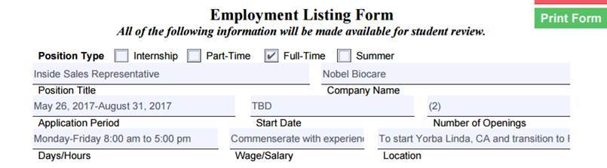

*Location: To start Yorba Linda, CA and transition to Sioux Falls, South Dakota.

[www.nobelbiocare.com](http://www.nobelbiocare.com)