Veteran Spotlight

Veteran Spotlight
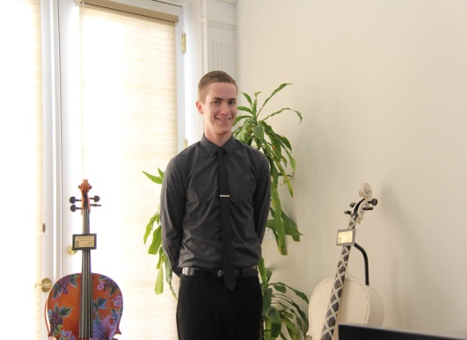

Ryan Lough
Class Level:
Junior
Degree Objective:
Bachelor of Arts
Major/Department:
Anthropology
Hometown/Branch of Service:
Kalama, Washington/ U.S. Navy

Biography
Why did you choose CSU Stanislaus?
I love Central California and Stan has a great anthropology program.
Where have you been stationed/Specialty while in the military?
NIOC Pensacola/Received signals analysis training but mainly performed quality control.
What advice would you give Prospective Students?
Talk to Nadine! No matter what the issues is, she can help!
What has been your favorite academic or student life experience so far?
Pledging Alpha Phi Omega
What is one of your memorable moments while in the military?
Free motorcycle training provided by the Motorcycle Safety Foundation.
What is your career objective?
Forensic Anthropologist
Do you plan to attend Graduate School?
Yes

