Veteran Spotlight

Veteran Spotlight
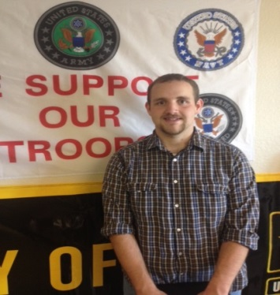

James Hurd
Name and Relation of Veteran:
John Hurd, Father
Branch of Service/ Stationed/ Specialty while serving?
U.S. Army/Fort Lee, Virginia/Quarter Master
Class Level:
Junior
Degree Objective:
Bachelors of Arts
Major/Department:
Agricultural Studies
Hometown:
Turlock, CA

Biography
What has been your favorite academic or student life experience so far?
Hanging out at the Veteran’s Center.
What is your career objective?
I want to either work dealing with money or in agriculture.
Do you plan to attend Graduate School?
I’m still debating if I want to.

