Veteran Spotlight

Veteran Spotlight
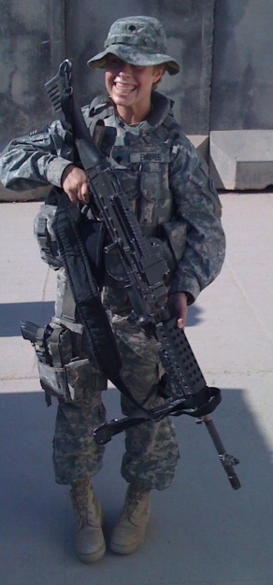

Christine Embree
Class Level:
Graduates Spring 2014
Degree Objective:
Bachelor of Arts
Major/Department:
Psychology
Hometown/Branch of Service:
Modesto, CA/U.S. Army

Biography
Why did you choose CSU Stanislaus?
It’s close to home and I heard it had a great psychology program. Then I saw how beautiful the campus is.
What advice would you give Prospective Students?
Sit and go to all your classes, maintain a positive attitude and find something to enjoy in each class.
What has been your favorite academic or student life experience so far?
Spending time in the student vet center – that’s where I feel safe and belong.
What is your career objective?
To graduate with a Masters in Social Work and become a counselor for veterans at a VA center.
Do you plan to attend Graduate School?
Yes, here.
What clubs, sports, and activities have you participated in?
Working out in the school gym.
Who are your most influential personal and/or University mentor?
I don’t have a mentor per se, but each faculty member and student who has talked with me would make it on this list.

