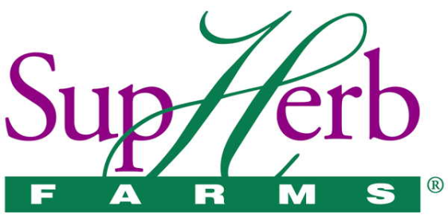

Job Title: Quality Assurance Project Intern
Department: Quality Assurance
Reports To: Quality Assurance Manager
FLSA Status: Non-Exempt/Hourly
Classification: Temporary – Part-time 15-25 hours/week. Up to 40 hours/week during the summer.

Summary: Project based job assignment that provides support to the Quality Assurance Manager or Assistant Quality Assurance Manager

Essential Duties and Responsibilities:
- Gold Standard Project
  - Performs quality checks
  - Taking pictures
  - Updating specifications and quality worksheets
  - Provide updates to team
- First Time Quality
  - Write procedures
  - Train on new procedures
  - Provide updates to team
- Other duties/projects as necessary

Qualification Requirements and Preferences:
- Associate Degree in Biology or Chemistry with related science college courses (general chemistry, general biology, and microbiology and/or food science preferred.
- Lab experience and good safety behaviors including GMPs required.
- Previous experience in Food manufacturing a plus.
- Work on projects and special assignments as assigned or initiated.
- Good problem solving skills
- Ability to take initiative and prioritize tasks. Good time management skills, organizational and problem-solving skills.
- Willingness and flexibility to adapt to changing business needs and deadlines.
- Good interpersonal skills with the ability to work effectively with individuals and groups at all organizational levels.
- Ability to work independently and as part of a team.
We offer a competitive compensation and benefits package and a collaborative work environment. If interested, please send resumes to:
HRRecruiting@supherbfarms.com or fax at (209) 216-5992
EEO Employer/Vet/Disabled

