Review Requisitions
This guide outlines the process to review a requisition. A Requisition is a request for goods or services for use by your department. The approval process for requisitions is a 3-tier system; The Requestor who enters the requisition, the Reviewer who reviews line items and expenditures, and the Approver who approves the requisition to be made into a Purchase Order. There could be more than one reviewer depending on the individual department policy, but only one Approver.
Purchasing > Requisition > Add/Update Requisitions
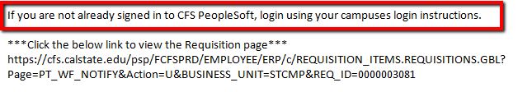  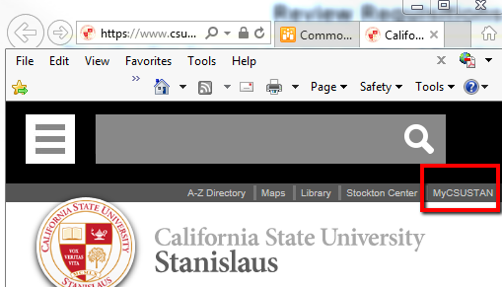  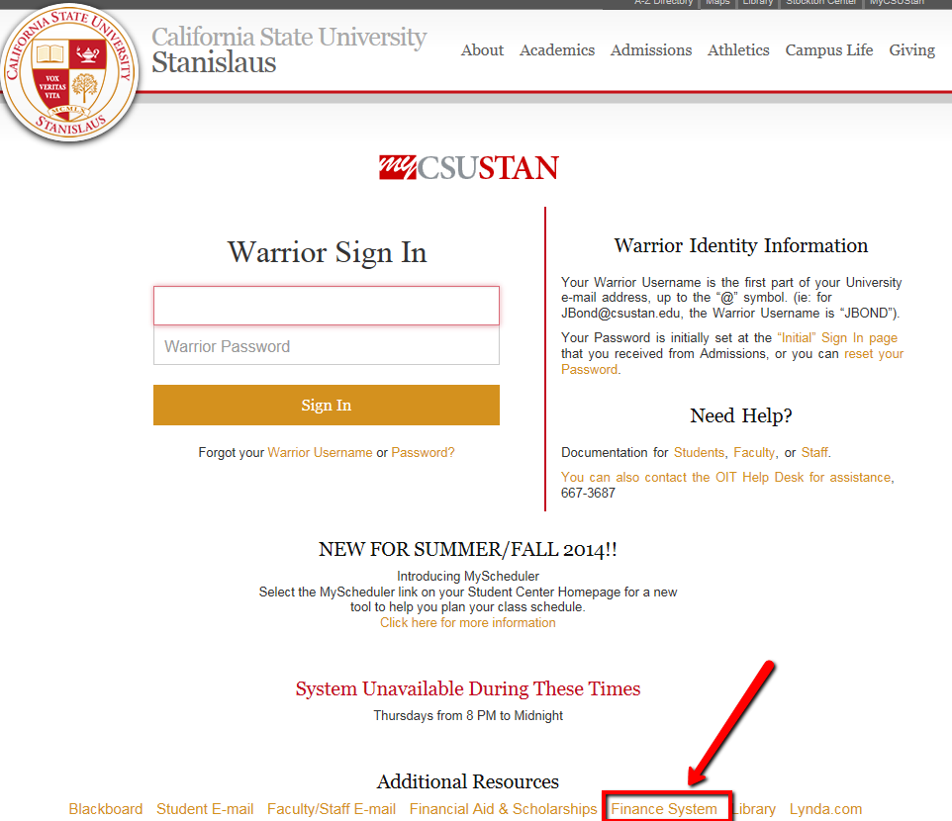 | - An email will be received for each requisition that needs to be reviewed and/or approved.  - Go to www.csustan.edu and click on the myCSUSTAN link before clicking the link in the email to view the requisition.  - Click the Finance Systems link at the bottom of the page

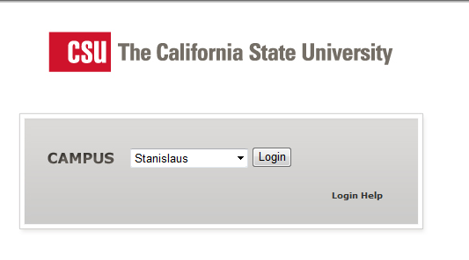 | - Select Stanislaus from the drop down menu, then click Login

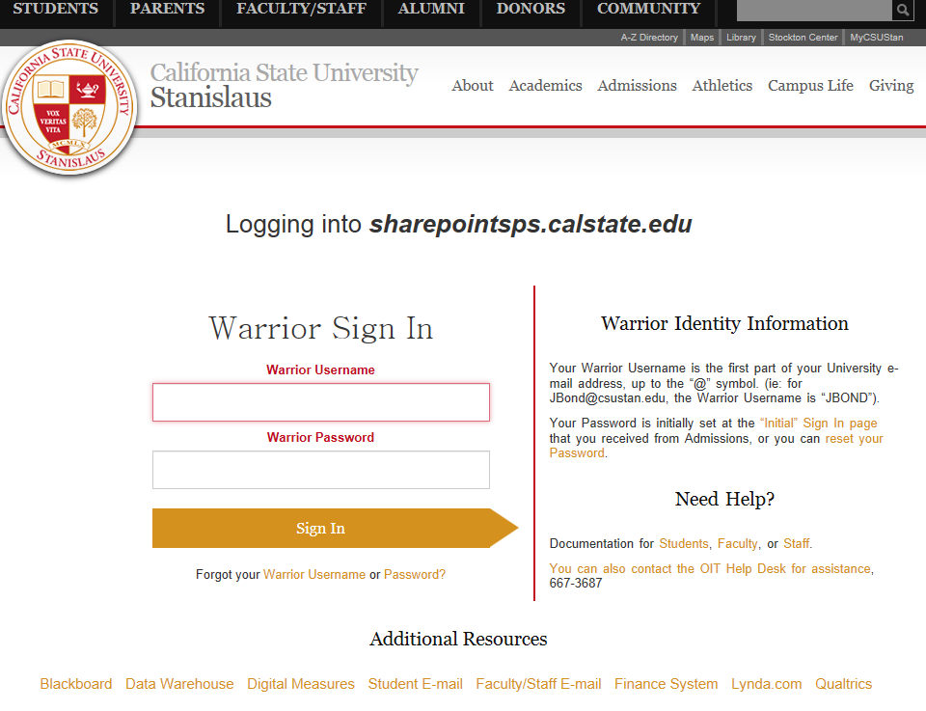 | - Enter a User ID  - Enter a Password  - Click the Sign In button  NOTE: User ID and Passwords are specific to each individual and are the normal credentials a user uses to login to their email.

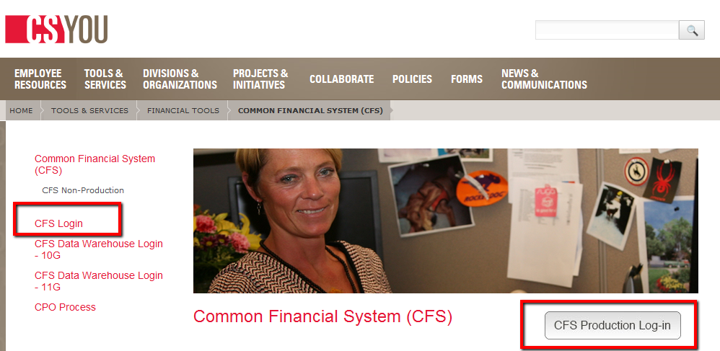 | - Select CFS Login from the list on the left or click the CFS Production Log-in button on the right.

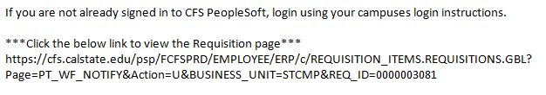 | - Navigate back to your original email  - Click on the link  NOTE: You will be directed to the requisition page.

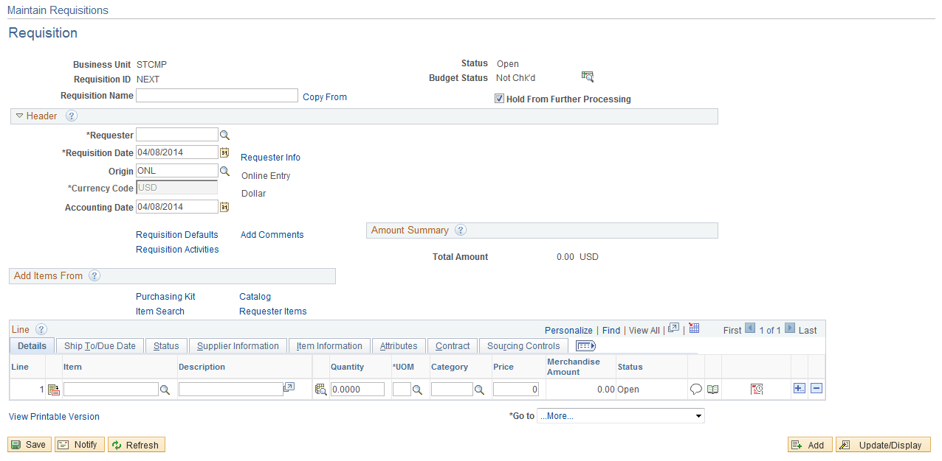 | - Select the Requisition Defaults link

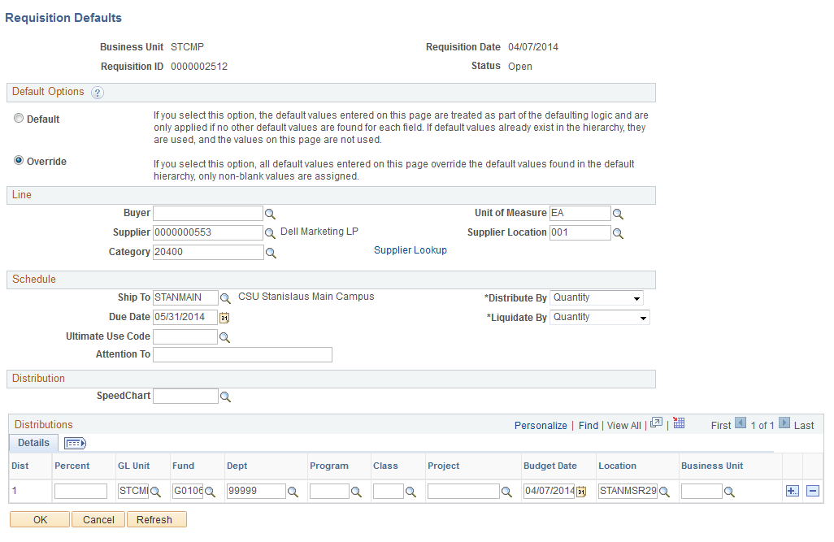 | - Review the Chartfield string  - Click the Cancel button.

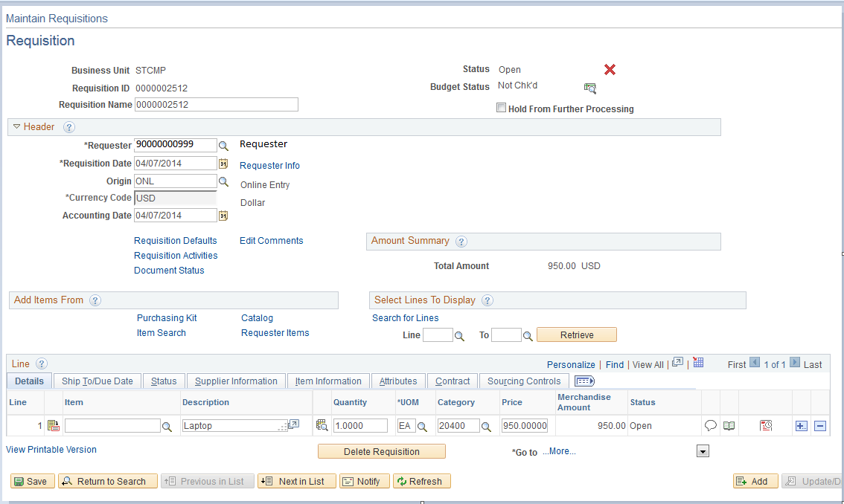 | - Click on the Edit Comments link.

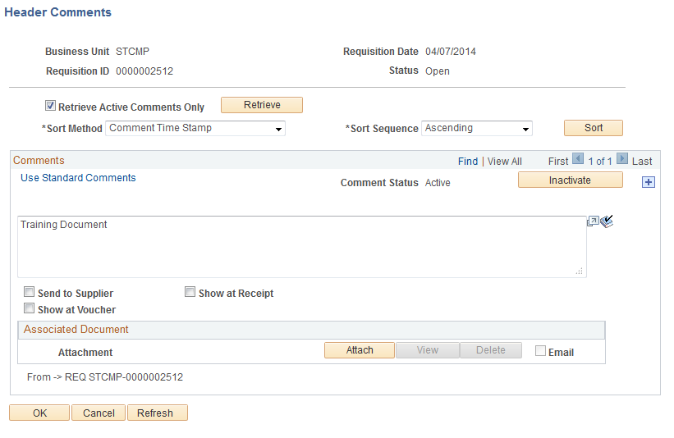 | - Click on View All; to view all the comments available.  - Review the comments listed.  NOTE: If there are split funding sources, there will be a comment stating such. Refer to step 21.  - Click the Add a New Row icon to add a comment  - Type a justification.  - Click the OK button.

NOTE: Steps 21-25 only need to be completed if a comment was entered stating that this order is being split between funding sources.

- Select the Schedule icon

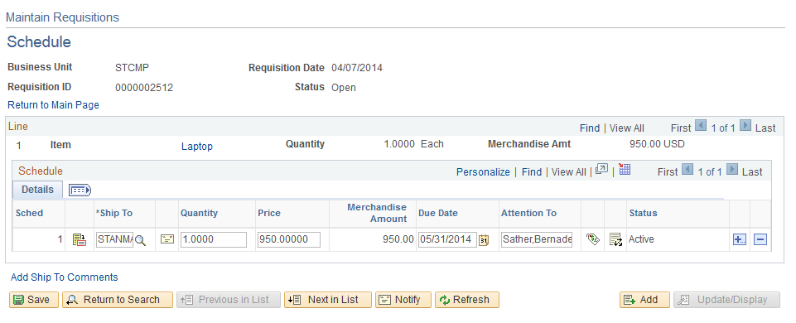 | - Select the Distribution icon 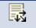

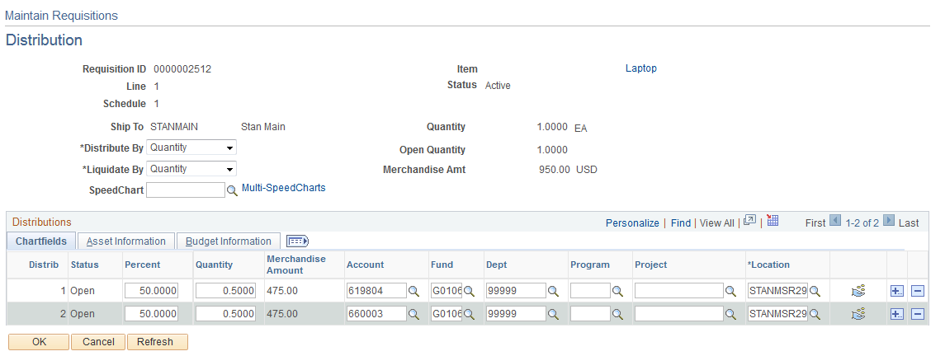 | - Review the split funding sources  - Click OK to return to the Schedule information.

- Select the Return to Main Page link

- Select the Requisition Activities link.

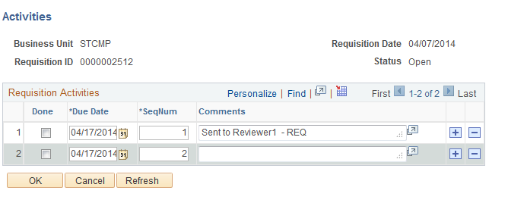 | - Enter your comment, including your initials or name.  Sample Comment: Reviewed and forwarded. REV  - Click OK button

- Click the Save button

- Once the requisition is saved, click the Notify button.

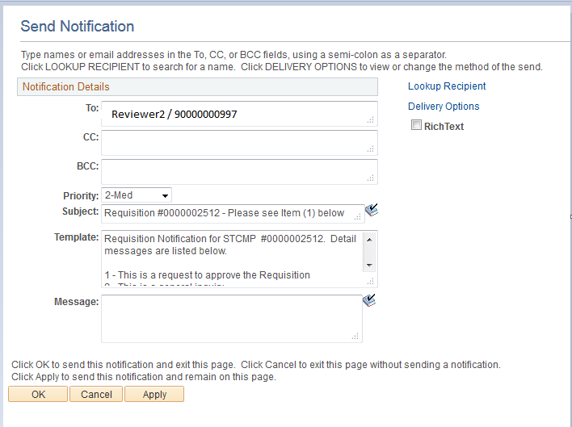  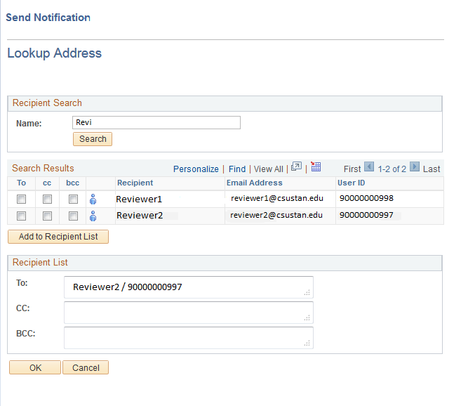 | NOTE: Notification is sent to the next person in line for review or approve.  - Enter the individuals email in the To: field  or  Click the Lookup Recipient link  **NOTE: If you use the lookup receipient feature the requisition will appear in the receipient’s worklist. Although worklist is not functional at this time it may be in the future.  - Select the priority level from the drop down menu  - Type your message  SAMPLE MESSAGE: Dear Reviewer, please review the requisition and forward to the next approving authority  - Click the OK button

